SCHEDULE – A
(See Clause 10.1)

SITE OF THE PROJECT

The Site

  - Site of the Project - Six Lane Project Highway with Service Roads shall include the land, buildings, structures and road works as described in Annex-I and Annex - II of this Schedule-A.

  - An inventory of the Site including the land, buildings, structures, road works, trees and any other immovable property on, or attached to, the Site is provided as a part of this schedule.

Annex - I
(Schedule-A)

Site of Six Lane divided Highway with Service Roads

The Site

The Chennai Metropolitan Development Authority (CMDA) as part of its Master Plan has developed Outer Ring Road (ORR) along the periphery of Chennai Metropolitan Area (CMA) in Kanchipuram and Thiruvallur Districts of Tamil Nadu with the objective of relieving congestion within the city and also for catalyzing the even dispersal of urban growth. The ORR provides orbital linkages to the major radials as well as decongests the traffic flow on the existing major roads including the Inner Ring Road (IRR) and disperse the urban growth over a large area. The proposed ORR connects NH-45 at Vandalur in the south with Thiruvottiyur-Ponneri-Panchetti (TPP) Road at Minjur in the north. This ORR intersects five major roads the NH 45 (GST Road), NH 4 (Bangalore Road), NH 205 (CTH Road), NH 5 (GNT Road) and TPP Road. The entire stretch is divided into four segments and implemented in two Phases:

Phase I:

Segment-I – NH 45 to NH 4 Ch.Km. 0+000 to Km.18+950 Segment-II – NH 4 to NH 205 Ch. Km.18+950 to Km.29+650

Phase II:

Segment-III – NH 205 to NH 5 Ch.Km. 29+650 to Km.47+590

Segment-IV–NH 5 to TPP Road Ch.Km. 47+590 to Km.60+150

Segments I and II (approx. length of 29.650 km) connecting NH-45 near Vandalur to NH-205 (Between Tandarai and Nemilicheri villages) The Project Highway is developed as a six lane divided carriageway (Separated by Public Transportation Corridor of 22 m width) with service roads.

Disclaimer

The data presented in this schedule is for an initial understanding and guidance of the concessionaire. GOTN or TNRDC will not be responsible for any inaccuracy in the information provided and shall not be liable for or be bound by the data in the information provided and shall not be liable for or be bound by the data used by the Concessionaire in evaluating the project viability. The Concessionaire will carry out his own independent surveys for assessing actual position of the Project Highway.

The Concessionaire acknowledges that prior to the execution of this Agreement, the Concessionaire has satisfied himself (based on his own independent assessment) of the survey data, specifications and standards, site and all information provided by the GOTN / TNRDC. The concessionaire acknowledges and accepts the difficulties, risks and hazards likely to arise during the course of performance of his obligations hereunder.

Description of the Project Highway

The index map and location of the Project Highway is given in Figure A-1. The alignment passes

through agriculture lands and small built up areas.

Linear Chainage Referencing System

“Design Chainages” given in the base plans are to be used as reference for the entire length of the Project Highway. Using these as references, the Concessionaire shall, establish the “Design Chainage” for the Project Highway

Start and End of Project Highway

The approximate length of the Phase I of Project Highway is 29.650 kms. The Project Highway starts at National Highway – 45 at Vandalur (chainage Km 32.300) and ends at NH- 205(chainage Km 29.000) at Nemilicheri Village.

The approximate length of the Phase II of Project Highway is 30.5 kms. The Project Highway starts at Nemilicheri in National Highway – 205 i at the end of Chennai ORR Phase 1 and ends near Minjur in TPP road.

Total Length of the Project Highway is 60.15 kms.

Latitudes & Longitudes
The Project Highway lies between latitude 80°50’ and longitude 12°50’and latitude 80°20’ and longitude 13°20’

Terrain
The alignment passes through plain terrain.

Traffic
The indicative traffic estimates for the Project Highway at each toll plaza location is given in Tables A-1 to A-4.

Figure A-1: ORR Alignment in Context of Chennai Metropolitan Area

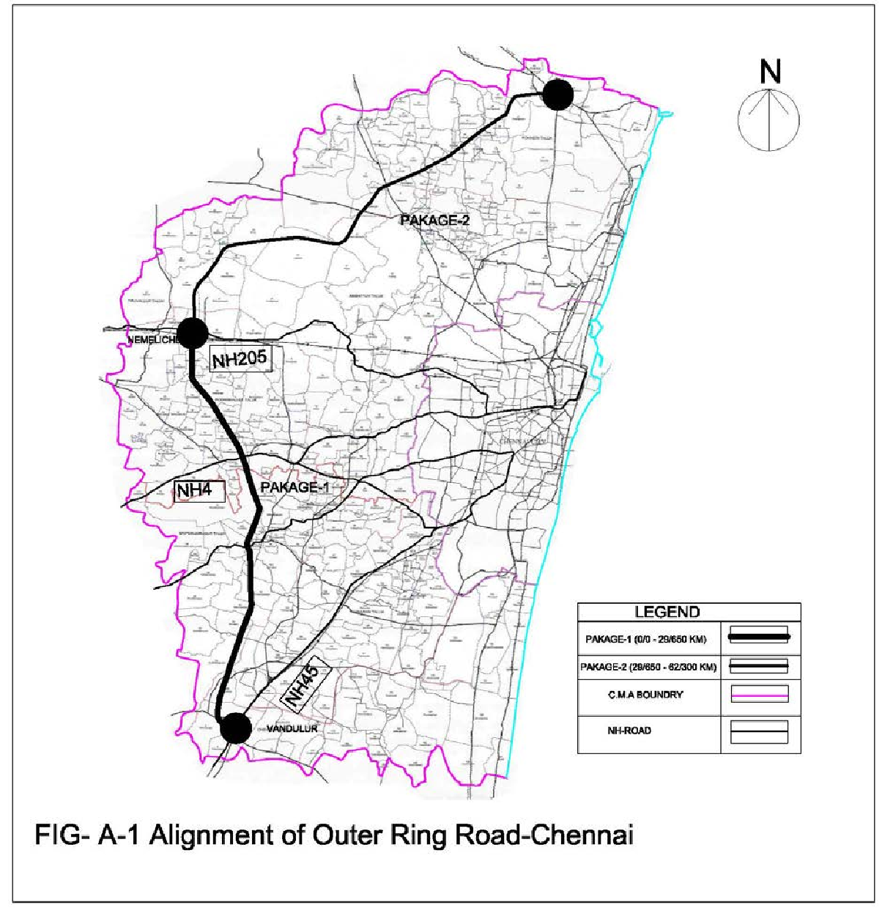

Chinnamullaivoyal Toll Plaza

Palavedu Toll Plaza

Kolappancheri Toll Plaza

Varadharajapuram Toll Plaza

Toll Plazas

Toll plaza locations shown are indicative and for general understanding only Map not to scale

Table A-1 Tollable Traffic on Varadharajapuram Toll Plaza

Year | Car, Van, Auto | LCV, Minibus | Bus and 2-axle | 3-axle | MAV,Tractors
2022 | 11875 | 3598 | 1642 | 1252 | 3023
2023 | 13141 | 3786 | 1731 | 1315 | 3204
2024 | 13992 | 3965 | 1809 | 1380 | 3396
2025 | 14902 | 4153 | 1890 | 1449 | 3599
2026 | 14933 | 4008 | 1805 | 1377 | 3425
2027 | 15903 | 4197 | 1886 | 1446 | 3630
2028 | 16938 | 4395 | 1970 | 1518 | 3847
2029 | 18043 | 4603 | 2059 | 1594 | 4077
2030 | 19223 | 4820 | 2151 | 1674 | 4321
2031 | 20359 | 5026 | 2238 | 1749 | 4554
2032 | 21564 | 5240 | 2329 | 1828 | 4799
2033 | 22843 | 5464 | 2424 | 1910 | 5057
2034 | 24201 | 5698 | 2523 | 1996 | 5330
2035 | 25642 | 5942 | 2627 | 2086 | 5617
2036 | 27020 | 6171 | 2723 | 2170 | 5889
2037 | 28475 | 6410 | 2824 | 2258 | 6175
2038 | 30011 | 6658 | 2929 | 2349 | 6474
2039 | 31632 | 6915 | 3037 | 2445 | 6788
2040 | 33344 | 7183 | 3150 | 2544 | 7117
2041 | 34973 | 7434 | 3256 | 2636 | 7427
2042 | 36684 | 7694 | 3365 | 2733 | 7751

*The above figures are for reference only and the Authority does not take any responsibility/liability for their accuracy

Table A-2 Tollable Traffic on Kolappancheri Toll Plaza

Year | Car, Van, Auto | LCV, Minibus | Bus and 2-axle | 3-axle | MAV,Tractors
2022 | 11875 | 3598 | 1642 | 1252 | 3023
2023 | 13141 | 3786 | 1731 | 1315 | 3204
2024 | 13992 | 3965 | 1809 | 1380 | 3396
2025 | 14902 | 4153 | 1890 | 1449 | 3599
2026 | 14933 | 4008 | 1805 | 1377 | 3425
2027 | 15903 | 4197 | 1886 | 1446 | 3630
2028 | 16938 | 4395 | 1970 | 1518 | 3847
2029 | 18043 | 4603 | 2059 | 1594 | 4077
2030 | 19223 | 4820 | 2151 | 1674 | 4321
2031 | 20359 | 5026 | 2238 | 1749 | 4554
2032 | 21564 | 5240 | 2329 | 1828 | 4799
2033 | 22843 | 5464 | 2424 | 1910 | 5057
2034 | 24201 | 5698 | 2523 | 1996 | 5330
2035 | 25642 | 5942 | 2627 | 2086 | 5617
2036 | 27020 | 6171 | 2723 | 2170 | 5889
2037 | 28475 | 6410 | 2824 | 2258 | 6175
2038 | 30011 | 6658 | 2929 | 2349 | 6474
2039 | 31632 | 6915 | 3037 | 2445 | 6788
2040 | 33344 | 7183 | 3150 | 2544 | 7117
2041 | 34973 | 7434 | 3256 | 2636 | 7427
2042 | 36684 | 7694 | 3365 | 2733 | 7751

*The above figures are for reference only and the Authority does not take any responsibility/liability for their accuracy

Table A-3 Tollable Traffic on Palavedu Toll Plaza

Year | Car, Van, Auto | LCV, Minibus | Bus and 2-axle | 3-axle | MAV,Tractors
2022 | 7199 | 3488 | 1385 | 1079 | 3447
2023 | 7920 | 3668 | 1456 | 1133 | 3654
2024 | 8413 | 3845 | 1527 | 1190 | 3873
2025 | 8940 | 4031 | 1601 | 1249 | 4104
2026 | 8541 | 3416 | 1396 | 1062 | 3458
2027 | 9070 | 3580 | 1464 | 1115 | 3665
2028 | 9634 | 3752 | 1535 | 1171 | 3884
2029 | 10235 | 3932 | 1610 | 1229 | 4117
2030 | 10875 | 4121 | 1688 | 1291 | 4363
2031 | 11490 | 4299 | 1762 | 1349 | 4598
2032 | 12142 | 4485 | 1840 | 1410 | 4846
2033 | 12833 | 4679 | 1921 | 1473 | 5107
2034 | 13565 | 4883 | 2005 | 1539 | 5382
2035 | 14342 | 5095 | 2093 | 1609 | 5672
2036 | 15082 | 5294 | 2176 | 1674 | 5947
2037 | 15863 | 5501 | 2262 | 1742 | 6235
2038 | 16687 | 5716 | 2352 | 1812 | 6538
2039 | 17555 | 5941 | 2445 | 1886 | 6855
2040 | 18471 | 6174 | 2542 | 1962 | 7187
2041 | 19341 | 6392 | 2633 | 2034 | 7501
2042 | 20254 | 6618 | 2727 | 2108 | 7828

*The above figures are for reference only and the Authority does not take any responsibility/liability for their accuracy

Table A-4 Tollable Traffic on Chinnamullaivoyal Toll Plaza

Year | Car, Van, Auto | LCV, Minibus | Bus and 2-axle | 3-axle | MAV,Tractors
2022 | 2538 | 748 | 643 | 1038 | 3336
2023 | 2798 | 788 | 676 | 1090 | 3536
2024 | 2974 | 825 | 709 | 1144 | 3748
2025 | 3162 | 863 | 743 | 1201 | 3972
2026 | 2898 | 790 | 699 | 1141 | 3540
2027 | 3079 | 827 | 734 | 1198 | 3752
2028 | 3271 | 865 | 770 | 1258 | 3977
2029 | 3475 | 906 | 808 | 1321 | 4215
2030 | 3694 | 948 | 847 | 1387 | 4468
2031 | 3903 | 988 | 885 | 1450 | 4709
2032 | 4125 | 1030 | 924 | 1515 | 4963
2033 | 4361 | 1073 | 965 | 1583 | 5230
2034 | 4611 | 1119 | 1008 | 1654 | 5512
2035 | 4875 | 1166 | 1053 | 1729 | 5810
2036 | 5128 | 1211 | 1095 | 1799 | 6092
2037 | 5394 | 1257 | 1138 | 1871 | 6387
2038 | 5675 | 1305 | 1184 | 1947 | 6697
2039 | 5971 | 1355 | 1231 | 2026 | 7022
2040 | 6283 | 1407 | 1281 | 2108 | 7363
2041 | 6580 | 1456 | 1327 | 2185 | 7685
2042 | 6892 | 1506 | 1375 | 2265 | 8020

*The above figures are for reference only and the authority does not take any responsibility/liability for their accuracy

Abutting Land use:
Abutting land use is predominantly agriculture and sparse residential development. The existing land uses along the Project Highway is given in Table A-5.

Table A-5 Abutting Land Use Phase I:
Chainage (Km) | LHS | RHS
0.000 - 4.000 | Agriculture | Agriculture and open
4.000 - 8.000 | Urbanisable | Primary Residential
8.000 - 10.000 | Non- urban | Non urban
10.000- 11.000 | Open, Industrial, Mixed Residential | Semi- urban, (Industrial and mixed Residential )
11.0000- 13.000 | Open Residential/ agriculture | Open Residential/agriculture
13.000- 18.000 | Water Body and Agriculture | Agriculture and Residential
18.000- 20.000 | Commercial/ Open | Mixed / Residential
20.000- 26.000 | Open / semi- urban | Open / Residential
26.000- 29.000 | Open/Residential | Open / Residential
29.000-29.650 | Open/Water Bodies | Open / Water Bodies

Phase II:

Chainage (Km) | LHS | RHS
0+000 to 0+950 | Residential area/barren | Residential area
0+950 to 1+800 | Agricultural, Pallavedu lake. | Agricultural/ Palavedu lake
1+800 to 2+200 | Palavedu lake and residential area | Barren, residential area, Educational institutions
2+200 to 4+950 | Agricultural and Commercial area | Agricultural
4+950 to 7+000 | Barren | Barren
7+000 to 7+600 | Commercial area and barren | Barren/Residential area
7+600 to 8+400 | Barren | Barren
8+400 to 8+800 | Educational Institutional area and barren | Educational Institutional area and barren
8+800 to 10+550 | Barren | Coconut Plantation and barren
10+550 to 11+400 | SIDCO, Eucalyptus plantation, Barren | Eucalyptus plantation, barren
11+400 to 12+750 | SIDCO | Educational institution area, residential area
12+750 to 15+050 | Barren/agricultural | Commercial area,  barren/agricultural.
15+050 to 15+900 | Barren, Commercial /residential area | Barren/ residential area
15+900 to 16+550 | Commercial / residential area. | Coconut Plantations and Commercial / residential area
16+550 to 18+200 | Barren | Agricultural, barren, and residential area
18+200 to 18+450 | Commercial area and barren. | Commercial area and barren
18+450 to 19+100 | Pannivakkam Lake | Pannivakkam Lake
19+100 to 21+250 | Barren/ Agricultural | Barren/agricultural
21+250 to 24+100 | Agricultural, residential area. | Residential and agricultural.
24+100 to 25+000 | Agricultural | Agricultural
25+000 to 25+800 | Periyamullaivoyal lake and agricultural | Periyamullaivoyal lake
25+800 to 28+750 | Agricultural | Agricultural.
28+750 to 29+000 | Kosathalayar River | Kosathalayar River
29+000 to 30+050 | Agricultural and barren. | Agricultural and barren.
30+050 to 30+500 | Barren and Commercial area | Barren and Education Institutional, Commercial area

Road Geometrics
The alignment traverses through plain terrain.

Road Inventory
The alignment length of Phase I is 29.650 km & Phase II is 30.50 km (approx.) traverses through plain terrain. The alignment is a green-field alignment developed on a new formation.

Land
The land width is 122 metres, and includes: (a) a 50 m road land width (in two strips of 25m each) allocated for Highways mode of transport (Main Carriage Way with Service Road) on either side of Public Transportation Corridor (PTC); (b) a strip of 22m earmarked for locating a PTC within the ROW (in-between the two strips of 25m for the main carriageway), and, (c) a strip of 50 m, earmarked for commercial development on the inner side of the alignment.

The Concessionaire shall have no objection during any time of the concession period for access to Government or its nominated agencies on development in the 22m PTC and 50m commercial development strip of land.

Road Crossings/Junctions
There are in total 25 road crossings / junctions in Phase I along the Project Highway, which includes 11 major intersections of primary importance with NH and SH and 14 minor intersections of secondary importance with MDR, ODR or Village roads.

There are in total 49 road crossings / junctions in Phase II along the Project Highway, which includes 12 major intersections of primary importance with NH and SH and 37 minor intersections of secondary importance with MDR, ODR or Village roads.

RoBs
The Project Highway cuts across Railway lines at-grade at two locations. RoBs are provided for these locations, i.e., at Km 0.100 and Km 28.050. Both the RoBs are part of the interchanges proposed at Major Intersections with NH-45 and NH-205 respectively.

Drainage
The designs for the Project Highway include adequate provisions for overall drainage (cross drainage and longitudinal and/or road side) as per standards.

Annex - II
(Schedule-A)

Description of Six Lane Project Highway with Service Roads

Width of Carriageway

  - The paved carriageway is 36 meters wide, as mentioned in the typical cross-section (figure B), which includes (i) dual three lane carriageway, each 10.5m wide, (ii) 2.0m wide paved shoulders (1.0m wide on either side of the main carriageway), on each direction, and, (iii) 5.5m wide service roads, on either side of the divided highway.

Features of Six Lane with Service Roads – Project Highway

  - General

The description of various elements of the Project Highway has been given here. The “Project” has the same meaning as defined in Para 1.1 of Concession Agreement. The locations for the proposed elements of the Project Highway shall be finalized in consultation and approval from IE and GOTN/TNRDC.

CROSS SECTIONS

The Project Highway comprises of a 6-lane divided carriageway with paved and earthen shoulders and
5.5 m wide service roads separated by planter strip on one side as per cross section type given in Table B-1 & B-2 Cross Section to be followed is enclosed separately as Figure B1 & B2. The typical cross section of 6-lane with paved shoulder with 22.0m of land reserved in between for accommodating a Public Transportation Corridor (PTC) as indicated in Figure B1 & B2, is applicable for the Project Highway.

Table B-1: Type of Road Cross Sections for Phase I

Segment | Location |  | Cross Section
 | From | To
I | NH-45 | NH-4 | Figure B-1
II | NH-4 | NH-205 | Figure B-1

Table B-2: Type of Road Cross Sections for Phase II

Segment | Location |  | Cross Section
 | From | To
I | NH-205 | NH-5 | Figure B-2
II | NH-5 | TPP Road | Figure B-2

Alignment Plan

The indicative alignment plan of Project Highway is available with the RFP.

Figure B-1: Typical Cross Section for Phase I

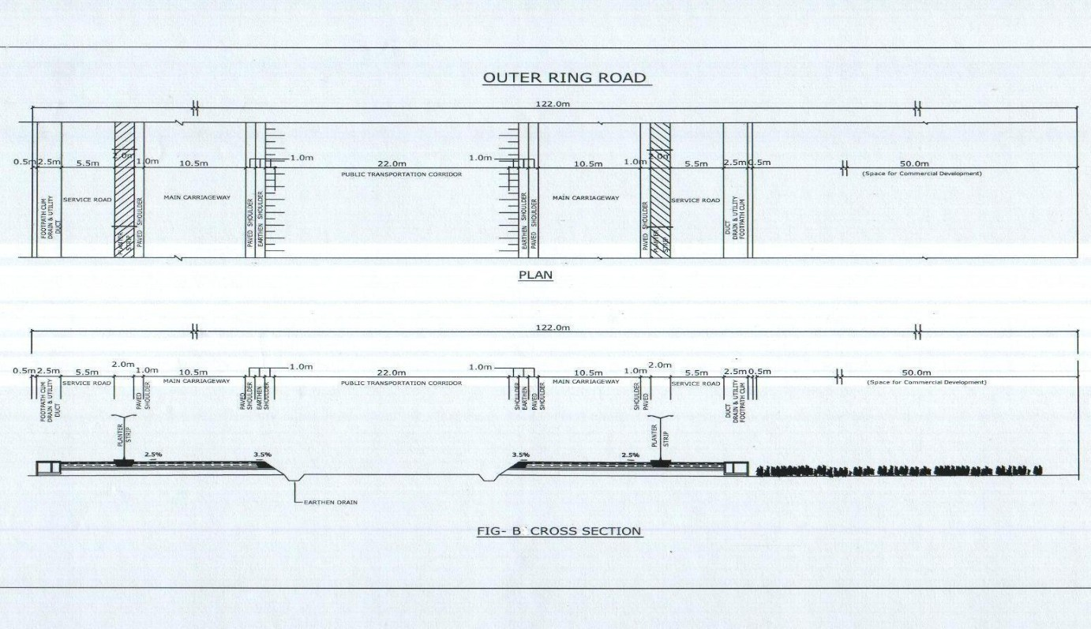

Figure B-2: Typical Cross Section for Phase II

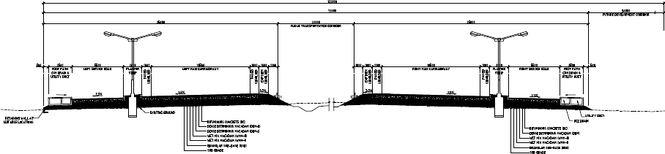

SERVICE ROADS

Service roads (5.5m wide), one each on the LHS and RHS of the divided six lane carriageway, for the entire length of the Project Highway are designed and constructed. Planter strips of 2.0m width separate the main carriageway and service roads.

  - PAVEMENT

General

    - Pavement are flexible for main carriageway, paved shoulders, service roads, pick up bus stops, Truck lay-byes, wayside amenities complex and for cross roads up to ROW limits.

Pavement composition

The pavement composition for the main carriageway was designed as per IRC: 37-2001.

Paved Shoulder composition

The paved shoulders are an integral part of the pavement for the main carriageway. The pavement thickness of the paved shoulders is the same as in the main carriageway.

Pavement Composition for Service Road
The pavement composition for service roads is designed as per IRC: 37- 2001.

Existing Features

    - Feature inventory for Phase 1
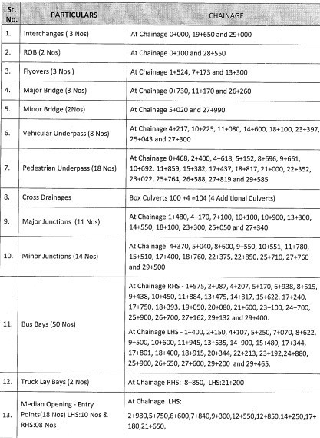

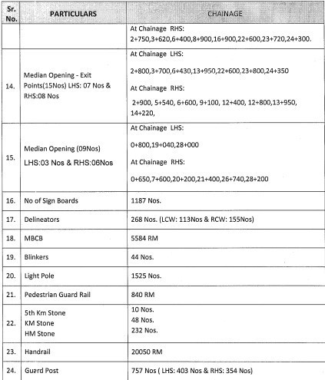

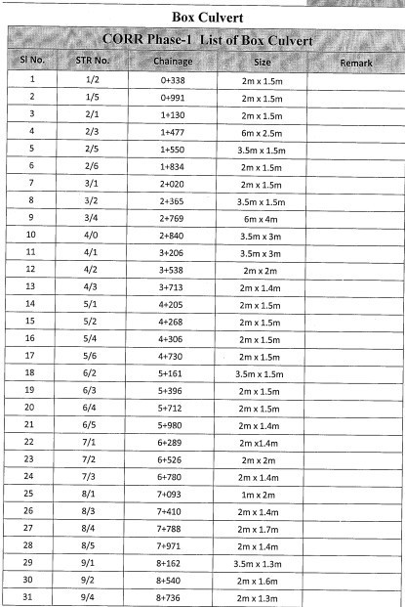

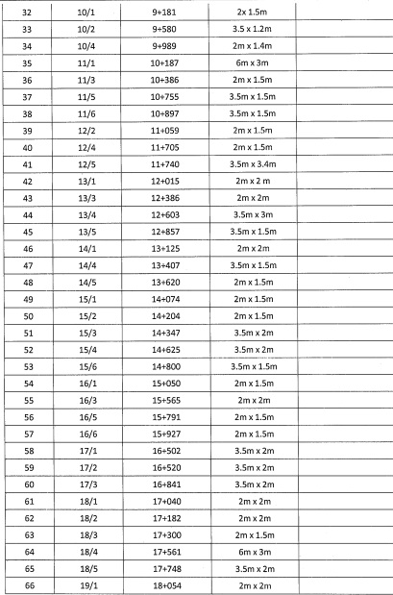

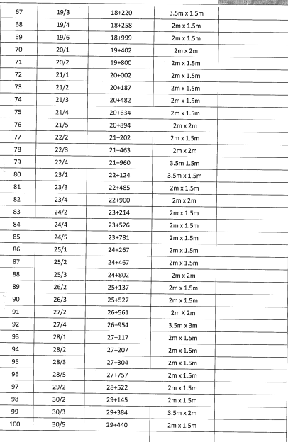

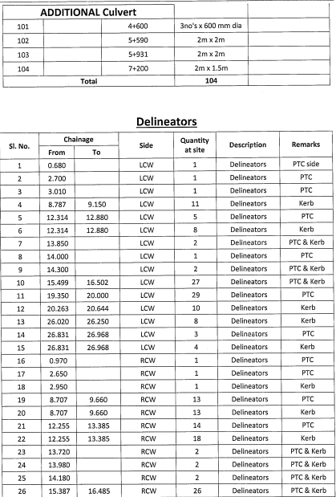

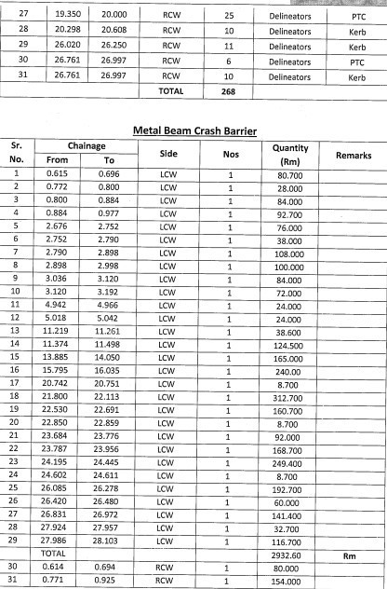

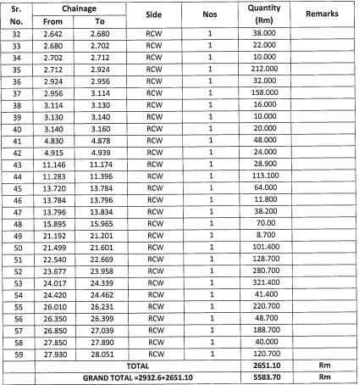

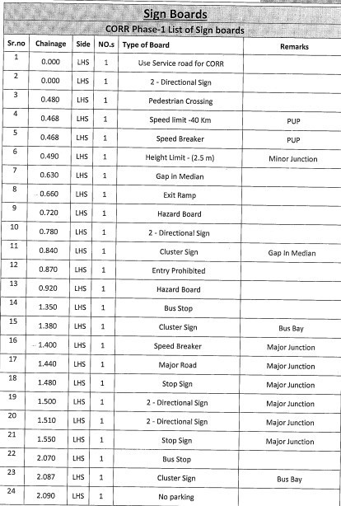

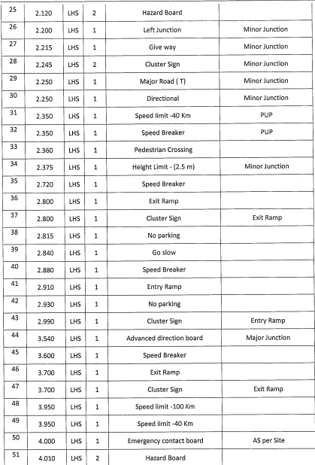

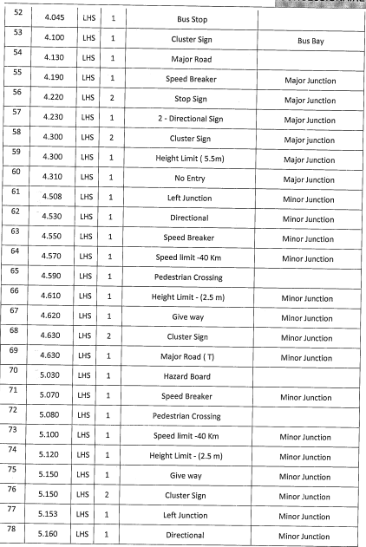

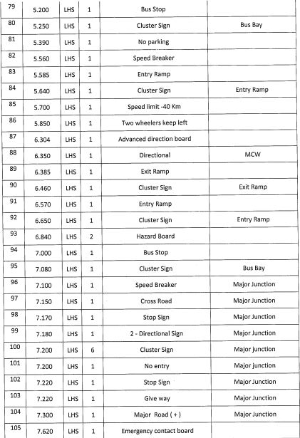

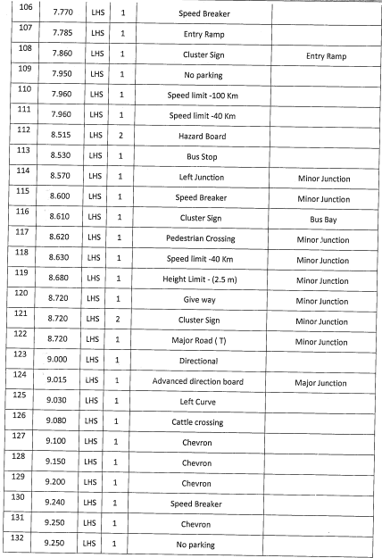

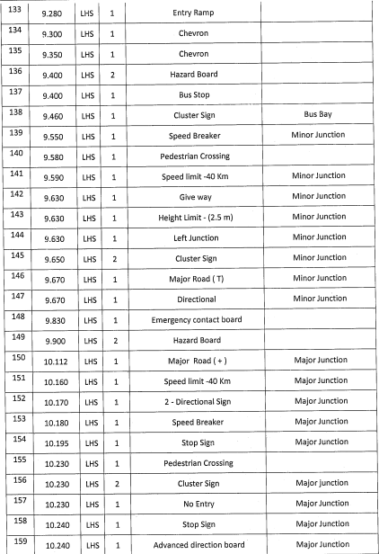

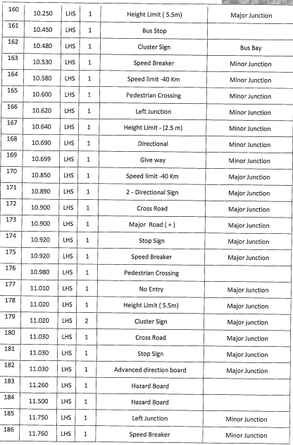

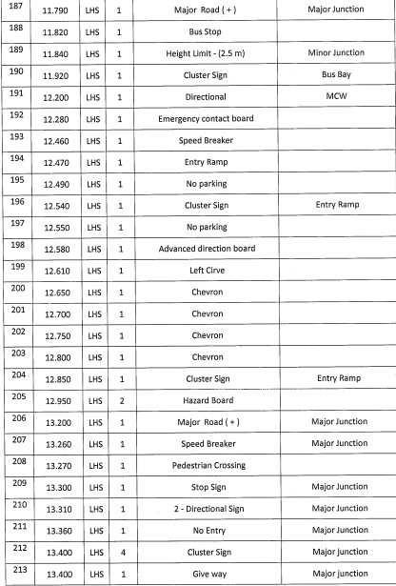

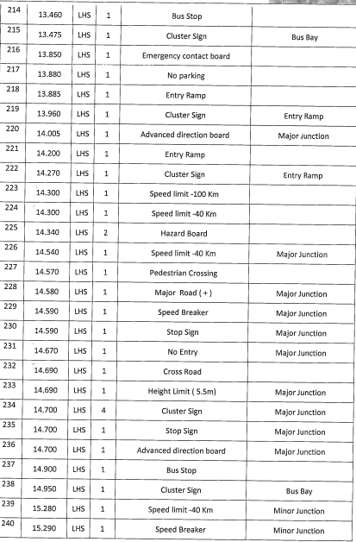

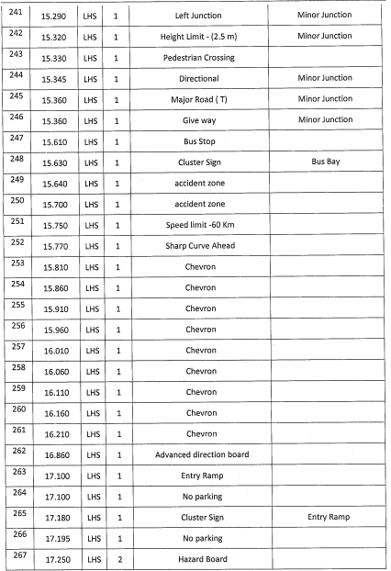

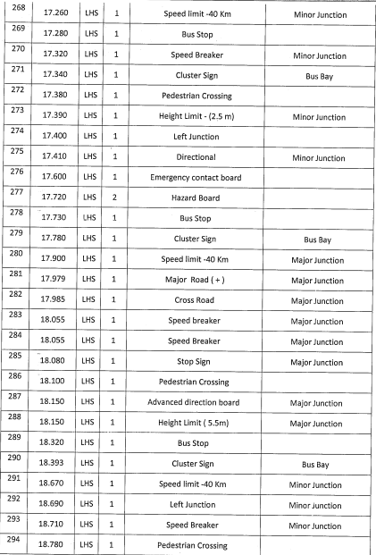

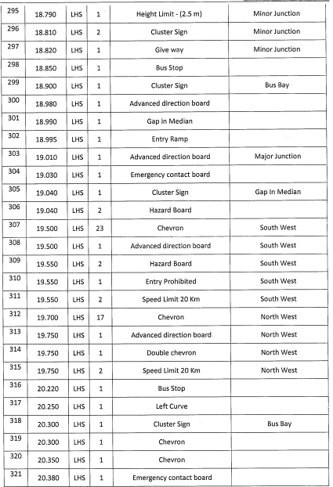

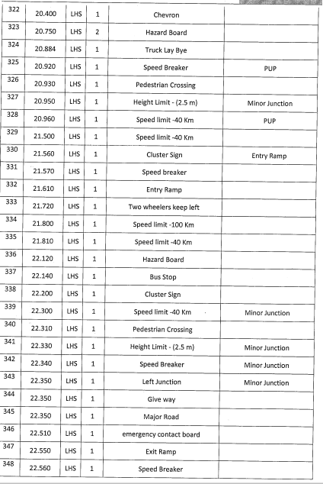

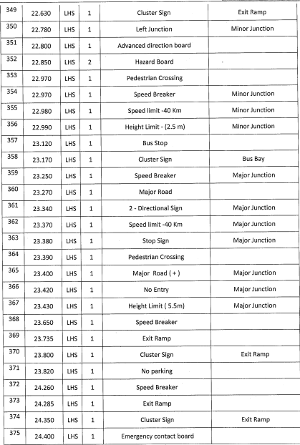

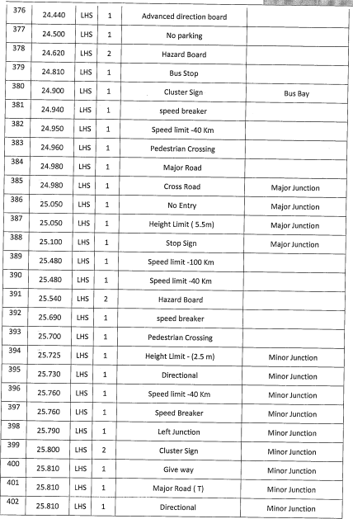

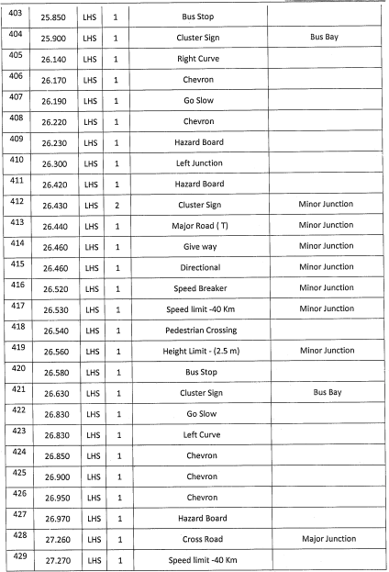

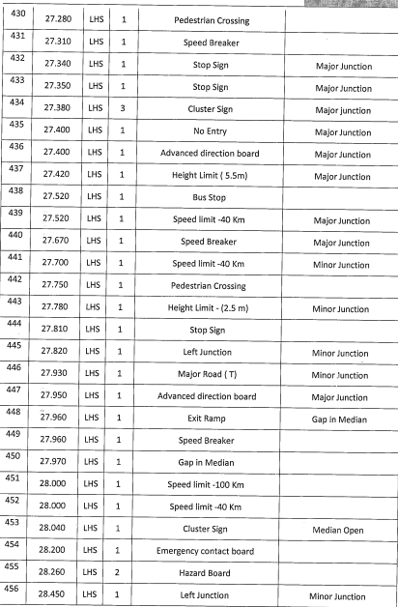

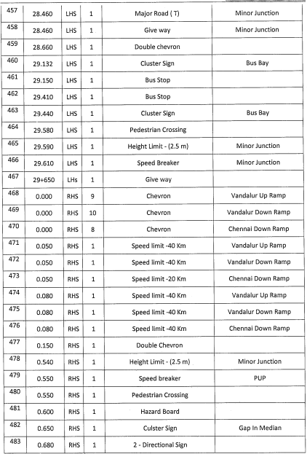

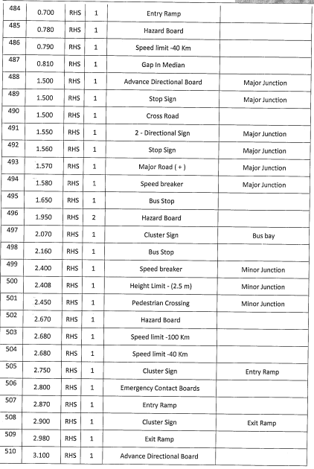

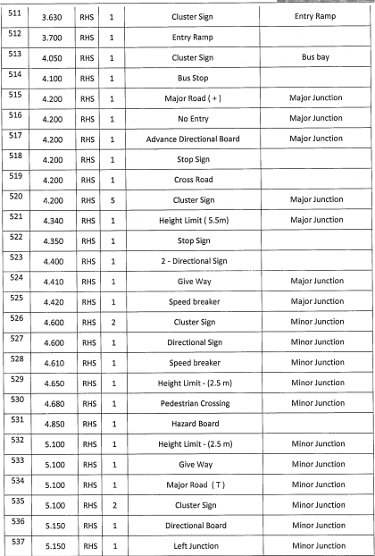

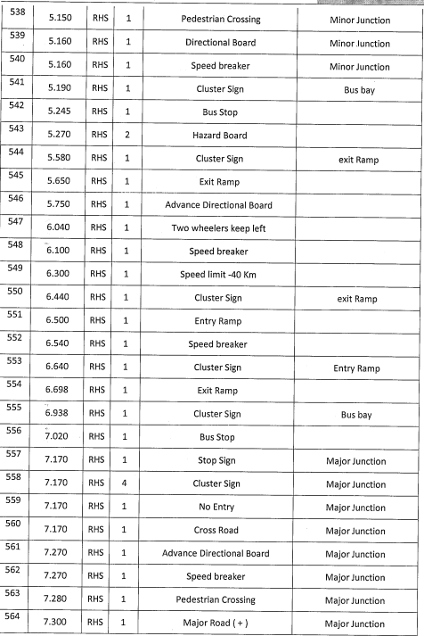

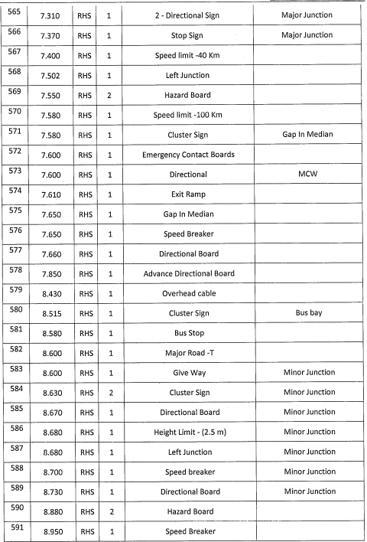

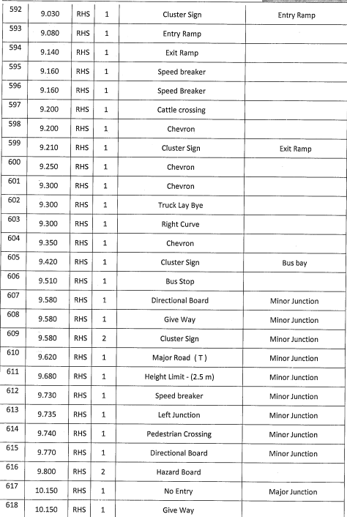

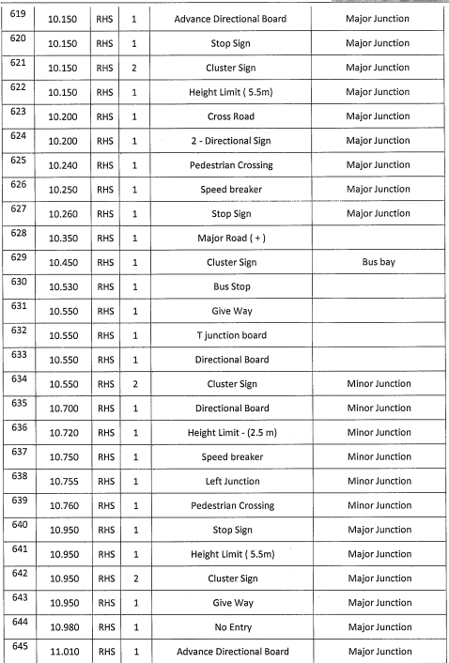

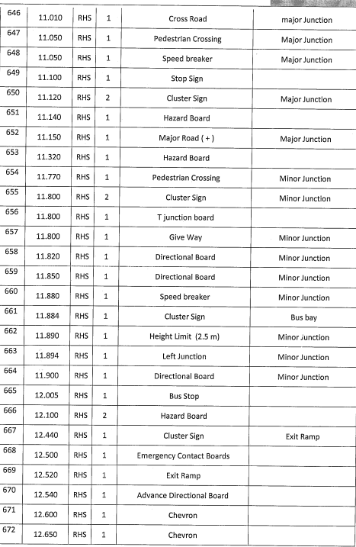

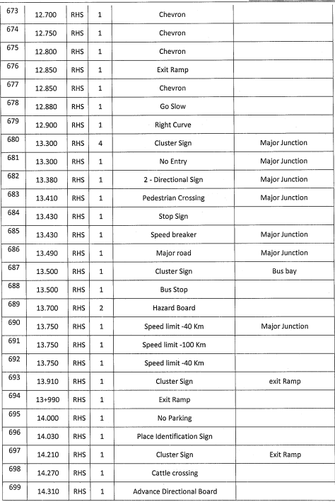

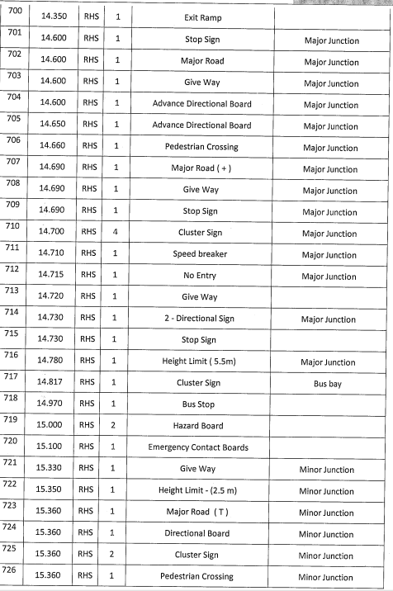

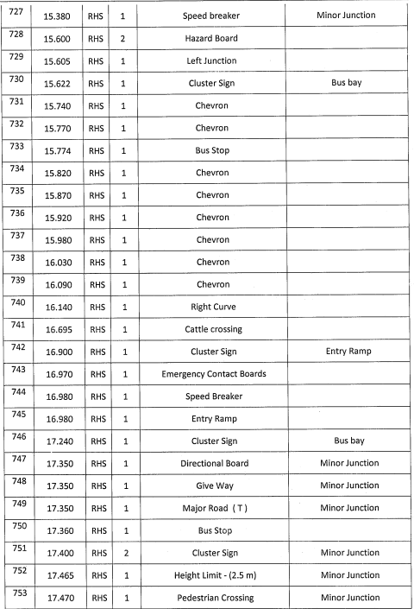

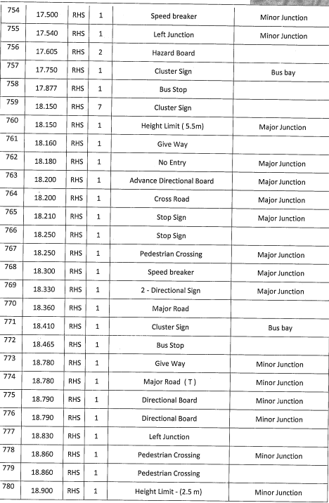

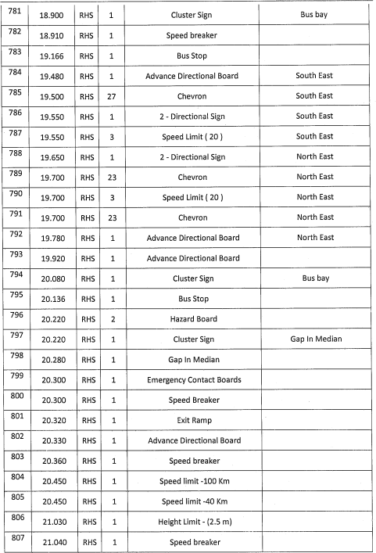

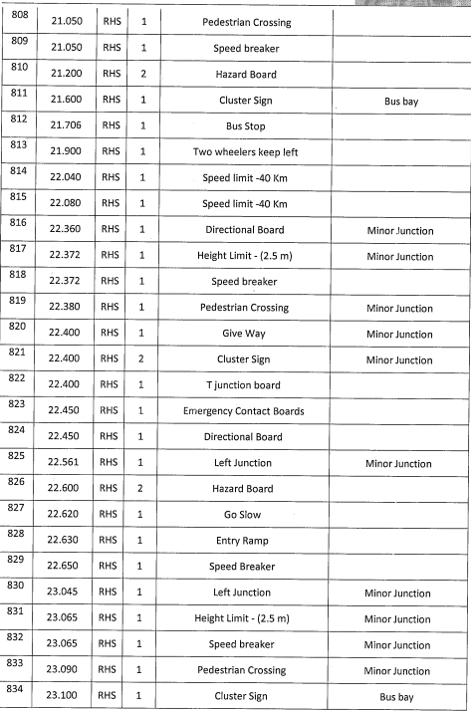

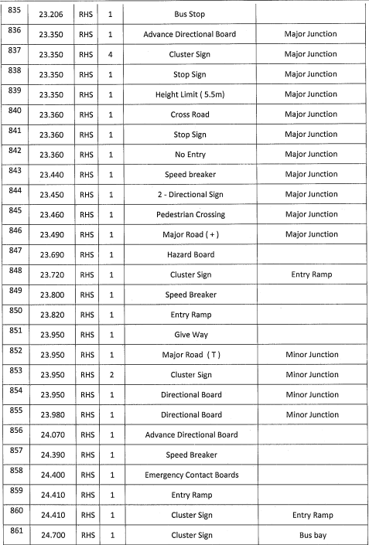

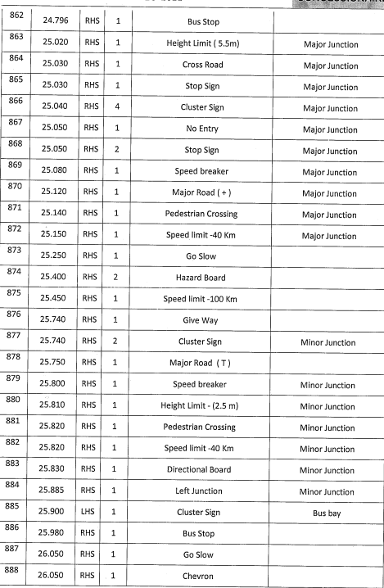

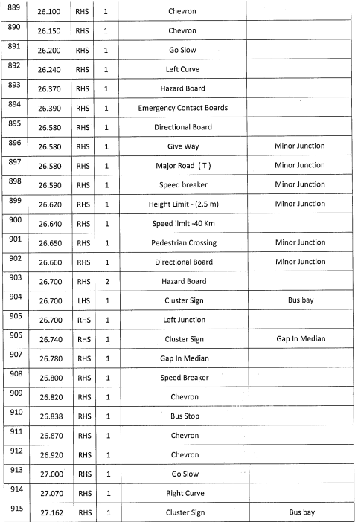

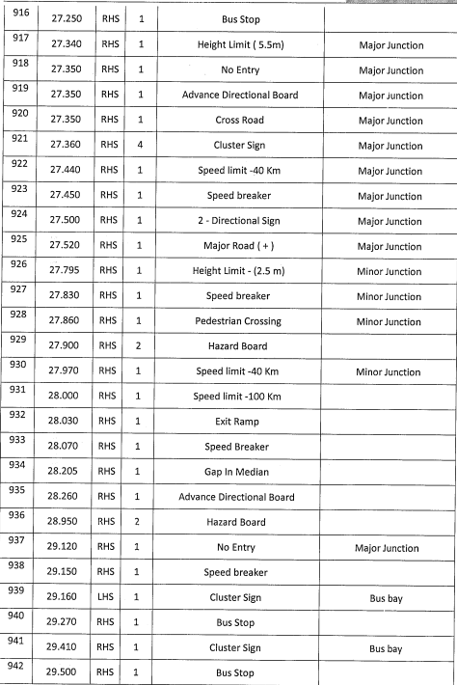

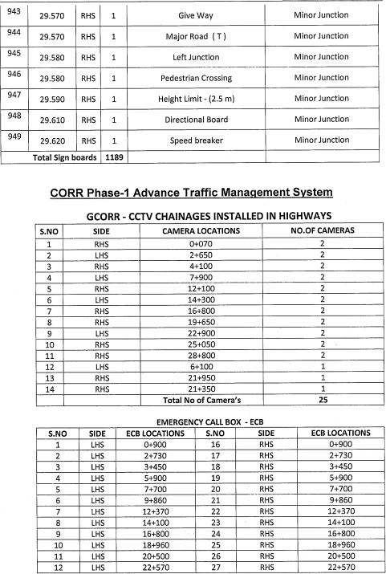

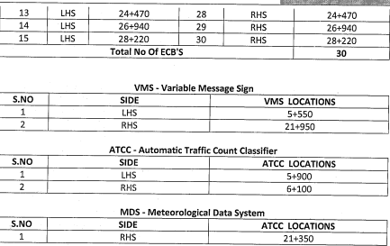

    - Feature inventory for Phase 2
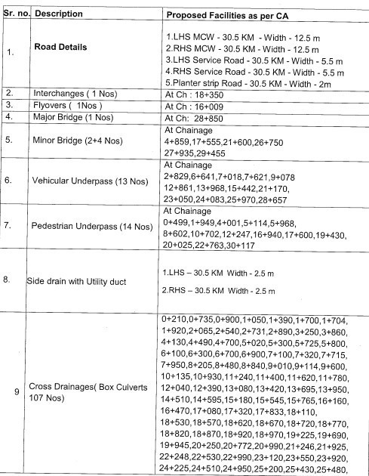

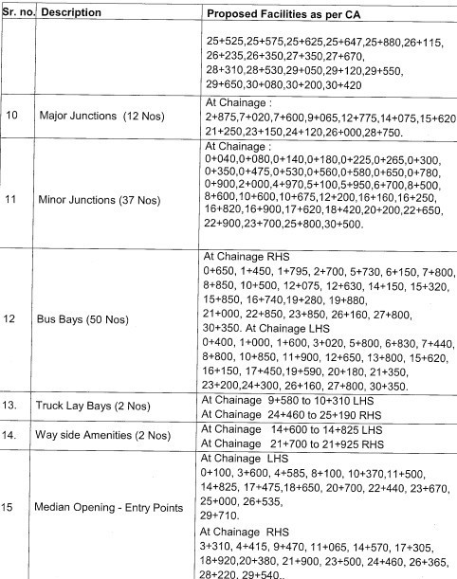

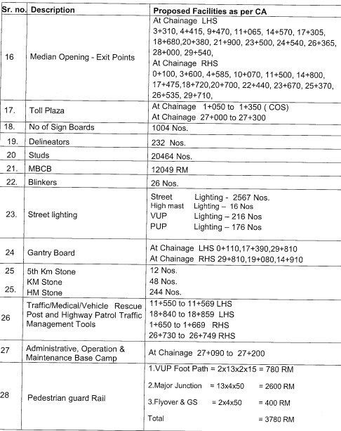

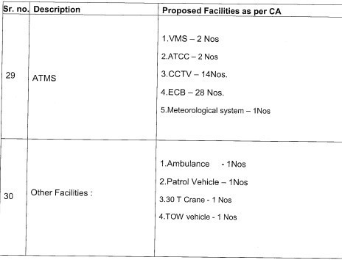

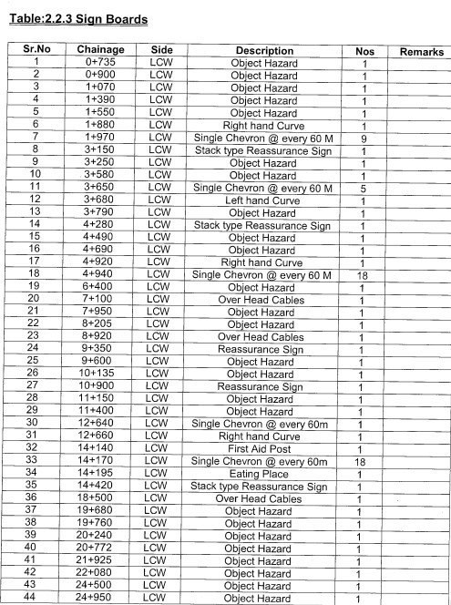

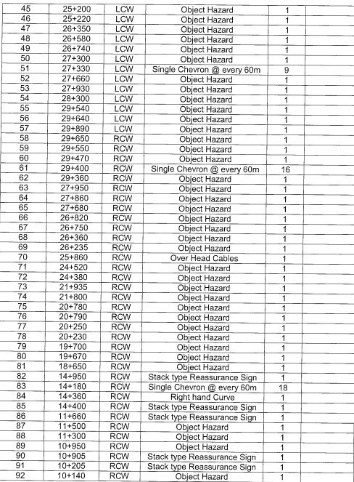

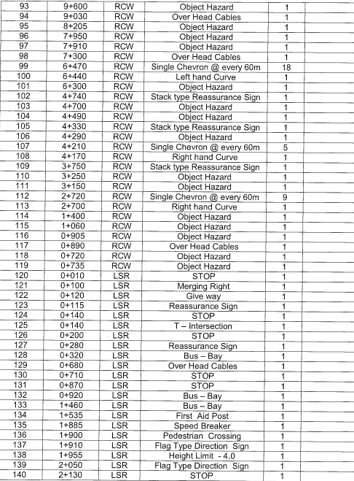

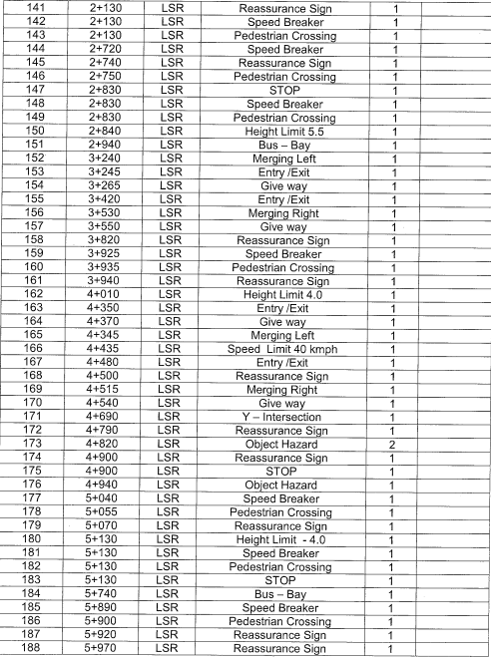

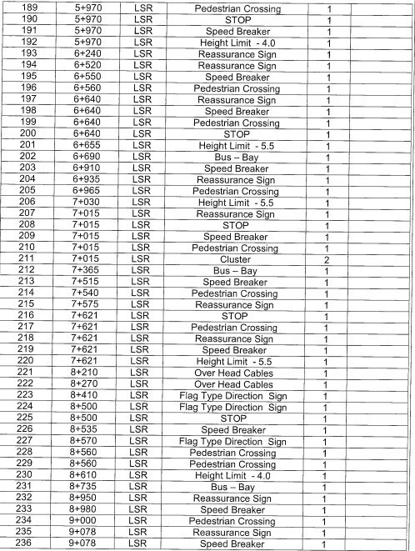

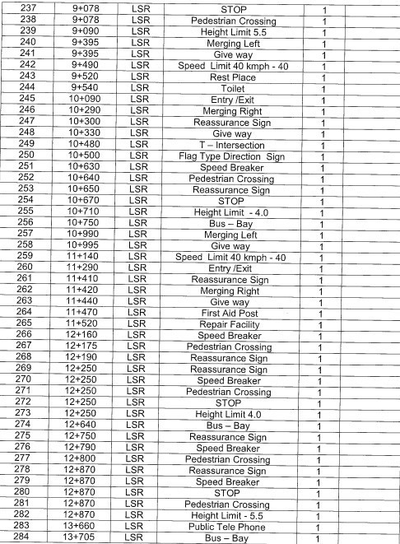

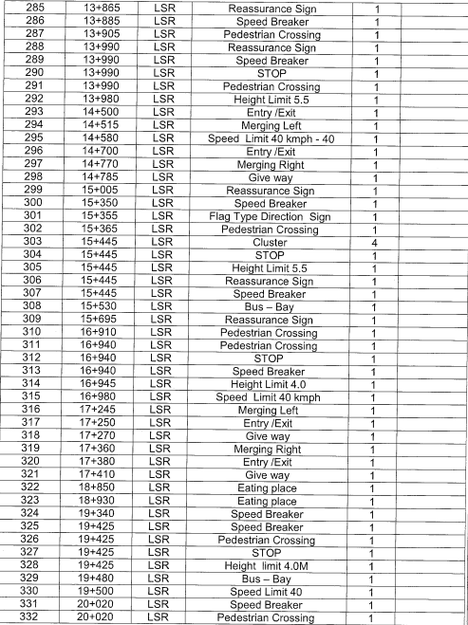

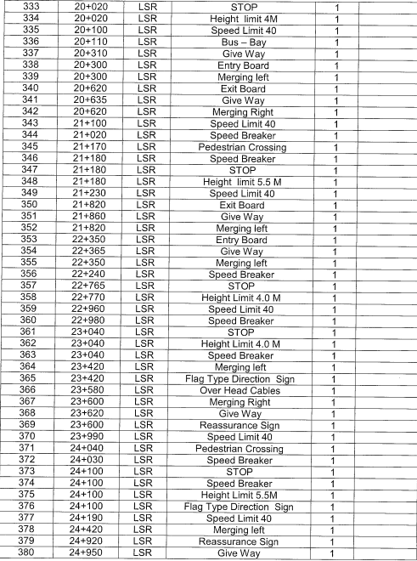

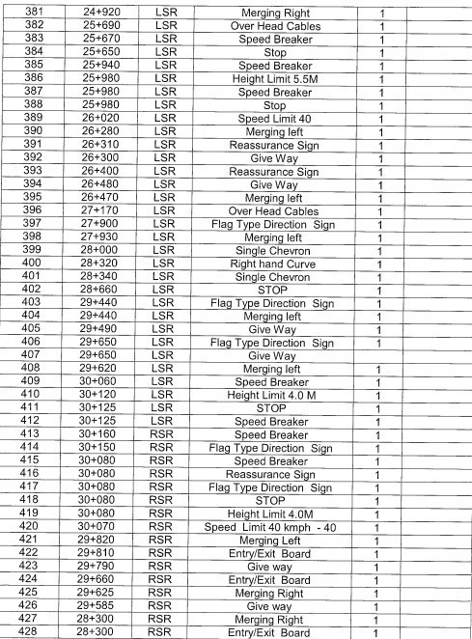

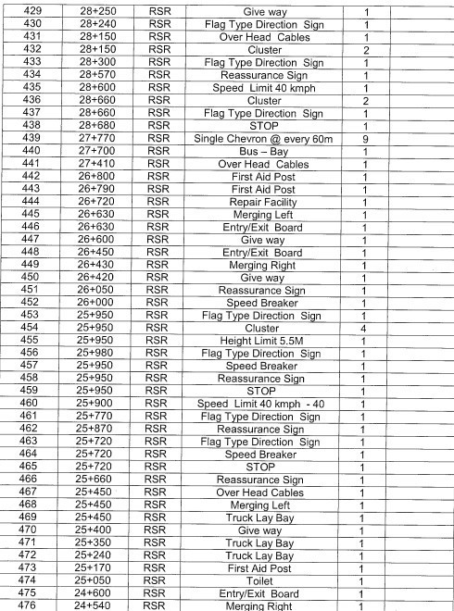

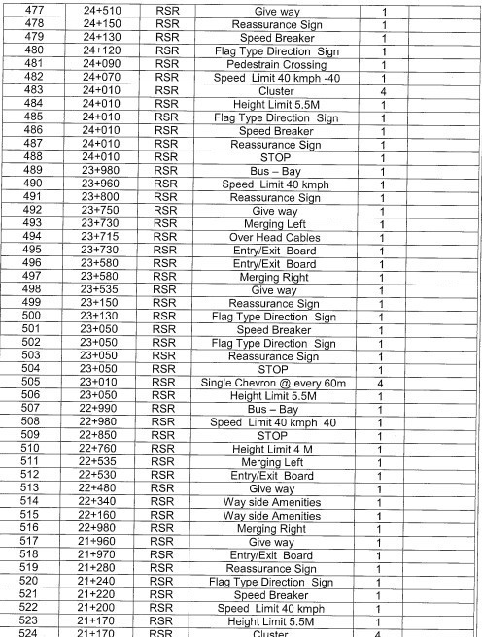

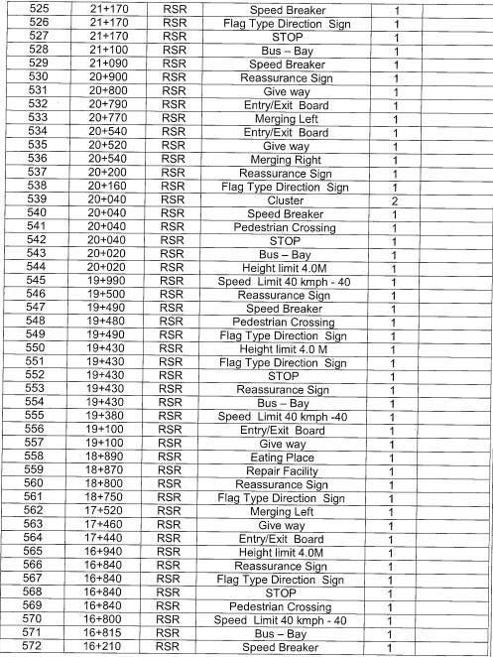

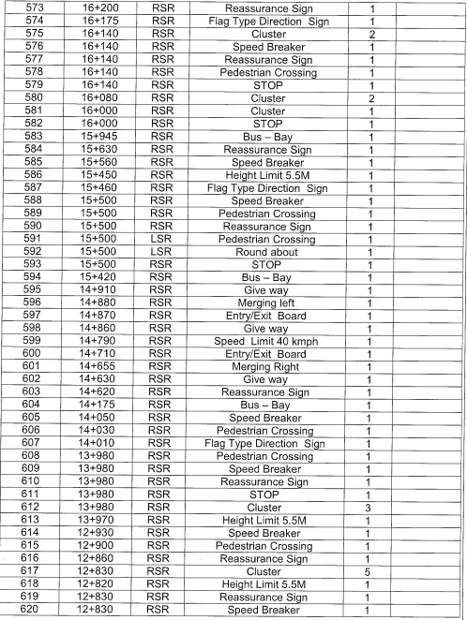

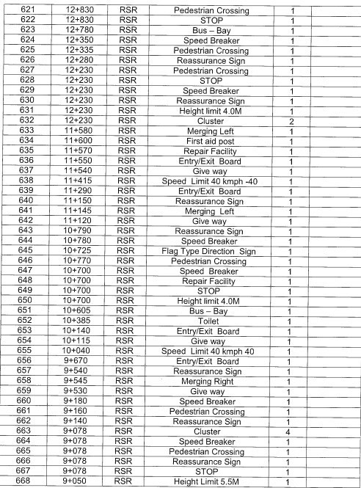

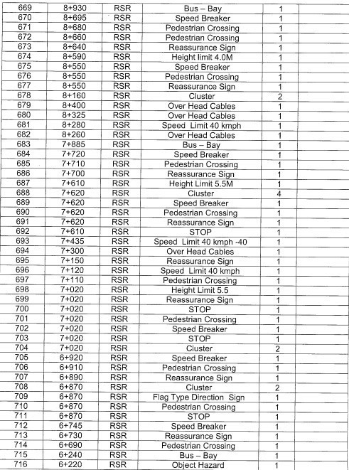

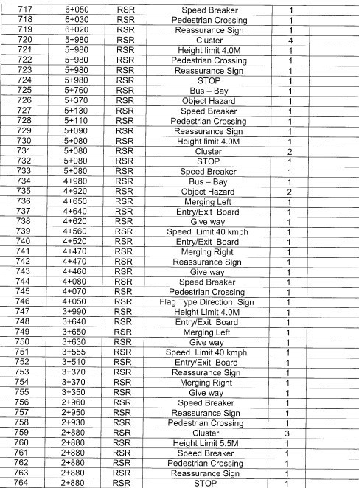

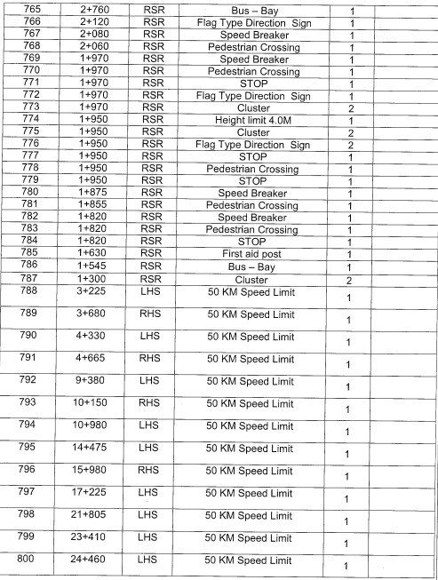

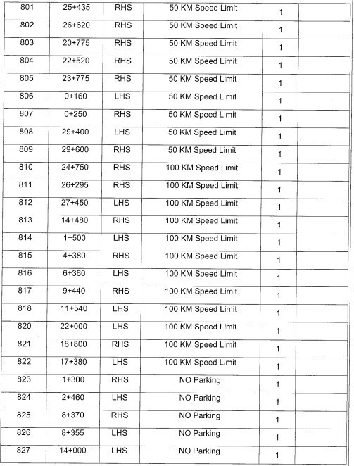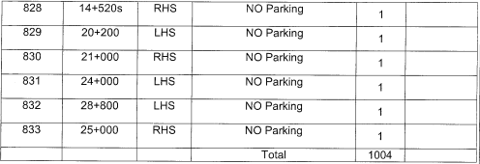

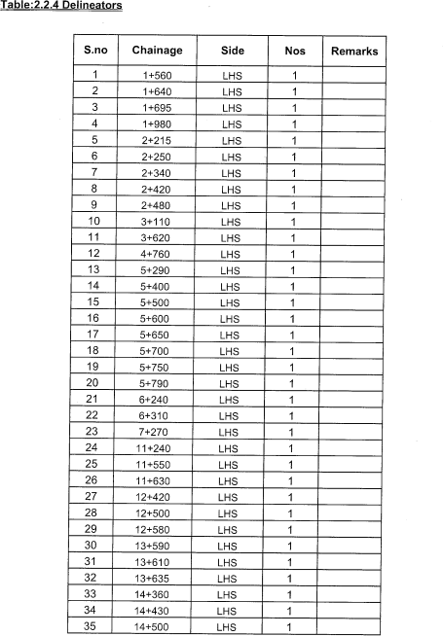
Delineators

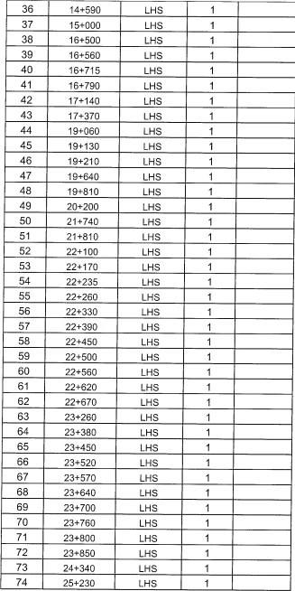

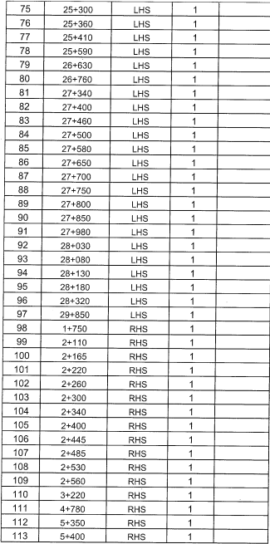

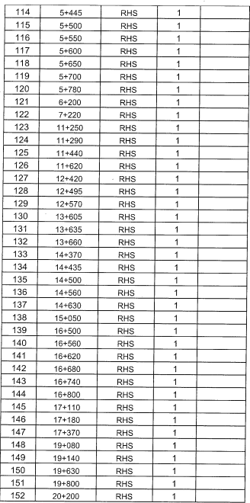

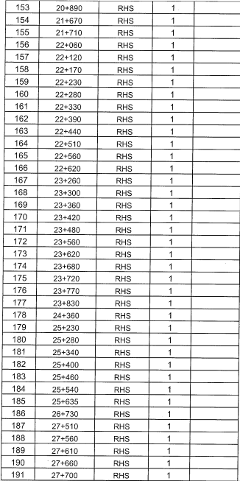

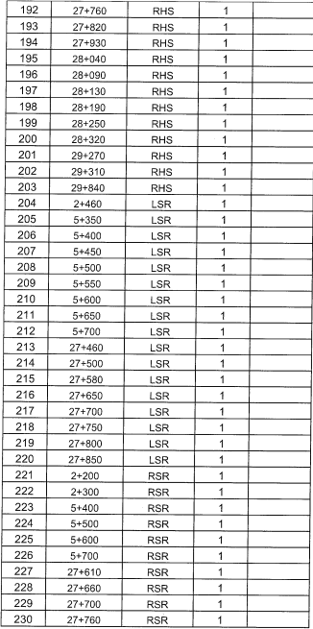

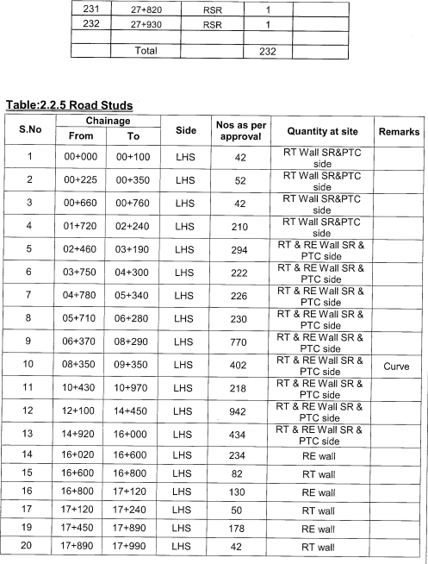

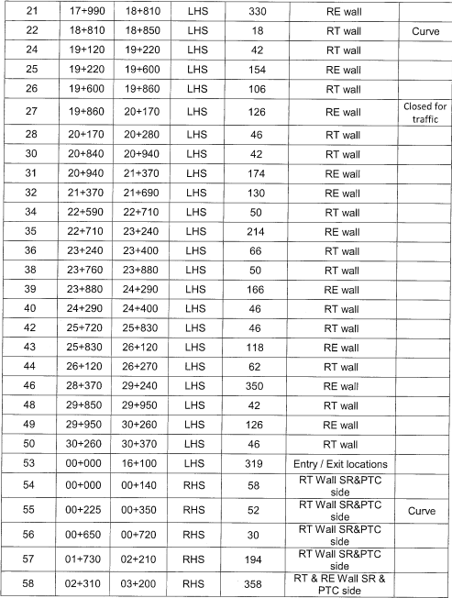

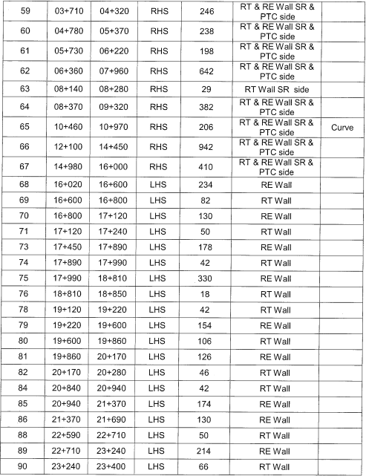

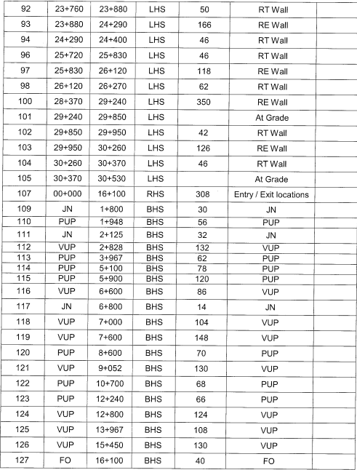

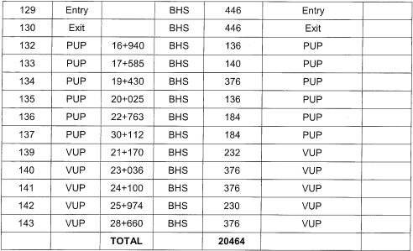

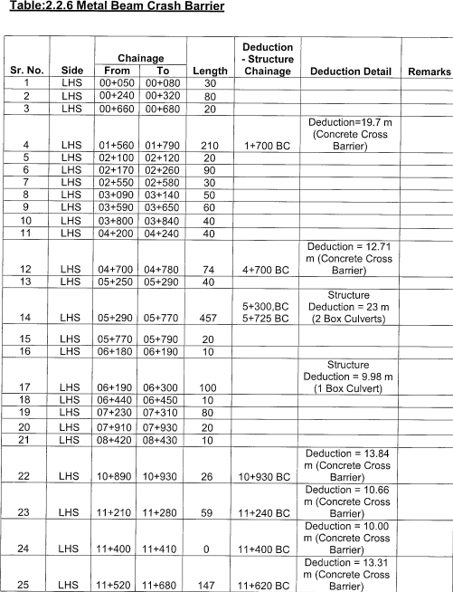

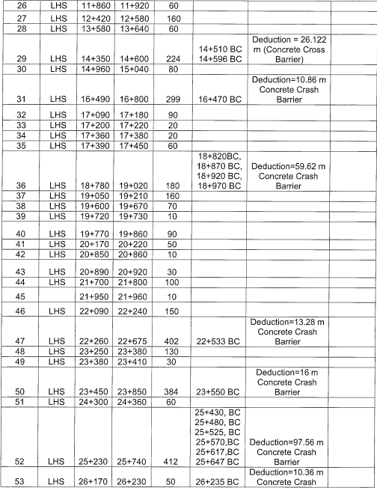

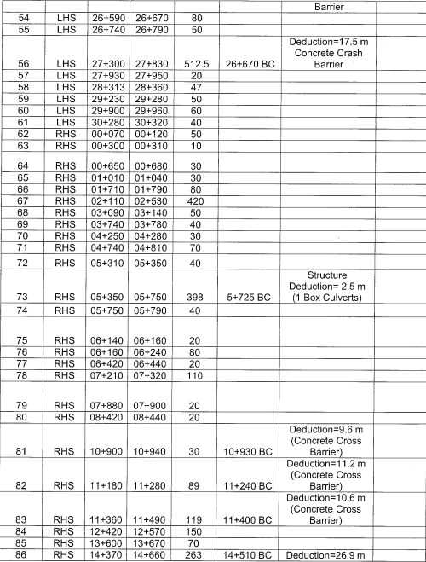

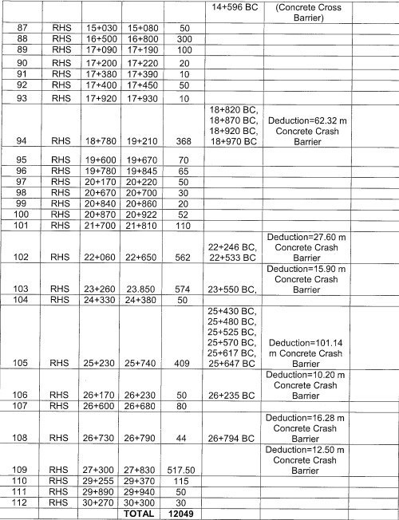

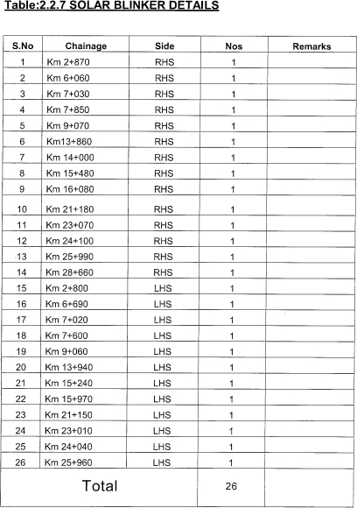
SO

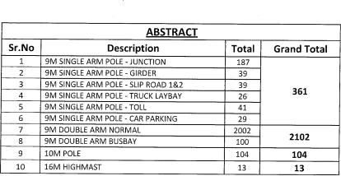
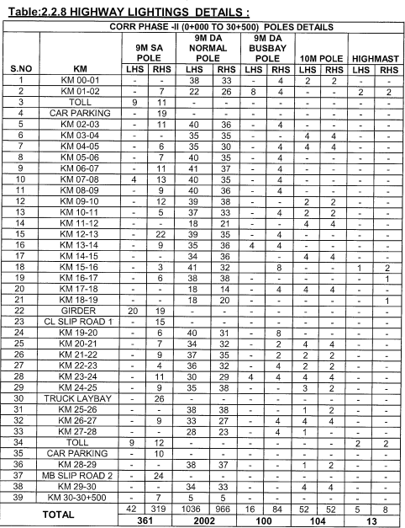
H

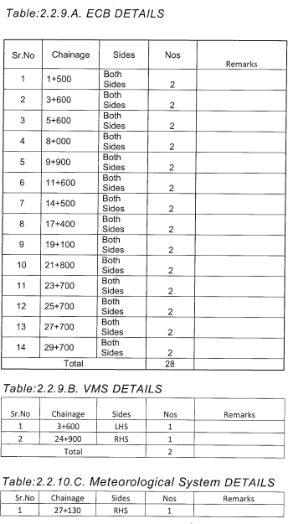
ECB D

SCHEDULE-B
(See Clause 2.1)

SCOPE OF THE PROJECT
The concessionaire is expected to visit the site as mentioned in Schedule A to assess the strength and durability conditions of all the assets including structures, pavement, boundary wall, lighting, ATMS, safety devices/furniture and other components of project highways for their proper functioning and to maintain Schedule F requirement after required rehabilitation, repair and restoration during concession period and the same shall be part of the contract. However, following additional works shall also be executed as per prescribed standard & specification applicable for NH/expressway as applicable.

The O&M operations shall be vested with the Concessionaire for the stretches 0/00 – 29/65 from 15.12.2030 and 29/65 – 60/15 from 28.10.2034. However, the Toll Plazas, O&M shall commence from the date of Appointed date/handing over date.

Service Road/Slip Road.

Nil

Construction of New Slip/Service Roads
Slip/Service Roads shall be constructed at the locations and forthe lengths indicated below:

S.N. | Existing Kilometer (Km) |  | Length (m) | Width (m) | Side | TCS Type
 | From | To
Nil

Widening/Improvement of existing service/slip road
Following service/slip road section shall be improved.
S.N. | Existing Kilometer (Km) |  | Length (m) | Width (m) | Side | TCS  Type
 | From | To
NIL

Widening of Existing Structures
Widening of Structures due to Improvement of Entry & Exit Arrangements are given below.

S.No | Exiting Kilometer (Km) | Details of Existing Culvert |  | Improvement Proposal
 |  | Type of Structure | Span/Dia. (m)
Nil

Construction of New Structures /Widening /Reconstruction
Following culverts shall be widened to match the proposed new road cross section.

New Construction/ Reconstruction of Structure
    - Pipe Culvert:

Sr. No | Exiting Kilometer (Km) | Existing Span (mm) | Proposed Span Arrangement (mm) | Proposed Width of Culvert (m) | Remark
NIL

Box Culvert:

Sr. No | Exiting Kilometer (Km) | Existing Span (mm) | Proposed Span Arrangement (mm) | Proposed Width of Culvert (m) | Remark
NIL
    - Minor Bridge:

Sr. No | Exiting Kilometer (Km) | Existing Span (mm) | Proposed Span Arrangement (mm) | Proposed Width (m) | Remark
Nil

Flyover:

Sr. No | Exiting Kilometer (Km) | Existing Span (mm) | Proposed Span Arrangement (mm) | Proposed Width (m) | Remark
Nil

- MAINTENANCE WORKS
The Concessionaire shall carryout following maintenance works.
- Repair and Rehabilitation of pavement
- Repair and Rehabilitation of Embankment /Earthen Shoulders/ /Paved Shoulders/ Stone Pitching etc.
- Repair and Rehabilitation of structures.

Repair and Rehabilitation of Pavement
The Concessionaire shall carry out Pavement condition survey (visual, deflection, roughness, Skid resistance, etc.) with NSV (Network Survey Vehicle) and assess the existing pavement condition and identify the pavement distresses/ type of defects (Structural distresses and Functional Distresses) and determine the root cause of pavement’s distress and track the rate of progression of the distress leading to pavement deterioration.

As per the pavement distresses, the remedial measures shall be carried out as per IRC 82-2015 for Flexible Pavement and IRC: SP: 83-2018 for Rigid Pavement.

Concessionaire shall also carryout FWD survey for the entire project highway as per IRC 115-2014 (Flexible) and IRC 117-2015 (Rigid) for structural evaluation and accordingly carry out the periodic maintenance as per the concession agreement and applicable standards.

Repair and Rehabilitation of Embankment/Earthen Shoulders/Paved Shoulders / Stone Pitching
i. Repair & Rehabilitation of Embankment:
The side slope along the Project Highway shall be improved as per site requirement and protected by using suitable slope protection measures, as per the provision of Section-4 of IRC SP-87-2019.
The damaged embankment slopes along the Project Highway and loops & Ramps etc. shall be re-instated as per the specifications & standards. The treatments for various embankment heights include the following but not limited to:

Repair & Rehabilitation of Embankment:
The damaged embankment slopes along the Project Highway and loops & Ramps etc. shall be re-instated as per the specifications & standards.

Repair and Rehabilitation of Earthen Shoulder:
The Concessionaire shall restore the existing earthen shoulder width to 2m.

Repair & Rehabilitation of Paved Shoulder:
The damaged paved shoulders shall be re-instated as per specifications and standards in consultation with Authority/Independent Engineer.

Repair & Rehabilitation of Damaged Stone Pitching:
The damaged stone pitching shall be re-instated as per MORT&H specifications and standards in Consultation with Authority/Independent Engineer.

Repair and Rehabilitation of Structures
All the Structures existing at site and mentioned in Schedule-A shall be repaired & rehabilitated as mentioned below:

Structures:
Concessionaire shall carryout the condition survey of all the structures and carryout repair and rehabilitation of existing structures which includes but not limited to general cleaning, removal of debris around the bridge structure, restoration of protection works
e. g. CC flooring flexible & rigid apron, guide bunds etc. , repair of damaged concrete due to spalling, honey combing , scaling, leaching and exposed reinforcement, relaying of wearing coat, hand rails on RCC crash barriers at structures and ramps etc., Cleaning/ Repairing/ Modification of existing drainage spouts, repair & replacement of

expansion joints, repair and replacement of damaged bearing with new bearings, painting of structure number plates etc.
As per NHAI Circular No. 18.61/2021 dated 5th January 2021, Concessionaire must check the riding quality at approaches /Expansion joints of structures and accordingly rectify the deficiency if any.
The concessionaire must carry out repair and rehabilitation of ROBs’, if any in consultation with Railway Authority’s.

Culverts
Concessionaire shall carryout the condition survey of all the culverts & utility ducts and carryout repair and rehabilitation which includes but not limited to general cleaning, removal of debris from barrel/box and around the culvert, restoration of protection works e. g. flexible & rigid apron, pitching in quadrant etc., repair of damaged concrete due to spalling, honey combing, scaling, leaching and exposed reinforcement, relaying of wearing coat, hand rails on RCC crash barriers, painting of structure number plates, etc.

Approach Slab
Approach slabs shall be rehabilitated, constructed/reconstructed at the structures where settlement observed including side drain, railing and rain cuts etc.

Note: Additional treatments to that mentioned insection1 & 2 above, if any, carried out by the Concessionaire shall not be considered under Change of Scope.

JUNCTION IMPROVEMENT
  - Improvement of Major Junctions
The Concessionaire shall improve the following junctions (below flyovers) as per details given below and specifications & Standards given in IRC: SP: 87- 2019.

S. No. | Existing Kilometer (Km) | Type | Improvement Strategies
Nil
Refer: Appendix B-III for Major Junction development drawing.

Improvement of Minor Junctions
The Concessionaire shall improve the following minor.

S.  No. | Existing Kilometer (Km) | Type | Improvement Strategies | Remarks
Nil

Entry/Exit arrangement
The entry /exit arrangements shall be constructed/modified as per the 2.1C and 3.13 of IRC: SP: 87 - 2019, at the below mentioned locations:

S. No. | Structure Location/ Existing Kilometer (Km) | LHS Exit | LHS  Entry | RHS Exit | RHS Entry
Nil

MEDIAN OPENINGS
The details of the median openings and their treatments are given in table belowThe Concessionaire shall not be allowed to construct any new median opening (without prior approval of Authority) except for improvement/construction of the median openings
For traffic management for maintenance works and vehicles involved in accidents, Median openings with detachable barriers shall be provided if missing:

S. No. | Existing Kilometer (Km) | Recommendations
Nil

DRAIN LOCATION
Reinforced Cement Concrete drains shall be provided as detailed below at the following locations:
S.N. | Existing Kilometer (Km) |  | Side | Length (m) | Improvement Proposal
 | From | To
Nil
Apart from above mentioned RCC Drains, Concessionaire shall maintain the existing earthen drain and construct if not available at site in full length of Project Highway near ROW in consultation with IE.

RAINWATER HARVESTING
As per Ministry of Environment and Forests Notification, New Delhi dated 14.01.1997 (as amended on 13.01.1998, 05.01.1999 & 6.11.2000), the construction of Rainwater, harvesting structure is mandatory in and around Water Crisis area, notified by the Central Ground Water Board.

PROJECT FACILITIES
Following Project Facilities shall be retained maintained in accordance with provisions mentioned in Schedule-C of this agreement.
- Toll plazas.
- Truck Lay Bye.
- Landscaping and tree plantation.
- Rest areas / Wayside Amenities.
- Others
  - Highway Lighting
  - Highway Patrol
  - Ambulances
  - Cranes
  - ATMS / TMS
  - Traffic Aid Post
  - Medical Aid Post

Toll Plaza
Toll plazas at all the locations along the Project Highway shall be retained and maintained.
The Existing Toll Booths, Toll Plaza premises including all facilities, parking etc. shall be re- instated and maintained. The Concessionaire shall restore and maintain the Administrative buildings. NHAI/Policy Guidelines/management of toll plaza/2021 Policy circular No.

17.5.82 dated 24th May 2021shall be followed.
Mini Nest and Toilet blocks at toll plaza on main carriageway shall be operated and maintained to desired level of cleanliness. If not maintained and for lack of proper upkeep, facilities etc. fine upto Rs. 10000/- will be imposed on every occurrence on Concessionaire.
Concessionaire shall also make arrangements for the water supply, electricity etc. for Mini Nest, Toilet blocks and Water ATM.

Truck Lay Bye
Truck Lay bye shall be provided at the following locations as per IRC: SP:87- 2019 within the ROW.

S.N. | Existing Kilometer (Km) |  | Side | Improvement Proposal
 | From | To
Nil
The existing toilets shall be suitably modified to give an aesthetically pleasing look and shall gel with the surroundings. The Sewage disposal system shall be through Bio-digestible system (including Septic Tank & Soak pit). The drinking water facility shall be RO Treated Water.

Bus Bay and Bus Shelter
Bus bay and Shelter bye shall be provided at the following locations as per IRC: SP:87- 2019 within the ROW.

S.N. | Existing Kilometer (Km) |  | Side | Improvement Proposal
 | From | To
Nil

The existing toilets shall be suitably modified to give an aesthetically pleasing look and shall gel with the surroundings. The Sewage disposal system shall be through Bio-digestible system (including Septic Tank & Soak pit). The drinking water facility shall be RO Treated Water.

Landscaping and Median Plantation
Landscaping and Median Plantation shall be done on, but not limited to the following as per IRC SP- 87-2019 and as per NHAI policy:
- Landscaping shall be provided at the following locations
  - Grade Separated Intersections
  - Entry and Exit ramp
  - At grade islands of intersection locations
  - Toll Plaza Area
- Median Plantation is to be provided throughout the project stretch where not available, the bed for plantation to be prepared by using good earth mixed with manure in appropriate proportion. The entire new plantation and existing plantation shall be maintained in healthy state throughout the Concession period and the causalities, if any.

Rest Areas / Wayside Amenities
As per the plan of Ministry, i.e.- “Development of Wayside Amenities along Highways”,

GoTN/TNRDC will come up with Wayside Amenities along the Project Highway in due course of time. The same will be operated and maintained by GoTN/TNRDC
However, Concessionaire shall provide necessary support during operations of the same.

Highway Lighting
The Concessionaire shall provide the lighting at the following locations as per the Manual for Four Laning IRC: SP: 87-2019.

- Truck Lay Byes
- Toll Plaza Approach & Canopy (including existing lighting in the approaches of Toll Plaza shall be re-instated).
- Grade Separated Structures: The Flyovers, ROB and service /slip roads shall have lighting with solar energy system, as per Manual.
Lighting shall be provided at top & underside of the Grade Separated structures. The locations are given below:

S.N. | Existing Kilometer (Km) |  | Length | Remarks
 | From | To
Nil

iv. Highmast
The highmast shall be provided at the following locations.

S. No. | Existing Kilometer (km) | Minimum Nos of  High masts | Location
Nil

Highway Patrol
Highway Patrol units (minimum two numbers) in accordance with IRC SP-87-2019 and comply with Operational requirements as mentioned in Schedule-F shall be provided. The Patrol Vehicles shall retain and maintained as per the specifications given in NHAI Policy No. 12.19, dated 20th March 2018. It shall be fitted with GPS based Vehicle Tracking System (VTS) to monitor movement on 24 hoursx7 days of a week basis.

Ambulances
Ambulance units (minimum two numbers) shall be continuously available along the Project Highway in accordance with IRC SP-87-2019 and comply with Operational requirements as mentioned in Schedule-F. The Ambulances shall be retained and maintained as per the specifications given in NHAI Policy No. 12.19, dated 20th March 2018.
It shall be fitted with GPS based Vehicle Tracking System (VTS) to monitor movement on 24hours x 7 days of a week basis.

Cranes
Mobile cranes having the capacity to lift a truck with a Gross Vehicle Weight of 30,000 (thirty thousand) kilograms shall be retained and maintained round the clock for rescue operations.
Cranes (minimum two numbers) shall be continuously available along the Project Highway in

accordance with the provision of IRC SP- 87-2019 and to comply with Operational requirements as mentioned in Schedule-F.

ATMS
The ATMS system shall be retained and maintained as contained in Functional and Technical Specifications released by the NHAI vide Ref. No. NHAI/CO/ATMS/02-2021, February 2021 and the warrants for the same shall be referred to the Circular released by NHAI vide Ref: No.11041/218/2007-Admn Dated 15th Sep 2016, also implement the circular issued time to time.

Traffic Aid Post
Traffic Aid Posts shall be retained and maintained at the Toll Plaza in accordance with Clause
17.3 of the DCA and the Manual of specifications & standards.

Medical Aid Post
Medical Aid Posts shall be retained and maintained at the Toll Plaza in accordance with Clause 18.2 of the DCA and the Manual of specifications & standards.

TRAFFIC CONTROL DEVICES/ ROAD SAFETY DEVICES/ ROADSIDE FURNITURE

Following traffic control devices/road safety devices/ roadside furniture’s shall be provided in accordance with provisions mentioned in schedule-C of this agreement. There are many traffic control/safety device/roadside furniture’s, which may not have the visibility at location as per the latest standards, so the Concessionaire shall replace and augment these devices and furniture’s as per the standards given in the agreement with the approval of IE/Authority as per the approved signage plan. These devices and furniture’s shall thereafter be maintained and replaced by Concessionaire due to any reasons (i.e., accident, theft, non-conformity standards etc.) throughout the concession period.

Traffic Signs, Road Marking, Road Studs, Road Delineators, Kilometer/Hectometer
/Boundary Stones

Traffic Signages:
  - Existing damaged and non-standards sign boards shall be replaced.
  - Road signages (cautionary, mandatory, and informatory) along the project highway shall be provided wherever required, as per IRC:67-2012 & IRC: SP:87-2019.

Road Marking
The Concessionaire shall provide new Road marking throughout the project highway including main carriageway, Service/slip roads, Ramps etc. as per IRC:35-2015 & IRC: SP:87-2019.

Road Studs
Road Studs including Solar Studs shall be provided throughout the project highways Per IRC: SP:87-2019.

Road Delineators
Road Delineators shall be provided throughout the project highway as per IRC: SP:87-2019 & IRC:79-2019.

Kilometer/ Hectometer/Boundary Stones

The damaged/missing kilometer and hectometer stones shall be retained and maintained. All the Kilometer & Hectometer stones shall be repainted. Boundary Stones shall be provided throughout the project highway as per IRC: SP:87-2019 if damage/missing.

In addition to the above new installation items, any deficient road furniture, kerb item shall be replaced / repaired as per provisions of applicable specifications and standards as mentioned in Schedule-C.

Solar Blinkers
Solar Blinkers shall be retained and maintained at all the median openings, entry/exit ramps and U-turn facility at Toll Plaza. Apart from above existing solar blinkers shall be re-instated.
In addition to the above new installation items, any deficient road furniture, kerb etc. shall be replaced / repaired as per provisions of applicable specifications and standards as mentioned in Schedule-C.

Transverse Bar Marking
The Transverse Thermoplastic Bar Marking shall be provided as per NHAI Circular (105/2012) issued vide letter no. 11041/218/2007-Admn, dated- 11th June 2012 and IRC:99- 2018, at the hazardous locations including but not limited to the locations, Median openings (U-Turn Facilities), Toll Plaza approaches, Approaches to At-Grade junctions, Exit ramps and downside of the approach of the flyovers for both carriageways of Main Highway etc.
Note: The locations of shall be finalized in consultation with Authority/IE.

W- Beam Crash Barriers
- The existing damaged and missing W-Beam crash barriers shall be re-stained throughout the project length including Service/Slip Roads
- The Concessionaire shall provide new W-beam crash barriers in median as per Fig.17 of IRC:119-2015 i.e., W-Beam on Raised median throughout the Project Highway.
- The W-Beam crash barrier shall be provided for embankment height more than and equal to 3m. on Main Carriageway & Service/Slip Roads.
- W-Beam crash barrier shall be provided between proposed Service Road & Main Carriageway as per the Typical Cross-sections in Appendix B-I.
Note: The Concessionaire shall maintain existing (including damaged/missing/theft etc.) and new crash barriers in functional condition throughout the concession period.

Kerb Stones:
- The existing damaged and missing Kerb stones shall be re-instated throughout the project length including slip/service road.
- Kerb stones shall be provided at median openings, separators at Truck Lay bye, Minor Junction Islands, at proposed service road /slip road as per Typical Cross-section given in Appendix B-I.
- The raising of Kerb stones/ new Kerb stones shall be provided throughout the project road after carrying out the strengthening of the main carriageway & service/slip roads.
- All Kerb stones shall be painted as per specifications and standards.
Note: The Concessionaire shall maintain existing (including damaged/missing/theft etc.) and new kerb stones in functional condition throughout the concession period.

RCC Crash Barriers:
- The damaged/ missing RCC crash barriers and the handrails over it shall be restrained.
- RCC crash barriers of Structures, Ramps etc. shall be painted as per specifications and standards.

COMPLETION SCHEDULE FOR IMPROVEMENT PROPOSALS
Completion schedule for Scope mentioned in Schedule-B shall be as below.

S. No. | Description of Work | Date of Completion
1 | Incident Management (8.7, 8.8, 8.9, 8.11 and 8.12) | O&M Handover Date
2 | Installation / Rectification of road furniture related items (Section 9) Landscaping and Tree Plantation (Section 8.4) | 3 months from O&M Handover Date
3 | Maintenance and Rehabilitation (Section 3) | 6 months from O&M Handover Date
4 | Toll Plaza and other facilities at Toll Plaza (Section 8.1) | From Appointed Date
5 | ATMS (Section 8.10) | 1 months from O&M Handover Date
6 | Other Improvements (Section 1, 2, 4, 5, 6, 7, 8.2,  8.3, 8.5 and 8.6) | 3 months from O&M Handover Date

SCHEDULE-C
(See Clause 41.1) SPECIFICATIONS AND STANDARDS

1. ENGINEERING AND SAFETY IMPROVEMENTS
The Concessionaire shall comply with the Specifications and Standards set forth in Annexure-I of this Schedule-C for construction of the Engineering and Safety Improvements.

Annexure – I (Schedule-C)
Specifications and Standards for Engineering and Safety Improvements

MANUAL OF SPECIFICATIONS AND STANDARDS TO APPLY
Subject to the provisions of Paragraph 2 of this Annexure-I, Engineering and Safety Improvements along the Project Highway shall conform to the IRC: SP:87-2019 Manual of Specifications & Standards for Six laning of Highways published by IRC.
Where the specification for a work is not given, Good Industry Practice shall be adopted to the satisfaction of the Independent Engineer.

DEVIATIONS FROM THE MANUAL
In the event of discrepancy in design, specifications and standards of the aforesaid manual and the existing design, specifications and standards, the later shall prevail.

SCHEDULE – D

DELETED

SCHEDULE –E
(See Clause 9.1)

PERFORMANCE SECURITY

Principal Secretary to Government,
Highways and Minor Ports Department, GoTN Secretariat, Fort St.George
Chennai 600 009

WHEREAS:

- ****(hereinafter called the “Bidder”) had submitted the proposal for Toll, operate and transfer of Six lane Chennai Outer Ring Road (CORR) for Phase-I i.e. Vandalur to Nemilichery (29.65 km) and Phase-II i.e. Nemilichery to Minjur in TPP Road (30.50 Km), for a total length of 60.15 Km on Toll, Operate and Transfer (TOT) Annuity Basis .

- Governor of Tamil Nadu, represented by its Principal Secretary, Highways and Minor Ports Department and having its office at Secretariat, Fort St. George, Chennai, Chennai-600009, Tamil Nadu, India (hereinafter referred to as “GOTN/Authority”) have appointed Tamil Nadu Road Development Company, (TNRDC), Chennai as its Managing Associate to assist GOTN and function on behalf of GOTN, in performing its roles and responsibilities during the bid process, Development Period, Concession Period etc. and TNRDC will, inter alia, finalize the bid process and accordingly select the successful bidder.

- Based on the above, the bid submitted by the ******* [Consortium] or ******** [Bidder] has been accepted by the Authority and a Letter of Award (LOA) was issued by the Authority vide its communication no. ******* dated ****** to the ******[Consortium] or ********[Bidder] requiring, inter alia, the execution of Concession Agreement within 30 (thirty) days of the date of LOA.

- Pursuant to the above, M/s.************************ Ltd having its Registered office at
*********************************** has been incorporated as a Special Purpose Vehicle (SPV) hereinafter called the “Concessionaire”.

- As provided in Request for Proposal (RFP) the Concessionaire has to furnish a Performance Security to the Authority for a sum of Rs. 10,47,06,468 (Rs Ten Crores forty seven lakhs six thousand four hundred and sixty eight only (the “Guarantee Amount”) as security for due and faithful performance of its obligations, under and in accordance with the RFP and/or LOA during the Concession Period (as defined in the Concession Agreement) and thereafter until expiry of 2 (two) months from the end of the Defects Liability Period.

(E) We, ***** through our Branch at ***** (the “Bank”) have agreed to furnish this Bank Guarantee by way of Performance Security.

NOW, THEREFORE, the Bank hereby, unconditionally and irrevocably, guarantees and affirms as follows:

- The Bank hereby unconditionally and irrevocably guarantees the due and faithful performance of the Concessionaire’s obligations during the Concession Period, under and in accordance with the Agreement, and agrees and undertakes to pay to the Authority, upon its mere first written demand, and without any demur, reservation, recourse, contest or protest, and without any reference to the Concessionaire, such sum or sums upto an aggregate sum of the Guarantee Amount as the Authority shall claim, without the Authority being required to prove or to show grounds or reasons for its demand and/or for the sum specified therein.

- A letter from the Authority, or under the hand of any of the employee of the Authority or any other person or entity duly authorised by the Authority in this regard, that the Concessionaire

has committed default in the due and faithful performance of all or any of its obligations under
and in accordance with the RFP and/or LOA and/or Draft Agreement shall be conclusive, final and binding on the Bank. The Bank further agrees that the Authority shall be the sole judge as to whether the Concessionaire is in default in due and faithful performance of its obligations during the Concession Period under the Agreement and its decision that the is in default shall be final, and binding on the Bank, notwithstanding any differences between the Authority and the Concessionaire, or any dispute between them pending before any court, tribunal, arbitrators or any other authority or body, or by the discharge of the Concessionaire for any reason whatsoever.

- We, the Bank unconditionally undertake to pay to the Authority any money so demanded under this Guarantee notwithstanding any dispute or disputes raised by the Concessionaire or any other party including in any suit or proceeding pending before any court or tribunal relating thereto or any instructions or purported instructions by the Concessionaire or any other party to the Bank not to pay or for any cause to withhold or defer payment to the Authority under this Guarantee. The Bank’s liability under this Guarantee is irrevocable, unconditional, absolute and unequivocal. The payment so made by the Bank under this Guarantee shall be a valid discharge of the bank’s liability for payment hereunder and the Concessionaire shall have no claim against the Bank for making such payment.

- In order to give effect to this Guarantee, Authority shall be entitled to act as if the Bank were the principal debtor and any change in the constitution of the Concessionaire and/or the Bank, whether by their absorption with any other body or corporation or otherwise, shall not in any way or manner affect the liability or obligation of the Bank under this Guarantee.

- It shall not be necessary, and the Bank hereby waives any necessity, for the Authority to proceed against the Concessionaire before presenting to the Bank its demand under this Guarantee.

- Authority shall have the liberty, without affecting in any manner the liability of the Bank under this Guarantee, to vary at any time, the terms and conditions of the Agreement or to extend the time or period for the compliance with, fulfilment and/ or performance of all or any of the obligations of the Concessionaire contained in the Agreement or to postpone for any time, and from time to time, any of the rights and powers exercisable by the Authority against the Concessionaire and either to enforce or forbear from enforcing any of the terms and conditions contained in the Agreement and/or the securities available to the Authority, and the Bank shall not be released from its liability and obligation under these presents by any exercise by the Authority of the liberty with reference to the matters aforesaid or by reason of time being given to the Concessionaire or any other forbearance, indulgence, act or omission on the part of the Authority or of any other matter or thing whatsoever which under any law relating to sureties and guarantors would but for this provision have the effect of releasing the Bank from its liability and obligation under this Guarantee and the Bank hereby waives all of its rights under any such law.

- This Guarantee is in addition to and not in substitution of any other guarantee or security now or which may hereafter be held by the Authority in respect of or relating to the Agreement or for the fulfilment, compliance and/or performance of all or any of the obligations of the Concessionaire under the Agreement.

- Notwithstanding anything contained hereinbefore, the liability of the Bank under this Guarantee is restricted to the Guarantee Amount and this Guarantee will remain in force for the period specified in paragraph 9 below and unless a demand or claim in writing is made by the Authority on the Bank under this Guarantee, not later than 6 (six) months from the date of expiry of this Guarantee, all rights of the Authority under this Guarantee shall be forfeited and the Bank shall be relieved from its liabilities hereunder.

- We, the Bank further agree that the Guarantee herein contained shall remain in full force and effect until (hereinafter called “the End Date”). Unless a demand or claim
under this Guarantee is made on the Bank by the Authority or under the hand of any of the employee of the Authority or any other person or entity duly authorised by the Authority in this regard, in writing on or before 6 (six) months from the said End Date, the Bank shall be

discharged from all liability under this Guarantee thereafter.

10 We hereby agree to renew and extend the validity of this guarantee for a period not exceeding one year from the End Date on a request made by the Authority or under the hand of any of the employee of the Authority or any other person or entity duly authorised by the Authority in this regard.

- Any notice by way of request, demand or otherwise hereunder may be sent by post addressed to the Bank at its above referred Branch, which shall be deemed to have been duly authorised to receive such notice and to effect payment thereof forthwith, and if sent by post it shall be deemed to have been given at the time when it ought to have been delivered in due course of post and in proving such notice, when given by post, it shall be sufficient to prove that the envelope containing the notice was posted and a certificate signed by an officer of the Authority that the envelope was so posted shall be conclusive.

- We, the bank lastly undertake not to revoke this Guarantee during its currency.

- Notwithstanding anything contained herein.

  - Our liability under the Bank Guarantee shall not exceed Rs 10,47,06,468 (Rs Ten Crores forty seven lakhs six thousand four hundred and sixty eight only)

  - The Bank Guarantee shall be valid upto [date], 20 .

  - Unless a demand in writing is made upon us on or before , or any other extended date, all our liability under this guarantee shall cease.

IN WITNESS WHEREOF THE BANK HAS SET ITS HANDS HERETO ON THE DAY, MONTH AND YEAR MENTIONED HEREUNDER.

Signed and Delivered
On behalf of ………………….(Bank name) (Signature) (Date)
by the hand of Mr ……………
(name of authorized signatory)

Designation
Address of the controlling office of the issuing branch with phone number and fax number to be provided.

Note: Authenticated copy of Letter of Authority authorizing the signatory of this guarantee to execute the same to be enclosed herewith).

SCHEDULE-F
(See Clause 15.2) Maintenance Requirements

Introduction
  - The Concessionaire shall be responsible for the improvement and Operation and Maintenance of the length of Project Highway stipulated by the Concession Agreement in accordance with scope defined in Schedule-B during the Concession Period. Thereafter, the length of Project Highway shall be transferred to the Authority. This schedule elaborates the Operation and Maintenance (O&M) requirements of the Concession and is to be read together with the Concession Agreement for this purpose. For clarification of doubt the period during which the Concessionaire shall comply with the O&M requirements covers the entire Concession Period. The Concessionaire shall operate and maintain the Project Highway such that from O&M Handover date, lane availability at the end of each year of the Concession will be minimum of 99% on cumulative basis. For this purpose, lane availability at the end of each year will be computed as follows:
{(Length of Project Road x Number of Lanes x Number of days since O&M Handover Date) -
∑ (lane length closed x number of days for which closed)}/ {(Length of Project Road x Number of Lanes x Number of days since O&M Handover Date)}
  - The Concessionaire shall, at all times maintain the Project Highway in accordance with the provisions of this Agreement, Applicable Laws, and Applicable Permits. In particular, the Concessionaire shall at all times during the operation period, conform to maintenance requirements set forth in this schedule-F (“Maintenance Requirements”)
  - The Concessionaire shall repair & rectify any defect or deficiency set forth in this Schedule-F within the time limit specified therein and any failure in this behalf shall constitute a breach of the agreement & non-fulfillment of the Maintenance obligations by the Concessionaire. Upon occurrence of any breach hereunder, the Authority shall be entitled to effect reduction in monthly lump sum payment as set forth in Clause 15.8 of this Agreement, without prejudice to the rights of the Authority under this agreement including Termination thereof.
  - All Materials works and construction operations shall confirm to the MORTH Specifications for Road and Bridges works, and the relevant IRC publications. Where the specifications for a work are not given, Good Industry Practice shall be adopted.
  - The Concessionaire shall, through its engineer, undertake daily visual inspection of the Project Highway and maintain a record thereof in a register to be kept in such form and manner as the Independent Engineer may specify. Such records shall be kept in safe custody of the Concessionaire and shall be open to inspection by the Authority and the Independent Engineer at any time during office hours.
  - The Concessionaire shall display a copy of this Schedule-F at the Toll Plaza[s] along with Complaint Register stipulated in Article-39.
  - All defects and deficiencies specified in this Schedule-F shall be repaired and rectified by the Concessionaire so that Project Highway confirms to the Maintenance Requirement on the Transfer date.

Repair/rectification of Defects and deficiencies
  - The obligations of the Concessionaire in respect of Maintenance Requirements shall include repair and rectification of the Defects and deficiencies specified in this Schedule-F within the time limit set forth therein.
  - The Concessionaire shall at all times maintain an adequate inventory of spares and consumables to meet the Maintenance Requirements.

Other Defects and Deficiencies
In respect of any Defect or deficiency not Specified in this Schedule-F, the Independent Engineer may,

in conformity with Good Industry Practice, specify the permissible limit of deviation or deterioration with reference to the Specifications and standards, and any deviation or deterioration beyond the permissible limit shall be repaired or rectified by the Concessionaire in accordance with Good Industry Practice and within the time limit specified by the Independent Engineer.

Extension of Time Limit
Notwithstanding anything to the contrary specified in this Schedule-F, if the nature and extent of any defect or deficiency justifies more time for its repair or rectification than the time specified herein, the Concessionaire shall be entitled to additional time in conformity with Good Industry Practice. Such additional time shall be determined by the Independent Engineer and conveyed to Concessionaire and Authority with reasons thereof.

Emergency repairs /restorations
Notwithstanding anything to the contrary contained in this Schedule-F, if any defect, deficiency or deterioration in the Project Highway poses a hazard to safety or risk of damage to property, the Concessionaire shall promptly take all reasonable measures for eliminating or minimizing such danger.

Operation and Maintenance (O&M) Requirements
  - The Concessionaire shall take all such actions and do all such things, including without limitation, organizing itself, adopting measures and standards, executing procedures such as inspection procedures, highway patrols, engaging and managing contractors, agents, and employees, as will secure:
    - The safety of users of the Project Highway, workers, or other persons on the Project Highway and/or facilities there on.
    - Unimpaired performance of statutory duties and functions of the TNRDC and other Authorities in relation to the Project Highway and/or other adjoining roads and facilities: and, subject to paragraphs a) and b) above, ensure that:
    - Adequate safety measures taking into account „Schedule-H‟ are taken up on the construction
zone during the O&M period.
    - Delay to users of the Project Highway and of adjoining roads or facilities is minimized.
    - Risk of adverse effects on the environment and on the amenity enjoyed by the owners and occupiers of property and/or land adjacent to the Project Highway, adjoining roads and facilities are minimized.
    - Accidents and emergencies on the Project Highway and facilities thereon are responded to as quickly as possible and their adverse effects minimized.
    - Risk of disturbance or damage or destruction to property of third party is minimized.
    - Members of the public are treated with due courtesy and consideration.
    - Users are given adequate information and forewarning of any event on or any other matter affecting the Project Highway which will enable them to minimize any adverse consequences on them of that event or matter.
    - Members of the public and others are given adequate opportunity to bring to the attention of the Concessionaire any matters affecting its ability to meet the maintenance Requirements.
    - Traffic data and data relating to the operation and maintenance of the Project Highway and its facilities and events on the Project Highway are collected and disseminated such that the TNRDC and other persons or bodies with statutory duties or functions in relation to the Project Highway or adjoining roads are able to perform those duties and functions efficiently.
    - The project facilities provided under Schedule-B and Change of Scopes as applicable, shall be operated and maintained in order to fulfill the requirements set forth in the Concession Agreement.
    - The Scope for Operation and Maintenance includes but not limited to following obligations:
      - Improvement – this includes improvement of the existing assets as per requirement of this Agreement and safety audit.
      - Maintenance of Civil Works and Assets- this includes maintenance of civil works and all

assets as per requirement of this agreement.
      - Road Maintenance – this includes routine maintenance, preventive maintenance, periodic maintenance as per IRC:82-2015, Design overlay as per Manual of 4-laning/6-laning, disaster maintenance, exigencies, and inspections.
      - Traffic Management – this includes enforcement of regulations together with the relevant authorities. This also includes hazard response, information gathering and dissemination, Road patrols and ATMS surveillance etc.
      - Safety– this includes accident prevention, after care, user education, enforcement, data collection and analysis.
      - Facility Management – this includes periodic inspections, routine maintenance, Rehabilitation, and expansion planning.
      - Road property management – this includes management of access, encroachment, and ribbon development.
      - General responsibilities – this includes budgeting, compliance with legal and accounting requirements, and public relations.
      - Maintaining public relations unit to interface with and attend to suggestions from users of the highway, the media, Govt. agencies and other external agencies.
The broad limit of responsibilities of the Concessionaire shall be as described below as per contractual obligations:
- In general, the limit of the Concessionaire's responsibility is to maintain all areas within the Right of way of the Project Highway inclusive of all features such as interchanges, toll plaza, street lighting facilities, traffic light facilities, ATMS and other facilities present within the Project Highway.
- Limit of Maintenance by the Concessionaire for another road joining or crossing the concession limit shall be according to the following condition:
  - Where the other road crosses an underpass the Concessionaire shall be responsible to maintain the crossing structure, viz., culverts, bridges and their abutments and related facilities such as drainage, turfing, etc. as per concession agreement.
  - The Concessionaire shall be responsible for maintenance of the road surface, or the roadside drains of the other roads that are within 100m beyond the Right of Way of Project Highway.
- The Concessionaire shall operate and maintain all the street lighting, traffic light system, structures, roadway surface and the related facilities such as drainage, turfing etc. within the interchanges, and such maintenance shall be extended until the end of the flare and the deceleration and acceleration lanes of the interchanges.
- The Concessionaire shall be responsible for maintaining all cross roads indicated in Schedule-A and B up to Right of Way of the Project Highway and their flares to junctions at any interchange within the Project Highway, whichever is more.
- For setting out the limit of maintenance for the Concessionaire, Tamil Nadu shall be responsible for negotiating with the local authorities or where required, with other relevant third parties. The Concessionaire shall maintain all the drainage system within the Right of Way including the culvert crossings and the drains. However, the Concessionaire shall not be liable to maintain rivers and the streams under the jurisdiction of Irrigation Department except when such Maintenance of Project Highway is required as a result of exceptional discharge.
- Report Formats- As per Article 15 of the Concession Agreement, the Concessionaire shall submit a Maintenance Program for the next year prepared in accordance with inventory of all assets created during COD of the project along with the deployment Schedule of manpower & other resources with testing facilities.
- The asset performance created by the Concessionaire as per the scope of the Concession

agreement shall be assessed by Independent Engineer as per consultancy agreement and shall be honored by the concessionaire pertaining to the outcome of equipment-based monitoring provisions as applicable.

Traffic Management and Lane Closure
  - Traffic Management during Operation and Maintenance of the Project Highway is an important activity the Concessionaire has to attend to ensure safety of the road users as well as the maintenance workers simultaneously throughout the Concession Period. It is usual activity to carry out various types of maintenance works at different stages and at different periods as per site requirement. Also, it is a vital activity during unforeseen and/or emergency situations arising on account of natural causes or accidents or administrative reasons.
  - Traffic Management is required during planned scheduled like Routine and Periodic maintenance activities.
However, traffic management will also be called for during unscheduled activities such as
- Emergency situation arising on account of
  - Force Majeure.
  - Accident/incident on the Project Highway
- Special repairs required on account of deficiency/failure of an element of the Project Highway; and
- Default of the Concessionaire with respect to any O&M activity on the Project Highway
  - The basic principles to be followed for traffic management and lane closure in this Project Highway shall be as follows:
    - Work programme schedule shall be prepared in a manner that diversion roads for the main traffic are minimized. Two-lanes of carriageway shall be available to the maximum extent possible.
    - Measures shall be taken such that the traffic is guided from a closed lane onto the operating lane without any conflict with the traffic from the opposite direction.
    - The activity of maintenance of pavement surface and/or strengthening/renewal of pavement structure shall not be taken up in a continuous length of more than 2 kilometers at a time to avoid long detour of the traffic.
    - The traffic diversion road where provided shall be appropriately designed for the traffic plying on the main carriageway. It shall also be properly maintained during its operation period.
    - During traffic detour involving traffic diversion, adequate safety measures as in ‘Schedule-H' shall be followed.
    - Proper and adequate information about the maintenance activity shall be notified to the road users well before approaching the work site. Traffic Management and Diversion arrangement at the work site shall be as per IRC: SP: 55- 2014 or subsequent updates thereof. In addition to this, Robot Flagman and other advanced traffic diversion devices shall be used for diversion arrangement.
  - Traffic Management Plan and programme for a planned scheduled construction and/or maintenance activity shall be prepared in advance of that activity keeping above in view and be approved by the Independent Engineer/TNRDC as the case may be.
  - In case of unscheduled activities, described above, an emergency traffic management for the affected reach of the highway shall be prepared and implemented in line with the guidelines set forth Specifications and Standards, complying with Article 18 and Schedule-H. This emergency traffic management plan shall take into account the various requirements spelt out in the Concession Agreement as well as in this schedule.
  - Traffic Management and Lane Closures Requirements during Emergency situations arising on the Project Highway needing Traffic Management are detailed below:

    - This stage could arise any time and shall have to be addressed based on its own merits. The extent of traffic management shall be assessed as per the site requirement and situation.
    - The nature of emergency requirement will determine the type and extent of the traffic diversion.
    - Traffic Management Plan in emergency shall be prepared and implemented as per Specifications and Standards set forth in Schedule-H.

Implementation of Asset Management Framework during O&M Period
  - Introduction
    - Asset Management is a systematic process of maintaining assets, upgrading and operating assets, combining engineering principles with sound business practice and economic rationale, and providing tools to facilitate a more organised and flexible approach to making the decisions necessary to achieve expectations. Objective of Asset Management shall be to fulfill the requirements mentioned in 6.1 with optimum allocation of resources for management, operation, preservation, and maintenance of highway infrastructure asset.
    - Basic common requirement for Asset Management are:
      - Establish a complete inventory of all road asset with all its elements.
      - Provide a clear picture of the current condition/performance of the road assets.
      - Create Real Time Database of the Asset Inventory and Condition with all-time data availability to all stakeholders.
      - Estimate future demand of traffic and service needs.
      - Estimate maintenance needs and costs.
      - Prioritise objectives related to the desired quality and performance of the road.
      - Define a strategy (Asset Management Plan) (This includes both Operation and Maintenance Plan).
      - Implementation of Asset Management Plan
    - As requirement of maintenance manual under Article 15 of the Concession Agreement, the Concessionaire shall in accordance with this schedule and Specifications and Standards also evolve an Asset Management Manual as required in Article 15 of the Concession Agreement. The same shall be submitted to Independent Engineer. Independent Engineer upon finding this as set Management Manual in accordance with schedules, Concession Agreement and the best industry practice of the day shall approve the same.
    - The Asset Management Manual prepared by the Concessionaire shall set out the Asset Management standards and details of the Operations & Maintenance activities to be undertaken during the Concession Period, so that the Project Facilities shall at all times conform to the Design Requirements/specifications.
    - The Asset Management Manual prepared by the Concessionaire shall set out the Asset Management standards and details of the Operations & Maintenance activities to be undertaken during the Concession Period, so that the Project Facilities shall at all times conform to the Design Requirements/specifications.
    - The manual shall include without limitation the following aspects:
- Organization structure with responsibilities of key personnel.
- Traffic Management Plan including the Corridor Control Plan.
- Safety Management Programme Including the Emergency Response Protocol.
- Inspection Procedures, Parameters, Frequency and schedule.
- Routine and Periodic Maintenance Intervention Levels.
- Asset Management Project Deliverables and Tolerance Criteria.
- Environment Management Plan.

- Maintenance Programme.
- Management Information System;
- Report Formats.
    - As per Article 15.4.1 of the Concession Agreement, the Concessionaire shall submit an annual Asset Management Plan/Maintenance Program for the next year prepared in accordance with Asset Management Manual.
    - The Asset Management System should be capable of monitoring real time compliance of the Asset Management Plan and provide necessary feedback to all stake holders.
    - In order to determine the Assets Performance Parameters for the Base Year, the Concessionaire shall carry out Revalidation and Testing on the road project to arrive at updated Base Year Parameters, 45 -days before Appointed Date {O&M Handover Date}. Initial Maintenance Requirement shall be assessed / revalidated based on Base Year Performance Parameters. It is hereby clarified that the concessionaire will arrive at Base Year Parameters within 45-days of the (a) Appointed Date for that part of O&M which is to be handed over to Concessionaire on Appointed Date, and (b) O&M Handover Date 2 for that part of O&M, which is to be handed over to Concessionaire on O&M Handover Date. TNRDC/ Independent Engineer may audit the Revalidation and Testing processes. The data to be collected for performance indicator along-with recommended revalidation / testing procedures are as mentioned in the following table.

Description of Data | Recommended Process
Asset Inventory (Highway, Structures, Road Furniture, Facilities) | Visual Survey Manual Validation of Past Data
Pavement Distress – (Cracking and other visual distress) | Network Survey Vehicle or ROMDAS or equivalent technology
Roughness Value (IRI), Rutting, Skid Resistance | Network Survey Vehicle (Laser Profilometer) or ROMDAS or equivalent technology
Deflection Value/Remaining Life | Falling Weight Deflectometer
Condition Survey of Structures | Updation of Past Data by Visual Condition Survey and Thorough Inspection using Mobile Bridge Inspection Unit.
Condition Survey of Road Furniture, Facilities | Updation of Past Data by Visual Condition Survey and thorough Inspection using Retro Reflectometer.
Traffic Data | 7-day ATCC based traffic Volume Count Survey backed by Video
Axle Load Data | 2-days Axle Load Survey with axle Pad
Encroachment Data | Survey to be carried out including Geotagged Images
Aerial Imaging of the Asset | Drone, LiDAR, or equivalent technology
Utility Mapping | Ground Penetration Radar, Visual Inspection

    - The Concessionaire in-accordance of provisions of the Concession Agreement shall plan/programme inspections of the Project Highway classified in the following categories for effective O&M/Asset Management System Implementation:
- Routine Inspection

- Close Inspection
- Detailed Inspection
    - Routine Inspection
Routine Visual Inspections are to be carried out by highway/bridge maintenance engineers having knowledge of highway/road structures. The purpose of visual inspection is to report the obstacles to traffic, defects and deficiencies of pavement/structure, missing or damages to safety barrier (crash barriers) and traffic signs installed or erected on highway. Such inspections should be done daily. The visual inspection may be carried out by visual assessment with careful observation of the specific object/item of the Project Facilities for identification and for quantification of the deficiencies or damages of the Project Facilities. Geo-tagging Cameras and Distance Measuring Devices shall be used to update base asset performance parameters on daily basis. If timely inspection and reporting of these safety related deficiencies are not done, they could lead to accidents or severe maintenance problems.
    - Close Inspection
Close inspections for assessment of defects/deficiencies of Project Highway shall be periodic in nature and would require detailed examination of all elements of the Project Highway. Close inspection may be visual or may involve investigations to be carried out using instruments. The frequency of close inspections would depend upon the nature of the elements of Project Highway. This inspection is to be carried out by the Highway/Bridge Engineer having good knowledge of Highway with theoretical background to analyse the nature, and extent of defects/deficiencies, suggest suitable remedial measures to rectify/remedy them and quantify repair work.
    - Detailed Inspection
A detailed inspection is comprehensive and detailed assessment of defects/deficiencies of the Project Highway with the aid of standard equipment and non-destructive testing. Such an inspection is to be carried out on the basis of comprehensive checklist of items related to the materials, condition of element of Project Highway. A checklist is to be prepared well in advance of inspection. The detailed inspection should be undertaken during the most critical weather condition. Detailed inspection carried out will offer the most critical evaluation of the performance of the Project Highway elements.
Besides being a qualified Highway/Bridge engineer, the inspection team leader must be familiar with design and construction features of the Highway /Bridges to be inspected so that the condition can be properly and accurately assessed for a meaningful report and quantification of repair works. The competence of team leader to recognize any structural distress/deficiencies and assess its seriousness with complete recommendation for appropriate repairs is important pre-requisites for entrusting this assignment to him.
    - The Concessionaire shall strictly maintain the assets of the Project Highway and adhere to the Asset Management Project deliverables and Tolerance Criteria as mentioned in the following tables.

Table 1: Maintenance Criteria for Pavements

Asset Type | Performance Parameter | Level of Service (LOS) |  | Frequency of Inspection | Tools/ Equiment | Standards and References for Inspection and Data Analysis | Time limit for Rectification  / Repair | Maintenance specifications
 |  | Desirable | Acceptable
Flexible Pavement – Routine Inspection (Pavement of MCW, Service Road, Approach of Grade structures, approaches  of connecting roads, slip roads, lay byes etc. as  applicable) | Potholes | Nil | <0.1% of area and subjected to  limit of 10mm in depth | Daily | Length Measurement Unit like Scale,  Tape, odometer etc. | IRC 82: 2015 and  Distress Identification Manual for Long Term Pavement Performance Program, FHWA 2003 | 24-48 hours | MORT&H  Specification 3004.2
 | Cracking | Nil | <5% subject to  limit of 0.5 sqm for any 50m length | Daily |  |  | 7-15 days | MORT&H  Specification 3004.3
 | Rutting | Nil | <5mm | Daily | Straight Edge |  | 15 -30 days | MORT&H  Specification 3004.2
 | Corrugations  and Shoving | Nil | 0.1% of area | Daily | Length Measurement Unit like Scale,  Tape, odometer etc. |  | 2-7 days | IRC:82-2015
 | Bleeding | Nil | <1% of area | Daily |  |  | 3-7 days | MORT&H  Specification 3004.4
 | Ravelling/ Stripping | Nil | <1% of area | Daily | Length Measurement Unit like Scale,  Tape, odometer etc. |  | 7-15 days | IRC:82-2015  read with IRC SP-81
 | Edge Deformation / Breaking | Nil | <1m for any 100m section and/or width  <0.1m at any Location restricted to  30cm from the edge. | Daily |  |  | 7-15 days | IRC:82-2015
Flexible  Pavement – | Roughness  BI | 2000 mm/km | 2400 mm/km | Bi-  Annually | Network  Survey vehicle | ASTM E950 (98)  :2004 –Standard | 180 days | IRC:82-2015

Asset Type | Performance Parameter | Level of Service (LOS) |  | Frequency of Inspection | Tools/ Equiment | Standards and References for Inspection and Data Analysis | Time limit for Rectification  / Repair | Maintenance specifications
 |  | Desirable | Acceptable
Programmed Inspection | Rutting | <10mm for any 50 m section and/or, length of section <5m | <10mm for any 50 m section and/or, length of section  <10m | Bi- Annually | (NSV) with all its module such as Laser Profilometers, Transverse profile logger, Laser crack measurement system, Video logging modules, high resolution Odometer etc. | Test Method for measuring Longitudinal Profile  of Travelled Surfaces  with Accelerometer Established Inertial Profiling Reference and ASTM E1656 -  94:2000- Standard Guide for Classification of Automatic Pavement Condition Survey Equipment | 15-30 days | IRC:82-2015
 | Pavement rating based on distress per IRC 82 /  Pavement Condition Index as per ASTM 6433-  07 | >3/85 | >2.1/70 | Bi- Annually |  |  | 180 days | IRC:82-2015/ ASTM D 6433-07
 | Other Pavement  Distresses | - | - | Bi- Annually |  |  | 2-7 days | IRC:82-2015
 | Skid | 60SN | 50SN | Bi- Annually | SCRIM  (Sideway force Coefficient Routine Investigation Machine or equivalent) British Pendulum  Tester | IRC:82-2015 | 180 days | BS:7941- 1:2006, IRC:82-2015/ ASTM 274
 | Deflection/ Remaining  Life |  | - | Annually | Falling Weight Deflectometer | IRC 115: 2014 | 180 days | IRC:115-2014
Rigid  Pavement | Roughness  BI | <2200mm/km | <2400mm/km | Bi-  Annually | Class I  Profilometer | ASTM E950 (98)  :2004 and ASTM | 180 days | IRC: SP:83-  2018

Asset Type | Performance Parameter | Level of Service (LOS) |  |  |  |  | Frequency of Inspection | Tools/ Equiment | Standards and References for Inspection and Data Analysis | Time limit for Rectification  / Repair | Maintenance specifications
 |  | Desirable |  |  | Acceptable
(Pavement of |  |  |  |  |  |  |  | Mounted on | E1656 -94: 2000
MCW, Service |  |  |  |  |  |  |  | NSV
Road, Grade  separated |  | Skid Resistance No. at different |  |  |  |  |  | SCRIM  (Sideway force Coefficient Routine Investigation Machine or equivalent) British  Pendulum Tester
structure, |  | speed of vehicles
 |  |  | Minimum SN | Traffic Speed
approaches
of connecting  roads, slip | Skid |  | 36 | 50 |  |  | Bi- Annually |  | IRC: SP:83-2018 | 180 days | IRC: SP:83- 2018
 |  |  | 33 | 65
roads, lay
 |  |  | 32 | 80
byes etc. as
 |  |  | 31 | 95
applicable.
 |  |  | 31 | 100
 | Edge drops at | Nil |  |  | 40mm |  | Daily |  |  | 7-15 days | MORT&H
 | shoulders |  |  |  |  |  |  |  |  |  | Specification
Embankment  /Slope | Slope of camber/cross fall | Nil |  |  | <2% variation in prescribed slope of camber  /cross fall |  | Daily | Length Measurement Unit like Scale,  Tape, odometer etc. | IRC | 7-15 days | MORT&H  Specification
 | Embankment Slopes | Nil |  |  | <15 %  variation in prescribe side  slope |  | Daily |  |  | 7-15 days | MORT&H  Specification
 | Embankment | Nil |  |  | Nil |  | Daily | NA |  | 7-15 days | MORT&H
 | Protection |  |  |  |  |  |  |  |  |  | Specification
 |  |  |  |  |  |  | Daily
 | Rain  Cuts/Gullies in slope | Nil |  |  | Nil |  | Specially  During Rainy | NA | IRC | 7-15 days | MORT&H  Specification
 |  |  |  |  |  |  | Season
Cut Section/  Slope | Unstable  Slopes | Nil |  |  | - |  |  | NA | IRC | 2-7 days | MORT&H  Specification

In addition to above performance criterion, the concessionaire shall strictly maintain the rigid pavements as per requirements in the following tables:

Table 2: Maintenance Criteria for Rigid Pavements

S. No | Type of Distress | Measured Parameter | Degree of Severity | Assessment Rating | Repair Action
 |  |  |  |  | For the case d < D/2 | For the case d > D/2
CRACKING
1 | Single Discrete Cracks Not intersecting with any joint  Single Transverse (or Diagonal) Crack intersecting with one or more joints | w = width of crack, L = length of crack, d = depth of crack, D = depth of slab w = width of crack L = length of crack d = depth of crack D = depth of slab | 0 | Nil, not discernible | No Action | -
 |  |  | 1 | w < 0.2 mm. hair cracks
 |  |  | 2 | w = 0.2 - 0.5 mm,  discernible from slow-moving car | Seal without delay | Full Depth Repair Dismantle and reconstruct affected portion - See Para 5.4, within 15 days
 |  |  | 3 | w = 0.5 - 1.5 mm,  discernible from fast-moving car
 |  |  | 4 | w = 1.5 - 3.0 mm | Seal and stitch if L > l  m. within 7 days
 |  |  | 5 | w > 3 mm.
2 | Single Transverse (or Diagonal) Crack intersecting with one or more joints | w = width of crack L = length of crack d = depth of crack D = depth of slab | 0 | Nil, not discernible | No Action
 |  |  | 1 | w < 0.2 mm. hair cracks | Route and seal with Epoxy within 7 days | Seal Staple within 15days & Cross stich or
 |  |  | 2 | w = 0.2 - 0.5 mm,  discernible from slow-moving car
 |  |  | 3 | w = 0.5 – 3.0 mm,  discernible from fast-moving car | Seal and stitch, if L > l  m. within 7 days | Full Depth Repair Dismantle and reconstruct affected portion with norms & Specifications - See Para  5.5 &refer  chapter 9 of IRC: SP: 83-2018, within 15 days.
 |  |  | 4 | w = 3.0 - 6.0 mm | Not Applicable | Staple or Dowel Bar

S. No | Type of Distress | Measured Parameter | Degree of Severity | Assessment Rating | Repair Action
Retrofit within 15
days.
 |  |  | 5 | w > 6 mm, usually associated with spalling,  and/or slab rocking under traffic | Not Applicable, (full depth crack) | Staple or Dowel Bar Retrofit within 15 days
3 | Single Longitudinal Crack intersecting with one or more joints | w = width of crack L = length of crack d = depth of crack D = depth of slab | 0 | Nil, not discernible | No Action
 |  |  | 1 | w < 0.5 mm, discernable from  slow moving vehicle | Seal and stich if L  >l m within 7 days | Seal and Cross-Stich or Staple within 15 days
 |  |  | 2 | w = 0.5 - 3.0 mm,  discernible from fast vehicle
 |  |  | 3 | w = 3.0 - 6.0 mm | Seal & Staple, within 15  days | Partial Depth Repair with or without dowel bar retrofit within 15 days or
 |  |  | 4 | w = 6.0 - 12.0 mm,  usually associated with spalling | Not applicable
 |  |  | 5 | w > 12 mm, usually associated with spalling, and/or slab rocking under traffic | Not Applicable, (Rocking/ Spalling indicates full depth crack) | Full Depth Repair Dismantle and reconstruct affected portion - See Fig 5.6 and Chapter 9 of IRC: SP:83-2018,  within 15 days
4 | Multiple Cracks intersecting with one or more joints | w = width of crack | 0 | Nil, not discernible | No Action
 |  |  | 1 | w < 0.2 mm. hair cracks | Seal and stitch if L > l  m. within 15 days | Dismantle and Reconstruct whole slab as per Specifications
 |  |  | 2 | w = 0.2 - 0.5 mm,  discernible from slow-moving car
 |  |  | 3 | w = 0.5 – 3.0 mm,  discernible from fast-moving car | Full depth repair within 15 days | within 30days.
 |  |  | 4 | w = 3.0 - 6.0 mm panel broken  into 2 or 3 pieces
 |  |  | 5 | w > 6 mm and/or panel |  | Reinstate sub- base,

S. No | Type of Distress | Measured Parameter | Degree of Severity | Assessment Rating | Repair Action
 |  |  |  | broken  into more than 4 pieces |  | reconstruct whole slab  within 30days.
5 | Corner Break | w = width of crack, L = length of crack | 0 | Nil, not discernible | No Action
 |  |  | 1 | w < 0.5 mm; only 1  corner broken | Seal with low viscosity epoxy to  secure broken parts within 7 days
 |  |  | 2 | w < 1.5 mm; L < 0.6 m,  only one corner broken
 |  |  | 3 | w < 1.5 mm; L < 0.6 m,  two  corners broken | Partial Depth (Refer Figure 8.3 of  IRC: SP:83-2018)  within 15 days | Full depth repair within 30 days.
 |  |  | 4 | w > 1.5 mm; L > 0.6 m or three  corners broken
 |  |  | 5 | three or four corners broken |  | Reinstate sub-base, and reconstruct the  slab as per norms & Specifications within 30 days.
6 | Punchout (Applicable to Continuous Reinforced Concrete Pavement CRCP only) | w = width of crack L = length (m/m2) | 0 | Nil, not discernible | No Action
 |  |  | 1 | w < 0.5 mm; L < 3 m/m2 | Not Applicable, (Punch- out is full depth Distress) | Seal with low viscosity epoxy to secure broken parts Within 15 days
 |  |  | 2 | either w > 0.5 mm or L <  3 m/m2
 |  |  | 3 | w > 1.5 mm and L < 3 m/m2
 |  |  | 4 | w > 3 mm, L < 3 m/m2 and  deformation |  | Full depth repair - Cut out and replace  damaged area taking care not to damage reinforcement. Within 30 days.
 |  |  | 5 | w > 3 mm, L > 3 m/m2 and  deformation
Surface Defects
 |  |  |  |  | Short Term | Long Term
7 | Ravelling or  Honeycomb type surface | r = area damaged  surface/total surface of slab | 0 | Nil, not discernible | No action. | Not Applicable
 |  |  | 1 | r < 2 % | Local repair of areas damaged and liable to
 |  |  | 2 | r = 2 - 10 %

S. No | Type of Distress | Measured Parameter | Degree of Severity | Assessment Rating | Repair Action
 |  | (%)  h = maximum depth of damage |  |  | damage. Within 15 days
 |  |  | 3 | r = 10-25% | Bonded Inlay, if affecting 2 or 3 slabs.  Within 30 days
 |  |  | 4 | r = 25 - 50 %
 |  |  | 5 | r > 50% and h > 25 mm | Reconstruct slabs, if  affecting 4 or more slabs. Within 30 days
8 | Scaling | r = area damaged surface/total surface of slab  (%) h = maximum depth of damage | 0 | Nil, not discernible | No action. | Not Applicable
 |  |  | 1 | r < 2 % | Local repair of areas  damaged and liable to within 7 days
 |  |  | 2 | r = 2 - 10 %
 |  |  | 3 | r = 10 - 20% | Bonded Inlay within 15 days
 |  |  | 4 | r = 20 - 30 %
 |  |  | 5 | r > 30 % and h > 25 mm | Reconstruct slab within  30 days.
9 | Polished Surface/Glazing | t = texture depth, sand patch test | 0 |  | No action. | Not Applicable
 |  |  | 1 | t > 1 mm
 |  |  | 2 | t = 1 - 0.6 mm | Monitor rate of deterioration
 |  |  | 3 | t = 0.6 - 0.3 mm
 |  |  | 4
 |  |  | 5 | t < 0.3 mm | Diamond Grinding if affecting 50% or more slabs in a continuous stretch of minimum 5 km.  Within 30 days
10 | Popout (Small Hole), Pothole Refer Para 8.4 | n = number/m2, d = diameter,  h = maximum depth | 0 | d < 50 mm; h < 25 mm; n < 1 per 5  m2 | No action. | Not Applicable
 |  |  | 1 | d = 50 - 100 mm; h < 50  mm; n <  1 per 5 m2 | Partial depth repair 65 mm deep. Within 15 days
 |  |  | 2 | d = 50 - 100 mm; h > 50  mm; n < 1 per 5 m2
 |  |  | 3 | d = 100 - 300 mm; h < | Partial depth repair

S. No | Type of Distress | Measured Parameter | Degree of Severity | Assessment Rating | Repair Action
 |  |  |  | 100 mm n <  1 per 5 m2 | 110mm i.e.,10 mm more than the depth  of the hole within 30 days
 |  |  | 4 | d = 100 - 300 mm; h >  100 mm; n  < 1 per 5 m2
 |  |  | 5 | d > 300 mm; h > 100 mm: n > 1  per 5 m2 | Full depth repair within 30 days.
JOINT DEFECT
 |  |  |  |  | Short Term | Long Term
11 | Joint Seal Defects | loss or damage L =  Length  as % total joint length | 0 | Difficult to discern. | No action.
 |  |  | 1 | Discernible, L< 25% but of little  immediate consequence with  regard to ingress of water or  trapping incompressible material. | Clean joint, inspect later. | Not Applicable
 |  |  | 3 | Notable. L > 25% insufficient protection against ingress of water and trapping  incompressible material. | Clean and reapply sealant in selected locations. Within 7 days.
 |  |  | 5 | Severe; w > 3 mm negligible protection against ingress of water and trapping  incompressible material. | Clean, widen and reseal the joint following strict procedures within 7 days.
12 | Spalling of Joints | w = width on either side of  the joint | 0 | Nil, not discernible | No action.
 |  |  | 1 | w < 10 mm | Apply low viscosity epoxy resin/mortar in
 |  |  | 2 | w = 10 - 20 mm, L <

S. No | Type of Distress | Measured Parameter | Degree of Severity | Assessment Rating | Repair Action
 |  | L = length of spalled portion (as % joint length) |  | 25% | cracked portion within 7  days
 |  |  | 3 | w = 20 - 40 mm, L >  25% | Partial Depth Repair, 30 - 50 mm deep, h = w+ 20% of w, within 30 days
 |  |  | 4 | w = 40 - 80 mm, L >  25%
 |  |  | 5 | w > 80 mm, and L > 25% | 50 - 100 mm deep repair. H = w + 20%  of w, within 30 days
13 | Faulting (or Stepping) in Cracks  or Joints | f = difference of level | 0 | not discernible, < 1 mm | No action.
 |  |  | 1 | f < 3 mm
 |  |  | 2 | f = 3 - 6 mm | Determine cause and observe
 |  |  | 3 | f = 6 - 12 mm | Diamond Grinding  within 15 days
 |  |  | 4 | f= 12 - 18 mm | Raise sunken slab  within 15 days.
 |  |  | 5 | f> 18 mm | Strengthen subgrade and sub-base by  grouting, within 30 days.
14 | Blowup or Buckling | h = vertical displacement  from normal profile | 0 | Nil, not discernible | No action.
 |  |  | 1 | h < 6 mm
 |  |  | 2 | h = 6 - 12 mm | Install Signs to Warn Traffic, within 24 hours  days
 |  |  | 3 | h = 12 - 25 mm
 |  |  | 4 | h > 25 mm | Full Depth Repair,  within 30 days.
 |  |  | 5 | shattered slabs, i.e.  4 or more pieces | Replace broken slabs,  within 30 days.
15 | Depression | h = negative vertical displacement from normal  profile. | 0 | Not discernible. h < 5  mm | No action.
 |  |  | 1 | h = 5 - 15 mm
 |  |  | 2 | h = 15 - 30 mm, | Install Signs to Warn

S. No | Type of Distress | Measured Parameter | Degree of Severity | Assessment Rating | Repair Action
 |  | L = length |  | Nos<20% joints | Traffic, within 24 hours
 |  |  | 3 | h = 30 - 50 mm
 |  |  | 4 | h > 50 mm or > 20%  joints | Strengthen subgrade. Reinstate pavement at normal level, within 30  days.
 |  |  | 5 | h > 100 mm
16 | Heave | h = positive vertical displacement from normal  profile. L = length | 0 | Not discernible. h < 5 mm | No action.
 |  |  | 1 | h = 5 - 15 mm | Follow up.
 |  |  | 2 | h = 15 - 30 mm,  Nos<20% joints | Install Signs to Warn Traffic, within 24 hours
 |  |  | 3 | h = 30 - 50 mm
 |  |  | 4 | h > 50 mm or > 20%  joints | Stabilise subgrade. Reinstate pavement at normal level, within 30  days
 |  |  | 5 | h > 100 mm
17 | Bump | h = vertical displacement  from normal profile | 0 | h < 4 mm | No action.
 |  |  | 1 | h = 4 - 7 mm | Grind, in case of new  construction. Within 7 days
 |  |  | 3 | h = 7 - 15 mm | Grind in case of  Ongoing maintenance within 15 days
 |  |  | 5 | h > 15 mm
18 | Lane to Shoulder Drop-off | f = difference of level | 0 | Nil, not discernible <  3mm | No action.
 |  |  | 1 | f = 3 - 10 mm | Spot repair of shoulder. Within 3 days
 |  |  | 2 | f = 10 - 25 mm
 |  |  | 3 | f = 25 - 50 mm | Fill up shoulder within 7  days
 |  |  | 4 | f = 50 - 75 mm |  | For any 100 m segment, Reconstruct shoulder, if affecting 25% or more of segment, within 30  days.
 |  |  | 5 | f > 75 mm
DRAINAGE
 |  |  |  |  | Short Term | Long Term

S. No | Type of Distress | Measured Parameter | Degree of Severity | Assessment Rating | Repair Action
19 | Pumping | quantity of fines and water  expelled through open joints  and cracks Nos/100 m stretch | 0 | not discernible | No action.
 |  |  | 1 to 2 | slight/occasional Nos<  10% | Repair cracks and  joints without delay | Inspect and repair Sub-drainage at  distressed sections and upstream
 |  |  | 3 to 4 | appreciable/Frequent 10 -  25% | Lift or jack slab within  30 days.
 |  |  | 5 | abundant, crack development > 25% | Repair distressed pavement sections. Strengthen subgrade  And sub-base. Replace slab. Within 30 days.
20 | Ponding | Ponding on slabs due to blockage of drains | 0-2 | No discernible problem | No action.
 |  |  | 3 to 4 | Blockages observed in drains, but water flowing | Clean drains etc., follow up, deep groving in transverse  direction to remove water, within 7 days | Action required to stop water damaging foundation within 15 days.
 |  |  | 5 | Ponding, accumulation of water observed | Deep groving in transverse direction to  remove water-hydro planning within 7 days

Table 3: Maintenance Criteria for Safety Related Items and Other Furniture Items

Asset Type | Performance Parameter | Level of Service (LOS) |  |  | Frequency of Measurement | Testing Method | Recommended Remedial Measures | Time limit for Rectification | Specifications and Standards
 |  | Design Speed (kmph) | Desirable Minimum Sight Distance (m) | Safe Stopping Sight Distance (m)
Highway | Availability of Safe Sight Distance | As per IRC SP:87-2019, a minimum of safe stopping sight distance shall be available throughout. |  |  | Monthly | Manual Measurements With Odometer  along with | Removal of obstruction within 24 hours, in case of sight line affected by temporary objects such as trees,  temporary encroachments. |  | IRC: SP:87- 2019
 |  | 100 | 360 | 180
 |  | 80 | 260 | 130 |  | video/ image backup | In case of permanent structure or design deficiency:  * Removal of obstruction/

Asset Type | Performance Parameter | Level of Service (LOS) |  |  | Frequency of Measurement | Testing Method | Recommended Remedial Measures | Time limit for Rectification | Specifications and Standards
 |  | Design Speed (kmph) | Desirable Minimum Sight  Distance (m) | Safe Stopping Sight  Distance (m)
improvement of deficiency at the earliest
* Speed Restriction boards and suitable traffic calming measures such as transverse bar marking, blinkers, etc. shall be applied during
the period of rectification.
Pavement Marking | Wear | <70% of marking remaining |  |  | Bi-Annually | Visual Assessment as per Annexure-F of IRC:35- 2015 | Re-Painting | Cat-1 Defect – within 24 hours Cat-2 Defect –  within 2 months | IRC:35-2015
 | Day time Visibility | During expected life Service Time  - Cement Road - 130mcd/m2/lux  - Bituminous Road - 100mcd/m2/lux |  |  | Monthly | As per Annexure- D of IRC:35- 2015 | Re-Painting | Cat-1 Defect – within 24 hours Cat-2  Defect –within 2 months | IRC:35-2015
 | Night Time Visibility | Initial and Minimum Performance for  Dry Retro reflectivity during night time: |  |  | Bi-Annually | As per Annexure-E of IRC:35- 2015 | Re-Painting | Cat-1 Defect – within 24 hours Cat-2 Defect – within 2 months | IRC:35-2015
 |  | Design  Speed | (RL) Retro-Reflectivity  (mcd/m²/lux)
 |  |  | Initial (7Days) | Minimum Threshold Level (TL) and warranty period required up to  2 years

Asset Type | Performance Parameter | Level of Service (LOS) |  |  | Frequency of Measurement | Testing Method | Recommended Remedial Measures | Time limit for Rectification | Specifications and Standards
 |  | Design Speed (kmph) | Desirable Minimum Sight  Distance (m) | Safe Stopping Sight  Distance (m)
 |  | Up to 65 | 200 | 80
 |  | 65 - 100 | 250 | 120
 |  | above  100 | 350 | 150
Initial and Minimum Performance for Night Visibility under wet condition (Retro reflectivity):
- Initial 7 days Retro reflectivity: 100 mcd/m2/lux
  - Minimum Threshold Level: 50 mcd/m2/lux
 | Skid Resistance | Initial and Minimum performance for Skid Resistance  - Initial (7days): 55BPN  - Min. Threshold: 44BPN  *Note: shall be considered under urban/city traffic condition encompassing  the locations like pedestrian crossings, bus bay, bus stop, cycle track intersection  delineation, transverse bar markings etc. |  |  | Bi-Annually | As per Annexure-G of IRC:35- 2015 |  | Within 24  hours | IRC:35-2015
Road Sign | Shape and Position | Shape and Position as per IRC:67- 2012. Signboard should be clearly visible for the design speed of the section |  |  | Daily | Visual with video/image backup | Improvement of shape, in case if shape is damaged.  Relocation as pe requirement | 48 hours in case of  Mandatory Signs, Cautionary and Informatory Signs (Single and Dual post  signs), 15 | IRC:67-2012

Asset Type | Performance Parameter | Level of Service (LOS) |  |  | Frequency of Measurement | Testing Method | Recommended Remedial Measures | Time limit for Rectification | Specifications and Standards
 |  | Design Speed (kmph) | Desirable Minimum Sight  Distance (m) | Safe Stopping Sight  Distance (m)
Days in case of Gantry/
Cantilever Sign boards
 | Retro reflectivity | As per specifications in IRC:67-2012 |  |  | Bi-Annually | Testing of each signboard using Retro Reflectivity Measuring Device. In accordance with ASTM D 4956-09 | Change of signboard | 48 hours in case  of Mandatory Signs, Cautionary and Informatory Signs (Single and Dual post signs).  1 Month in case  of Gantry/ Cantilever  Sign boards | IRC:67-2012
Kerb | Kerb Height | As per IRC 86:2018 depending upon type  of Kerb |  |  | Bi-Annually | Use of distance measuring tape | Raising Kerb Height | Within 1  Month | IRC 86:2018
 | Kerb Painting | Functionality: Functioning of Kerb painting as intended |  |  | Daily | Visual with video/image  backup | Kerb Repainting | Within 7-days | IRC 35:2015
Other Road Furniture | Reflective Pavement Markers  (Road Studs) | Numbers and Functionality as per specifications in IRC: SP:87-2019 and IRC:35-2015, unless specified in  Schedule-B. |  |  | Daily | Counting | New Installation | Within 2  months | IRC: SP:87- 2019, IRC:35-  2015
 | Pedestrian  Guardrail | Functionality: Functioning of guardrail  as intended |  |  | Daily | Visual with  video/image | Rectification | Within 15 days | IRC: SP:87-  2019

Asset Type | Performance Parameter | Level of Service (LOS) |  |  | Frequency of Measurement | Testing Method | Recommended Remedial Measures | Time limit for Rectification | Specifications and Standards
 |  | Design Speed (kmph) | Desirable Minimum Sight  Distance (m) | Safe Stopping Sight  Distance (m)
 |  |  |  |  |  | backup
 | Traffic Safety Barriers | Functionality: Functioning of Safety Barriers as intended |  |  | Daily | Visual with video/image  backup | Rectification | Within 7-days | IRC: SP:87- 2019,  IRC:119-2015
 | End Treatment of  Traffic Safety Barriers | Functionality: Functioning of End treatment as intended |  |  | Daily | Visual with video/image backup | Rectification | Within 7-days | IRC: SP:87- 2019, IRC:119-2015
 | Attenuators | Functionality: Functioning of Attenuators as intended |  |  | Daily | Visual with video/image  backup | Rectification | Within 7-days | IRC: SP:87- 2019,  IRC:119-2015
 | Guard Posts and  Delineators | Functionality: Functioning of Guard Posts and Delineators as intended |  |  | Daily | Visual with video/image  backup | Rectification | Within 15 days | IRC:79-2019
 | Overhead  Sign Structure | Overhead sign structure shall be structurally adequate |  |  | Daily | Visual with  video/image backup | Rectification | Within 15 days | IRC:67-2012
 | Traffic Blinkers | Functionality: Functioning of Traffic Blinkers as intended |  |  | Daily | Visual with video/image  backup | Rectification | Within 7-days days | IRC: SP:87- 2019
Highway Lighting System | Highway Lights | Illumination: Minimum 40 Lux illumination on the road surface |  |  | Daily | The illumination level shall be  measured with lux- meter | Improvement in Lighting System | 24 hours | IRC: SP:87- 2019
 |  | No major failure in the lighting system |  |  | Daily | - | Rectification of  failure | 24 hours | IRC: SP:87-  2019
 |  | No minor failure in the lighting system |  |  | Monthly | - | Rectification of  failure |  | IRC: SP:87-  2019
 | Toll Plaza  Canopy Lights | Minimum 40 Lux illumination on the road surface |  |  | Daily | The  illumination level shall be | Improvement in Lighting System | 24 hours | IRC: SP:87- 2019

Asset Type | Performance Parameter | Level of Service (LOS) |  |  | Frequency of Measurement | Testing Method | Recommended Remedial Measures | Time limit for Rectification | Specifications and Standards
 |  | Design Speed (kmph) | Desirable Minimum Sight  Distance (m) | Safe Stopping Sight  Distance (m)
measured with
lux- meter
 |  | No major/minor failure in the lighting  system |  |  | Daily | - | Rectification of  failure | 8 hours | IRC: SP:87-  2019
Trees and plantation including median plantation | Obstruction in a minimum head- room of  5.5 m above carriageway or obstruction  in visibility of road signs |  |  |  | Monthly | Visual with video/image backup | Removal of trees | Immediate | IRC: SP:87- 2019
 | Deterioration in health of trees and bushes |  |  |  | Daily | Visual with video/image backup | Timely watering and treatment. Or Replacement  of Trees and Bushes. | Within 90 days | IRC: SP:87- 2019
 | Vegetation affecting sight line and  road structures |  |  |  | Daily | Visual with video/image backup | Removal of trees | Immediate | IRC: SP:87- 2019
Rest Area | Cleaning of  toilets |  |  |  | Daily | - | - | Every 4 hours | -
 | Defects in electrical, water and  sanitary installations |  |  |  | Daily | - | Rectification | 24 hours | -
Other Project Facilities  and Approach | Damage or deterioration in Approach Roads, pedestrian facilities, truck lay-bys, bus-bays, bus- shelters, cattle crossings, Traffic Aid Posts, Medical Aid Posts, and other works |  |  |  | Daily | - | Rectification | 15 Day | IRC: SP:87- 2019

Asset Type | Performance Parameter | Level of Service (LOS) |  |  | Frequency of Measurement | Testing Method | Recommended Remedial Measures | Time limit for Rectification | Specifications and Standards
 |  | Design Speed (kmph) | Desirable Minimum Sight  Distance (m) | Safe Stopping Sight  Distance (m)
roads

Table 4: Maintenance Criteria for Structures and Culverts

Asset Type | Performance Parameter | Level of Service (LOS) | Frequency of Measurement | Testing Method | Recommended Remedial measures | Time limit  for Rectification | Specifications and Standards
Pipe/box/slab culverts | Free waterway/ unobstructed flow section | 85% of culvert normal flow area to available. | 2 times in a year (before and after rainy season) | Inspection by Bridge Engineer as per IRC SP: 35- 1990 and  recording of depth of silting and area of vegetation | Cleaning silt up soils and debris in culvert barrel after rainy season, removal of bushes and vegetation, U/s of barrel, under barrel  and D/s of barrel before rainy season. | 15 days before onset of monsoon and  within 30 days after end of rainy season. | IRC 5-2015, IRC SP:40-2019 and IRC SP:13-2004
 | Leak-proof expansion joints if any | No leakage through expansion joints | Bi-Annually | Physical inspection of expansion joints as per IRC SP: 35- 1990  if any, for leakage strains on walls at  joints. | Fixing with sealant suitably | 30 days or before onset of rains whichever comes earlier | IRC SP:40-2019 and IRC SP:69- 2011
 | Structurally sound | Spalling of concrete not more  than 0.25 sq.m. | Bi-Annually | Detailed inspection of all components of culvert as per IRC SP:35-1990 and  recording the defects | Repairs to spalling, cracking, delamination, rusting shall be followed as per IRC: SP:40- 2019. | 15 days | IRC SP 40-2019  and MORTH  Specifications clause 2800
Delamination of
concrete not more than 0.25 sq.m.
Cracks wider than
0.3 mm not more than 1m
aggregate length

Asset Type | Performance Parameter | Level of Service (LOS) | Frequency of Measurement | Testing Method | Recommended Remedial measures | Time limit for Rectification | Specifications and Standards
 | Protection works in good condition | Damaged of rough stone apron or bank revetment  not more than 3 sq.m, damage to solid apron (concrete apron)  not more than 1 sq.m | 2 times in a year (before and after rainy season) | Condition survey as per IRC SP:35-1990 | Repairs to damaged aprons and pitching | 30 days after defect observation or 2 weeks before onset of rainy season whichever is earlier. | IRC: SP 40-2019 and IRC: SP:13- 2004.
Bridges including ROB‟s,  Flyover and  Viaducts etc. as applicable | Riding quality  or user comfort No pothole in wearing coat on | No pothole in wearing coat on bridge deck | Daily | Visual inspection as per IRC SP:35-1990 | Repairs to BC or wearing coat | 15 days | MORT&H  Specification 2811
Bridges including ROB‟s,  Flyover and Viaducts etc.  -Super Structure | Bumps | No bump at expansion joint | Daily | Visual inspection as per IRC SP:35-1990 | Repairs to BC on either side of expansion joints, profile correction course on approach slab in case of settlement to  approach embankment | 15 days | MORT&H  Specification 3004.2  & 2811
 | User safety (condition of crash barrier and guard rail) | No damaged or missing stretch of crash barrier or pedestrian hand  railing | Daily | Visual inspection and detailed condition survey as per IRC SP: 35- 1990 | Repairs and replacement of safety barriers as the case may be | 3days | IRC: 5-2015, IRC  SP: 87-2019 and IRC SP:  40- 2019
 | Rusted  reinforcement | Not more than  0.25 sq.m | Bi-Annually | Detailed condition survey as per IRC SP: 35-1990 using Mobile Bridge Inspection unit. | All the corroded reinforcement shall need to be thoroughly cleaned from rusting and | 15 days | IRC SP: 40-2019  and MORTH Specification 1600  IRC SP: 40-2019  and MORTH
 | Spalling of  concrete | Not more than  0.50 sq.m
 | Delamination | Not more than

Asset Type | Performance Parameter | Level of Service (LOS) | Frequency of Measurement | Testing Method | Recommended Remedial measures | Time limit for Rectification | Specifications and Standards
 |  | 0.50 sq.m |  |  | applied with anti- corrosive coating before carrying out the repairs to affected concrete portion with  epoxy mortar/concrete. |  | Specification
 | Cracks wider than 0.30 mm | Not more than 1m total length | Bi-Annually | Detailed condition survey as per IRC SP: 35-1990using Mobile Bridge Inspection Unit. | Grouting with epoxy mortar, investigating causes for cracks or other defects development and  carry out necessary rehabilitation. | 48 Hours | IRC SP: 40-2019  and MORTH Specification2800
 | Rainwater seepage through deck slab | Leakage - nil | Quarterly | Detailed condition survey as per IRC SP: 35-1990 | Grouting of deck slab at leakage areas, waterproofing,  repairs to drainage spouts | 1 month | MORTH  specifications 2600  & 2700.
 | Deflection due to permanent loads and live loads | Within design limits. | Once in every 10 years for spans more than 40 m | Load test method | Carry out major rehabilitation works on bridge to retain  original design loads capacity | 6 months | IRC SP: 51-2015
 | Vibrations in bridge deck due to moving trucks | Frequency of vibrations shall not be more than 5 Hz | Once in every 5 years for spans more than 30m and every 10 years for spans between 15 to  30 | Laser displacement sensors or laser vibro- meters | Strengthening of super structure | 4 months | AASHTO, LRFD  specifications
 | Leakage in Expansion joints | No damage to elastomeric sealant compound  in strip seal | Bi-Annually | Detailed condition survey as per IRC SP: 35-1990. using  Mobile Bridge | Replacement of seal in expansion joint.  Replacement of Sealing compound in | 15 days | MORTH  specifications 2600 and IRC SP: 40- 2019.

Asset Type | Performance Parameter | Level of Service (LOS) | Frequency of Measurement | Testing Method | Recommended Remedial measures | Time limit for Rectification | Specifications and Standards
 |  | expansion joint, no leakage of rainwater through expansion joint in case of buried and  asphalt plug and copper strip joint. |  | Inspection Unit. | case of leakage I copper strip type joint.
 | Debris and dust in strip seal expansion joint | No dust or debris in expansion joint gap. | Monthly | Detailed condition survey as per IRC SP: 35-1990. | Cleaning of expansion joint gaps thoroughly | 3 days | MORTH  specifications 2600, IRC SP: 40-  2019 and IRC: SP:69-2011
 | Drainage spouts | No down take Pipe missing/broken below soffit of the deck slab. No silt, debris, clogging of drainage spout collection chamber. | Monthly | Detailed condition survey as per IRC SP: 35-1990. using Mobile Bridge Inspection Unit. | Cleaning of drainage spouts thoroughly. Replacement of missing/broken down take pipes with a minimum pipe extension of 500mm below soffit of slab.  Providing sealant around the edrainage spout if any leakages  observed. | 3 days | MORTH  specification 2700
Bridges including ROB‟s,  Flyover and Viaducts etc.- Bridge Substructure | Cracks/ spalling of concrete  /rusted steel | No cracks, spalling of concrete and rusted steel | Bi-Annually | Detailed condition survey as per IRC SP: 35-1990 using Mobile Bridge Inspection Unit. | All the corroded reinforcement shall need to be thoroughly cleaned from rusting and applied with anti- corrosive coating before carrying out repairs to  substructure by grouting/guiniting | 30 days | IRC SP: 40-2019  and MORTH specification 2800

Asset Type | Performance Parameter | Level of Service (LOS) | Frequency of Measurement | Testing Method | Recommended Remedial measures | Time limit for Rectification | Specifications and Standards
and micro concreting
depending on type of defect noticed
 | Elastomeric Bearings | Delamination of bearing reinforcement not more than 5%, cracking or tearing of rubber not more than 2 locations per side, no rupture of reinforcement or  rubber | Bi-Annually | Detailed condition survey as per IRC SP: 35-1990 using Mobile Bridge Inspection Unit. | In case of failure of even one bearing on any pier/abutment, all  the bearings on that pier/abutment shall be replaced, in order to get uniform load transfer on to bearings. | 3 months | MORTH  specification 2810,  IRC SP: 40- 2019  and IRC:83 (Part- II)-2018
 | POT/PFFE and Spherical Bearings | No locking of movable and rotational parts, No Corrosion, Cleanliness | Bi-Annually | Detailed condition survey as per IRC SP: 35-1990 using Mobile Bridge Inspection Unit. | Unlocking of affected parts, Cleaning of  Rust and repainting. General Cleaning of bearings. | 30 days | IRC:83 (Part-III)- 2018, IRC:83 (Part- IV)-2014
Bridges including ROB‟s,  Flyover and Viaducts etc.- Bridge Foundations | Scouring around Foundations | Scouring shall not be lower than maximum scour level for the bridge | Bi-Annually | Condition survey and visual inspection as per IRC SP:35-1990  using Mobile Bridge Inspection Unit. In case of doubt Underwater camera  for Inspection of deep wells in Major Rivers. | Suitable protection works around pier/abutment | 1 month | IRC SP: 40-2019,  IRC: 89-2019, IRC:78-2014, MORTH  specification 2500
 | Protection works in good condition | Damaged of rough stone apron or bank revetment not more than 3 sq.m, damage to  solid apron | 2 times in a year (before and after rainy season) | Condition survey as per IRC SP:35-1990 | Repairs to damaged aprons and pitching | 30 days after  Defect observation or  2 weeks before onset of rainy Season whichever is | IRC: SP 40-2019,  IRC: SP:13- 2004 and IRC:89-2019

Asset Type | Performance Parameter | Level of Service (LOS) | Frequency of Measurement | Testing Method | Recommended Remedial measures | Time limit for Rectification | Specifications and Standards
 |  | (concrete apron)  not more than 1 sq.m |  |  |  | earlier.

Note:
Any structure / part of the structure component during entire concession period which is found not complying with all /or either of the requirements of this table will be rehabilitated or even reconstructed to achieve the desired level of services.
MoRT&H Specification for Roads and Bridge works (Vth Revision) shall be applicable.
IRC Codes indicated above shall be applicable as per year of publication in consonance with the start of project implementation.

Annexure D: Service Level Agreement:

- The uptime availability of all critical components of Hybrid ETC/ETC lanes shall be 99% per lane per month for 90% of total lanes in a toll plaza (rounded off to nearest integer). The permissible downtime is 7 hours per lane per month. For the balance 10% l1nes, uptime availability of all critical components shall be 98% per lane per month.
- The downtime for a toll lane shall be calculated at a cumulative level when any of the below mentioned critical component is non-operational for that specific lane:
  - RFID Reader
  - Toll Lane Controller System
  - Automatic Vehicles Classification Controller and Sensor
  - Automatic Barrier
  - Customized Keyboard
  - Thermal Receipt Printer
  - License Plate Image Capture Camera
  - Incident Capture Camera
  - Any plaza level Equipment that results in lane downtime.
- For all the components of Hybrid ETC/ETC System, the uptime availability shall be 98% per lane per month.
- Scheduled downtime is defined as a period of time when system will remain unavailable for conducting necessary preventive maintenance, urgent repairs etc. The maximum scheduled downtime for any Site shall be 4 hours per lane per month.
- The formula for calculation of Hybrid ETC System availability shall be as follows: System Uptime = [1-{A/(B-C)} *100]
Where A = Time for which system is down per month basis scenarios B = Total time in a month
C = Scheduled downtime basis as per section (iv) above.
- The Concessionaire shall maintain adequate inventory to ensure the service level‟s prescribed in section i. are adhered. Spares of critical components of Hybrid ETC/ETC System as identified in section (ii) above.
- The Concessionaire shall ensure that the Hybrid ETC/ETC Systems are operational as per the service levels defined in section (i) above to facilitate payment of user fee through ETC. In case, a vehicle user with a valid, functional ETC RFID tag with sufficient balance in the linked account is not able to pay user fee through ETC, through any lane owing to malfunctioning of Hybrid ETC/ETC equipment/hardware, the vehicle user shall be permitted to pass without payment of any user fee.
- In case of non-adherence to service levels as defined in section (i), Damages shall be levied on each lane as per the below table. This shall be over and above the Damages described in Clause G:

S.  No. | Downtime (per month) | Toll plazas with less than or equal to 10 lanes | Toll plazas with greater than 10 lanes
A | Per Lane (beyond permissible  limit) | Damages (% of monthly user fee revenue as per Escrow Account or as reported in [Schedule G] of  Concession Agreement whichever in higher) | Damages (% of monthly user fee revenue as per Escrow Account or as reported in Schedule G of Concession  Agreement whichever is higher)
1 | Up to 2 hours | 1% | 0.5%
2 | 2 hours – 5 hours | 3% | 1%
3 | 5 hours – 10 hours | 4% | 2%
4 | Greater than 10 hours | 5% | 3%
B | SWB System Downtime
If SWB information is not available in Overweight transactions |  | Deductions = SWB downtime in hours (per month) X 0.5% of monthly user fee revenue as per Escrow Account or as reported in Schedule G of Concession Agreement whichever is higher  * This shall be calculated for each SWB separately and added to arrive at the final Damages for SWB.

The total Damages for a month shall be calculated by adding the Damages imposed on each lane and SWB at the Toll Plaza. The maximum Damages per month shall be capped at Rs. 25,00,000 which may be revised to the extent of variation in WPI after every three years from the date of signing of the Agreement. An INDICATIVE example is shown in the table below:

Example – 6 lane Toll Plaza
Estimated user fee revenue (as per Escrow Account or  as reported in Schedule G whichever is higher) | INR 40,000,000 per month (INDICATIVE)
Lane | Downtime  (outside SLA in minutes) | Damages
Lane 1 | 40 | 4,00,000
Lane 2 | 0
Lane 3 | 30 | 4,00,000
Lane 4 | 100 | 4,00,000
Lane 5 | 140 | 12,00,000
Lane 6 | 0 | 0
 | Total Damages | 24,00,000

Testing and Investigation
After thorough visual inspection and detailed condition survey of various bridge components at 5 years interval and also whenever distress/ serious distress observed in the conditional survey, following test shall need to be carried out: -

S.  No | Name of Tests | Minimum no. of tests sample per  span/pier/abutment | Minimum no. of spans to tested in a  bridge | Frequency of testing
1 | Ultra-Pulse Velocity  Test | 3 | 1 span for every 3  spans | 5 Years
2 | Rebound Hammer  Test | 3 | 1 span for every 3  spans | 5 Years
3 | Half Cell Potential  Test | 3 | 1 span for every 3  spans | 5 Years
4 | Carbonation Depth | 3 | 1 span for every 3  spans | 5 Years
5 | Transient Dynamic  Response test | 3 | 1 span for every 3  spans | 5 Years
6 | Laser vibrometer test | 1 at mid span | 1 span for every 3 spans | Once every 5 years for spans more than 30m and every 10 years for spans  between 15 to 30m

    - The results of tests like Profilometer/Transient Dynamic Response tests, the encrypted files should be submitted to the Authority and Independent Engineer. The results of tests conducted shall be updated in Asset Management System and should be preserved.
    - For all the items in Table 4 for which Priority Level is critical, redundant inventory shall be maintained at site for all times by the concessionaire.
    - The Concessionaire shall maintain the Project Highway in traffic-worthy condition and the Project's Ancillary Facilities in usable condition throughout the Concession Period or any extension thereof in terms of the Concession Agreement through regular maintenance and preventive maintenance of the various items and elements of the Project Highway.
  - Based on updated base parameter and future demand of traffic and service needs, Concessionaire shall define an asset management strategy/operation and maintenance plan.
  - Asset Management Plan – Operations
Asset Management plan on the operation side shall prescribe procedures and systems for activities including but not be limited to the following for the regular and emergency operations of the Project Highway and facilities thereon.
- Permitting smooth and uninterrupted flow of traffic during normal operating conditions
- Functioning of Toll System including charging and collecting fees from the road users in accordance with the Concession Agreement and IRC: SP 87-2019
- Functioning of the lighting system
- Functioning of the Patrolling System as per IRC: SP 87-2019
- Functioning of rescue and medical aid services
  - Ambulance
  - Fire BrigadeFire Extinguishers
  - Tow away truck and cranesFunctioning of Advanced Traffic Highways Management System as per standard ATMS provisions as contained in Functional and Technical Specifications released by the NHAI vide Ref.No. NHAI/CO/ATMS/02-2021, February is being practiced. Latest Policy / Circular at the time of execution shall prevail.
- Functioning of the Project Facilities
  - Administrative, Operation and Maintenance Base Camp
  - Rest Areas
  - Truck Lay-Byes
  - Public toilets and other sanitary facilities at rest areas and Truck Lay-Byes

  - Potable Water supply system including supply of drinking water at Truck Lay-Byes, Rest Areas, Toll Plazas etc.
  - Solid wastes disposal system including those from litterbins
    - Minimizing disruption to the traffic in the event of emergency accidents and/or incidents affecting the safety and use of the Project Highway by providing a rapid and effective response and maintaining liaison procedures with emergency services.
      - Reasonably smooth and safe movement of traffic during emergency activities such as special repairs during floods, storms, hurricane, and earthquakes.
      - Failure of a system due to human error, electrical or mechanical failure.
    - The Concessionaire shall keep regular record of accidents that occur including the nature of accident, location of occurrence, time and date in the prescribed format, included in the Maintenance Manual and shall update/report the same on Asset Management System.

SCHEDULE – G
(See Clause 16.5)

MONTHLY FEE STATEMENT

Project Highway: Month:

Toll Plaza Location:

Stretch | Start (Km) | End (Km) | Length (km)
Six – Lane Chennai Outer Ring Road (Phase I) i.e. Vandalur to Nemilichery | 0.00 | 29.65 | 29.65
Six – Lane Chennai Outer Ring Road (Phase II) i.e. Nemilichery to Minjur | 29.65 | 60.15 | 30.50

Table- 1: Vehicle Count

Vehicle Category | No. of vehicles using the Project Highway
 | Single journey | Return Pass (Within a day – 24 hrs) | Daily Pass (Multiple Trips)  (Valid for 24 hrs) | 50 Trip Pass (Valid for 3  months) | Monthly pass (30 days) | Exempted vehicles
Car, Jeep, Van, Light Motor Vehicle & Motorized Three
Wheelers
Light Commercial Vehicle, Light Goods Vehicle, Mini
Bus
Truck/ Bus (Two
axles)
Three Axle
Commercial Vehicle
Heavy Construction Machinery (HCM)/ Earth Moving Equipment (EME) or
Multi Axle Vehicle (MAV) (4 to 6 axles)
Over Sized Vehicles
(7 or more axles)

Remarks, if any:

Note: The Concessionaire is required to provide the information for all toll plazas

Table- 2: Fee statement

Vehicle Category | Fee from vehicles using the project highway
 | Single journey | Return Pass (Within a day – 24 hrs) | Daily Pass (Multiple Trips) (Valid for  24 hrs) | 50 Trip Pass (Valid for 3 months) | Monthly pass (30 days)
Car, Jeep, Van, Light Motor Vehicle & Motorized Three
Wheelers
Light Commercial Vehicle, Light Goods Vehicle, Mini
Bus
Truck/ Bus (Two
axles)
Three Axle
Commercial Vehicle
Heavy Construction Machinery (HCM)/ Earth Moving Equipment (EME) or
Multi Axle Vehicle (MAV) (4 to 6 axles)
Over Sized Vehicles
(7 or more axles)

Remarks, if any:

Note: The Concessionaire is required to provide the information for all toll plazas

SCHEDULE – H
(See Clause 18.1)

SAFETY REQUIREMENTS

Guiding principles

  - Safety Requirements aim at reduction in injuries, loss of life and damage to the properties resulting from accidents on the Project Highway, irrespective of the person(s) at fault.

  - Users of the Project Highway include motorised and non-motorised vehicles as well as pedestrians and animals involved in, or associated with accidents. Vulnerable Road Users (VRU) include pedestrians as well as riders of motorised two-wheelers, bicycles and other vehicles which do not provide adequate occupant protection.

  - Safety Requirements apply to all phases of construction, operation and maintenance with emphasis on identification of factors associated with accidents, consideration of the same, and implementation of appropriate remedial measures.

  - Safety Requirements include measures associated with traffic management and regulation such as road signs, pavement marking, traffic control devices, roadside furniture, highway design elements, enforcement and emergency response.

Obligations of the Concessionaire

The Concessionaire shall abide by the following as they relate to safety of the Users:

- Applicable Laws and Applicable Permits;

- Manual for Safety in Road Design, issued by MORTH;

- relevant Standards/Guidelines of IRC relating to safety, road geometrics, bridges, culverts, road signs, pavement marking and roadside furniture;

- provisions of this Agreement; and

- Good Industry Practice.

- Appoint a safety officer to ensure all the safety measures are implemented by the concessionaire.

Appointment of Safety Consultant

For carrying out safety audit of the Project Highway under and in accordance with this Schedule-H, the Authority shall appoint from time to time, one or more qualified firms or organisations as its consultants (the “Safety Consultant”). The Safety Consultant shall employ a team comprising, without limitation, one road safety expert and one traffic planner to undertake safety audit of the Project Highway.

Safety measures during Development Period

  - Not later than 90 (ninety) days from the date of signing of Concession Agreement, the Authority shall appoint a Safety Consultant for carrying out safety audit at the design stage of the Project.

  - The Concessionaire shall provide to the Safety Consultant, in four copies, the relevant drawings containing the design details that have a bearing on safety of Users (the “Safety Drawings”). Such design details shall include horizontal and vertical alignments; sightlines; layouts of intersections; interchanges; road cross-section; bridges and culverts; side drains; provision for parked vehicles, slow moving vehicles (tractors, bullock carts, bicycles) and pedestrians; bus bays; truck lay-bys; and other incidental or consequential information. The Safety Consultant shall review the design details and forward three copies of the Safety Drawings with its recommendations, if any, to the IE who shall record its comments, if any, and forward one copy each to the Authority and the Concessionaire.

  - The design details shall be compiled, analysed and used by the Safety Consultant for evolving a package of recommendations consisting of safety related measures for the Project Highway. The safety audit shall be completed in a period of three months and a report thereof (the “Safety Report”) shall be submitted to the Authority , in 5 (five) copies. One copy each of the Safety Report shall be forwarded by the Authority to the Concessionaire and the forthwith.

  - The Concessionaire shall endeavor to incorporate the recommendations of the Safety Report in the design of the Project Highway, as may reasonably be required in accordance with Applicable Laws, Applicable Permits, Manuals and Guidelines of MORTH and IRC, Specifications and Standards, and Good Industry Practice. If the Concessionaire does not agree with any or all of such recommendations, it shall state the reasons thereof and convey them to the Authority forthwith. In the event that any or all of the works and services recommended in the Safety Report fall beyond the scope of Schedule-B or Schedule-C, the Concessionaire shall make a report thereon and seek the instructions of the Authority for funding such works in accordance with the provisions of Article 18.

  - Without prejudice to the provisions of Paragraph 4.4, the Concessionaire and the IE shall, within 15 (fifteen) days of receiving the Safety Report, send their respective comments thereon to the Authority , and not later than 30 (thirty) days of receiving such comments, the Authority shall review the same along with the Safety Report and by notice direct the Concessionaire to carry out any or all of the recommendations contained therein with such modifications as the Authority may specify; provided that any works or services required to be undertaken hereunder shall be governed by the provisions of Article 18.

Safety measures during Construction Period

  - The Safety Consultant appointed by the Authority in the Development Period, shall, during the Construction Period, carry out a periodic safety audit, of the safety measures adopted, including those for the safety of workers and road users during construction.

  - The Concessionaire shall make adequate arrangements during the Construction Period for the safety of workers and road Users in accordance with the guidelines of IRC for safety in construction zones, and notify the Authority and the IE about such arrangements.

  - On completion of the construction works, the Safety Consultant shall study the Safety Report for the Development Period and inspect the Project Highway to assess the adequacy of safety measures. The Safety Consultant shall complete the safety audit within a period of 4 (four)

months and submit a Safety Report recommending a package of additional road safety measures, if any, that are considered essential for reducing accident hazards on the Project Highway. Such recommendations shall be processed, mutatis mutandis, and acted upon in the manner set forth in Paragraphs 4.3, 4.4 and 4.5 of this Schedule-H.

Safety measures during Operation Period

  - The Concessionaire shall develop, implement and administrate a surveillance and safety programme for Users, including correction of safety violations and deficiencies and all other actions necessary to provide a safe environment in accordance with this Agreement.

  - The Concessionaire shall establish a Highway Safety Management Unit (the “HSMU”) to be functional on and after COD, and designate one of its officers to be in-charge of the HSMU. Such officer shall have specialist knowledge and training in road safety and traffic engineering by having attended a course conducted by a reputed organisation on the subject.

  - The Concessionaire shall keep a copy of every FIR recorded by the Police with respect to any accident occurring on the Project Highway. In addition, the Concessionaire shall also collect data for all cases of accidents not recorded by the Police but where a vehicle rolled over or had to be towed away. The information so collected shall be summarised in the form prescribed by IRC/ MORTH for this purpose. The Concessionaire shall also record the exact location of each accident on a road map. The aforesaid data shall be submitted to the Authority at the conclusion of every quarter and to the Safety Consultant as and when appointed.

  - The Concessionaire shall submit to the Authority before the 31st (thirty first) May of each year, an annual report (in ten copies) containing, without limitation, a detailed listing and analysis of all accidents of the preceding Accounting Year and the measures taken by the Concessionaire pursuant to the provisions of Paragraph 6.1 of this Schedule-H for averting or minimising such accidents in future.

  - Once in every Accounting Year, a safety audit shall be carried out by the Safety Consultant to be appointed by the Authority. It shall review and analyse the annual report and accident data of the preceding year, and undertake an inspection of the Project Highway. The Safety Consultant shall complete the safety audit within a period of 15 (fifteen) days and submit a Safety Report recommending specific improvements, if any, required to be made to the road, bridges, culverts, markings, signs, road furniture and Project Facilities, including cattle crossings and pedestrian crossings. Such recommendations shall be processed, mutatis mutandis, and acted upon in the manner set forth in Paragraphs 4.3, 4.4 and 4.5 of this Schedule- H.

  - The audit report will be reviewed by the committee consists of representatives from concessionaire, Safety Audit consultant and the Authority. The committee will give direction for the necessary remedial measures to the concessionaire within 15 (fifteen) days from the receipt of the report.

Costs and expenses

Costs and expenses incurred in connection with the Safety Requirements set forth herein, including the provisions of Paragraph 2 of this Schedule, shall be met in accordance with Article 18, and in particular, the remuneration of the Safety Consultant, safety audit, and costs incidental thereto, shall be met out of the Safety Fund.

SCHEDULE-I
(See Clause 19.1)

Weekly Traffic Census

Project Highway: Week ending:

Toll Plaza:

Stretch | Start (Km) | End (Km) | Length (km)
Six – Lane Chennai Outer Ring Road (Phase I) i.e. Vandalur to Nemilichery | 0.00 | 29.65 | 29.65
Six – Lane Chennai Outer Ring Road (Phase II) i.e. Nemilichery to Minjur | 29.65 | 60.15 | 30.50

Vehicle Category | No. of vehicles using the Project Highway
 | Single journey | Return Pass (Within a day – 24 hrs) | Daily Pass (Multiple Trips) (Valid for  24 hrs) | 50 Trip Pass (Valid for 3  months) | Monthly pass (30 days) | Exempted vehicles
Car, Jeep, Van, Light Motor Vehicle & Motorized Three
Wheelers
Light Commercial Vehicle, Light Goods Vehicle, Mini
Bus
Truck/ Bus (Two
axles)
Three Axle
Commercial Vehicle
Heavy Construction Machinery (HCM)/ Earth Moving Equipment (EME) or
Multi Axle Vehicle (MAV) (4 to 6 axles)
Over Sized Vehicles
(7 or more axles)

Remarks, if any:

Note: The Concessionaire is required to provide the information for all toll plazas

Weekly Report for Weigh Stations

Project Highway: Week ending:

Toll Plaza:

Stretch | Start (Km) | End (Km) | Length (km)
Six – Lane Chennai Outer Ring Road (Phase I) i.e.  Vandalur to Nemilichery | 0.00 | 29.65 | 29.65
Six – Lane Chennai Outer Ring Road (Phase II) i.e. Nemilichery to Minjur | 29.65 | 60.15 | 30.50

 |  |  | No. of vehicles carrying load
Type of Vehicle | Permitted Gross | No. of  Vehicles | Within permissible limits | Up to 10% in excess | Over 10% and up to 20% in  excess | Over 20% in excess
(1) | (2) | (3) | (4) | (5) | (6) | (7)
A- LCV
B- Truck
C- Three-Axle
vehicle
D- Multi- Axle
truck
E- Total

Note: Sample size shall not be less than 200 Trucks per week and 20 Trucks per day and should include a proportionate number of Multi-axle Trucks.

Remarks, if any:

Note: The Concessionaire is required to provide the information in the format requested by TNRDC

SCHEDULE – J
(See Clause 19.3)

TRAFFIC SAMPLING

Traffic sampling

Authority may, in its discretion and at its own cost, undertake traffic sampling, pursuant to Clause 19.3, in order to determine the actual traffic on the Project Highway. Such traffic sampling shall be undertaken through the IE in the manner set forth below.

Manual traffic count

The IE shall employ the required number of enumerators who shall count, classify and record all the vehicles as they pass by, and divide the survey into fixed time periods. The count stations shall be located on a straight section of the road with good visibility. The survey shall be conducted continuously for a minimum of 24 (twenty four) hours and maximum of 7 (seven) days at a time. The count period shall be 15 (fifteen) minutes with results summarised hourly.

Automatic traffic count

For automatic traffic count to be conducted on intermittent (non-continuous) basis, the IE shall use suitable and standardised equipment to classify and record the range of vehicles passing through the Toll Plaza[s]. For this purpose, the counter shall be checked with at least 100 (one hundred) vehicles, including all major vehicle types, over a range of speeds to ensure that all vehicles are being counted and classified correctly.

Variation between manual and automatic count

Average Daily Traffic (ADT) for each type of vehicle shall be determined separately by the aforesaid 2 (two) methods and in the event that the number of vehicles in any category, as counted by the manual method, varies by more than 1% (one per cent) of the number of such vehicles as counted by the automatic method, the manual and automatic count of such category of vehicles shall be repeated, and in the event of any discrepancy between the two counts in the second enumeration, the average thereof shall be deemed to be the actual traffic. For the avoidance of doubt, it is expressly agreed that the Authority may, in consultation with the Concessionaire, adopt modified or alternative processes of traffic sampling for improving the reliability of such sampling.

Target Fee Calculation

Traffic Sampling of target points 1 or 2, as the case may be, shall be estimated in accordance with Clause 19.3. The Authority shall carryout traffic sampling using suitable technology, for estimation of trip-wise spilt for estimation of Target Fee. The technology, duration (not less than 7 days) and frequency of traffic sampling shall be decided by the Authority at the time of carrying out such sampling. The Concessionaire shall provide full assistance as the Authority may reasonably require for such activity of trip-wise traffic for estimation of Target Fee.

SCHEDULE-K
(See Clause 20.2)

Terms of Reference for Independent Engineer

Scope

These Terms of Reference for the Independent Engineer (the “TOR”) are being specified pursuant to the Concession Agreement dated (the “Agreement”), which has been entered into between
the Authority and ………………… (the “Concessionaire”) for Six lane Chennai Outer Ring Road (CORR) for Phase-I i.e. Vandalur to Nemilichery (29.65 km) and Phase-II i.e. Nemilichery to Minjur in TPP Road (30.50 Km), for a total length of 60.15 Km. on toll, operate and transfer on Annuity (TOT Annuity) basis, and a copy of which is annexed hereto and marked as Annex-A to form part of this TOR.

Definitions and interpretation

  - The words and expressions beginning with or in capital letters used in this TOR and not defined herein but defined in the Agreement shall have, unless repugnant to the context, the meaning respectively assigned to them in the Agreement.
  - References to Articles, Clauses and Schedules in this TOR shall, except where the context otherwise requires, be deemed to be references to the Articles, Clauses and Schedules of the Agreement, and references to Paragraphs shall be deemed to be references to Paragraphs of this TOR.
  - The rules of interpretation stated in Clauses 1.2, 1.3 and 1.4 of the Agreement shall apply, mutatis mutandis, to this TOR.

Role and functions of the Independent Engineer

  - The role and functions of the Independent Engineer shall include the following:

    - Review of the Drawings and Documents as set forth in Paragraph 4;

    - Determine the Project Facilities Completion Schedule;

    - Review, inspection and monitoring of Construction Works as set forth in Paragraph 5;

    - Conducting tests on completion of construction and issuing Completion Certificate as set forth in Paragraph 5;
    - Review, inspection and monitoring of O&M as set forth in Paragraph 6;

    - Review, inspection and monitoring of Divestment Requirements as set forth in Paragraph 7;
    - Determining, as required under the Agreement, the costs of any works or services and/or their reasonableness;
    - Determining, as required under the Agreement, the period or any extension thereof, for performing any duty or obligation;

    - Assisting Authority in review and inspection of the books of accounts submitted by the Concessionaire to the Authority and the records maintained by the Concessionaire as set forth in Paragraph 12.
- Assisting the Parties in resolution of disputes as set forth in Paragraph 9; and

- Undertaking all other duties and functions in accordance with the Agreement.

  - The Independent Engineer shall discharge its duties in a fair, impartial and efficient manner, consistent with the highest standards of professional integrity and Good Industry Practice.

Review of Drawings and Documents

  - The Independent Engineer shall undertake a detailed review of the Documents and Drawings to be furnished by the Concessionaire along with supporting data, including the pavement, structural, geo- technical and hydrological investigations, characteristics of materials from borrow areas and quarry sites, topographical surveys and traffic surveys. The Independent Engineer shall complete such review and send its comments/observations to the Authority and the Concessionaire within 15 (fifteen) days of receipt of such Documents and Drawings. In particular, such comments shall specify the conformity or otherwise of such Documents and Drawings with the Scope of the Project and Specifications and Standards.
  - The Independent Engineer shall review any modified Drawings or supporting Documents sent to it by the Concessionaire and furnish its comments within 7 (seven) days of receiving such Drawings or Documents.
  - The Independent Engineer shall review the Drawings sent to it by the Safety Consultant in accordance with Schedule-H and furnish its comments thereon to the Authority and the Concessionaire within 7 (seven) days of receiving such Drawings. The Independent Engineer shall also review the Safety Report and furnish its comments thereon to the Authority within 15 (fifteen) days of receiving such report.
  - The Independent Engineer shall review the detailed design, construction methodology, quality assurance procedures and the procurement, engineering and construction time schedule sent to it by the Concessionaire and furnish its comments within 15 (fifteen) days of receipt thereof.

Construction/Improvement Period

  - In respect of the Drawings, Documents and Safety Report received by the Independent Engineer for its review and comments during the Construction Period, the provisions of Paragraph 4 shall apply, mutatis mutandis.
  - The Independent Engineer shall review the monthly progress report furnished by the Concessionaire and send its comments thereon to the Authority and the Concessionaire within 7 (seven) days of receipt of such report.
  - The Independent Engineer shall inspect the Construction Works and the Project once every month, preferably after receipt of the monthly progress report from the Concessionaire, but before the 20th (twentieth) day of each month in any case, and make out a report of such inspection (the “Inspection Report”) setting forth an overview of the status, progress, quality and safety of construction, including the work methodology adopted, the materials used and their sources, and conformity of Construction

Works with the Scope of the Project and the Specifications and Standards. In a separate section of the Inspection Report, the Independent Engineer shall describe in reasonable detail the lapses, defects or deficiencies observed by it in the construction of the Project. The Inspection Report shall also contain a review of the maintenance of the existing lanes in conformity with the provisions of the Agreement. The Independent Engineer shall send a copy of its Inspection Report to the Authority and the Concessionaire within 7 (seven) days of the inspection.
  - The Independent Engineer may inspect the Project more than once in a month if any lapses, defects or deficiencies require such inspections.
  - For determining that the Construction Works conform to Specifications and Standards, the Independent Engineer shall require the Concessionaire to carry out, or cause to be carried out, tests on a sample basis, to be specified by the Independent Engineer in accordance with Good Industry Practice for quality assurance. For purposes of this Paragraph 5.5, the tests specified in the IRC Special Publication-11 (Handbook of Quality Control for Construction of Roads and Runways) and the Specifications for Road and Bridge Works issued by the Authority (the “Quality Control Manuals”) or any modification/substitution thereof shall be deemed to be tests conforming to Good Industry Practice for quality assurance. The Independent Engineer shall issue necessary directions to the Concessionaire for ensuring that the tests are conducted in a fair and efficient manner, and shall monitor and review the results thereof.
  - The sample size of the tests, to be specified by the Independent Engineer under Paragraph 5.5, shall comprise 10% (ten percent) of the quantity or number of tests prescribed for each category or type of tests in the Quality Control Manuals; provided that the Independent Engineer may, for reasons to be recorded in writing, increase the aforesaid sample size by up to 10% (ten percent) for certain categories or types of tests.
  - The timing of tests referred to in Paragraph 5.5, and the criteria for acceptance/ rejection of their results shall be determined by the Independent Engineer in accordance with the Quality Control Manuals. The tests shall be undertaken on a random sample basis and shall be in addition to, and independent of, the tests that may be carried out by the Concessionaire for its own quality assurance in accordance with Good Industry Practice.
  - In the event that the Concessionaire carries out any remedial works for removal or rectification of any defects or deficiencies, the Independent Engineer shall require the Concessionaire to carry out, or cause to be carried out, tests to determine that such remedial works have brought the Construction Works into conformity with the Specifications and Standards, and the provisions of this Paragraph 5 shall apply to such tests.
  - In the event that the Concessionaire fails to achieve any of the Project Milestones, the Independent Engineer shall undertake a review of the progress of construction and identify potential delays, if any. If the Independent Engineer shall determine that completion of the Project is not feasible within the time specified in the Agreement, it shall require the Concessionaire to indicate within 15 (fifteen) days the steps proposed to be taken to expedite progress, and the period within which COD shall be achieved. Upon receipt of a report from the Concessionaire, the Independent Engineer shall review the same and send its comments to the Authority and the Concessionaire forthwith.
  - If at any time during the Construction Period, the Independent Engineer determines that the Concessionaire has not made adequate arrangements for the safety of workers and Users in the zone of construction or that any work is being carried out in a manner that threatens the safety of the workers

and the Users, it shall make a recommendation to the Authority forthwith, identifying the whole or part of the Construction Works that should be suspended for ensuring safety in respect thereof.
  - In the event that the Concessionaire carries out any remedial measures to secure the safety of suspended works and Users, it may, by notice in writing, require the Independent Engineer to inspect such works, and within 3 (three) days of receiving such notice, the Independent Engineer shall inspect the suspended works and make a report to the Authority forthwith, recommending whether or not such suspension may be revoked by the Authority.
  - If suspension of Construction Works is for reasons not attributable to the Concessionaire, the Independent Engineer shall determine the extension of dates set forth in the Project Completion Schedule, to which the Concessionaire is reasonably entitled, and shall notify the Authority and the Concessionaire of the same.
  - The Independent Engineer shall carry out, or cause to be carried out, all the Tests specified in clause 16.3 and issue a Completion Certificate or Provisional Certificate, as the case may be. For carrying out its functions under this Paragraph 5.13 and all matters incidental thereto, the Independent Engineer shall act under and in accordance with the provisions of Article 14 and clause 16.3.
  - Upon reference from the Authority, the Independent Engineer shall make a fair and reasonable assessment of the costs of providing information, works and services as set forth in Article 21 and certify the reasonableness of such costs for payment by the Authority to the Concessionaire.
  - The Independent Engineer shall aid and advise the Concessionaire in preparing the Maintenance Manual.
  - Upon reference from the Authority, the Independent Engineer shall undertake the assessment of cost of civil works, as per applicable schedule of rates, for the reduction of Scope of work as provided in Clause 21.6.1 of the Concession Agreement.

Operation and Maintenance Period

  - Review proposed practice/scheme of maintenance (routine and maintenance) for roads and bridges, including the planning approach (prioritization, resource allocation, resource utilization), timelines and methodology as mentioned in the Annual Maintenance Plan.
  - In respect of the Drawings, Documents and Safety Report received by the Independent Engineer for its review and comments during the Operation Period, the provisions of Paragraph 4 shall apply, mutatis mutandis.
  - The Independent Engineer shall review the Annual Maintenance Program furnished by the Concessionaire and send its comments thereon to the Authority and the Concessionaire within 15 (fifteen) days of receipt of the Maintenance Program.
  - The Independent Engineer shall review the monthly status report furnished by the Concessionaire and send its comments thereon to the Authority and the Concessionaire within 7 (seven) days of receipt of such report.
  - The Independent Engineer shall inspect the Project as per Schedule F.

  - The Independent Engineer should be well versed with advanced survey/inspection technologies mentioned in Schedule F.

  - The Independent Engineer shall ensure the development, implementation and functioning of the Asset Management plan by the Concessionaire as per Schedule F.
  - The Independent Engineer after receipt of the monthly status report from the Concessionaire, but before the 20th (twentieth) day of each month in any case, prepare an O&M Inspection Report setting forth an overview of the status, quality and safety of O&M including its conformity with the Maintenance Requirements and Safety Requirements. In a separate section of the O&M Inspection Report, the Independent Engineer shall describe in reasonable detail the lapses, defects or deficiencies observed by it in O&M of the Project. The Independent Engineer shall send a copy of its O&M Inspection Report to the Authority and the Concessionaire within 7 (seven) days of the inspection. In respect of the Drawings, Documents and Safety Report received by the Independent Engineer for its review and comments during the Operation Period, the provisions of Paragraph 4 shall apply, mutatis mutandis.
  - The Independent Engineer shall in its O&M Inspection Report specify the tests if any, in accordance with Schedule F, that the Concessionaire shall carry out, or cause to be carried out, for the purpose of determining that the Project is in conformity with the Maintenance Requirements. It shall monitor and review the results of such tests and the remedial measures, if any, taken by the Concessionaire in this behalf.
  - In respect of any defect or deficiency referred to Schedule- F, the Independent Engineer shall ensure that there is no deviation from the permissible limits and time limit for repair and rectification mentioned in Schedule F with reference to the Specifications and Standards.
  - The Independent Engineer shall determine if any delay has occurred in completion of repair or remedial works in accordance with the Agreement, and shall also determine the Damages, if any, payable by the Concessionaire to the Authority for such delay.
  - The Independent Engineer shall examine the request of the Concessionaire for closure of any lane(s) of the carriageway for undertaking maintenance/repair thereof, keeping in view the need to minimize disruption in traffic and the time required for completing such maintenance/repair in accordance with Good Industry Practice. It shall grant permission with such modifications, as it may deem necessary, within 3 (three) days of receiving a request from the Concessionaire. Upon expiry of the permitted period of closure, the Independent Engineer shall monitor the re-opening of such lane(s), and in case of delay, determine the Damages payable by the Concessionaire to the Authority under Clause 15.7.
  - The Independent Engineer shall monitor and review the curing of defects and deficiencies by the Concessionaire as set forth in Clause 16.4.
  - In the event that the Concessionaire notifies the Independent Engineer of any modifications that it proposes to make to the Project, the Independent Engineer shall review the same and send its comments to the Authority and the Concessionaire within 15 (fifteen) days of receiving the proposal.
  - The Independent Engineer shall undertake traffic sampling, as and when required by the Authority, under and in accordance with the provisions of this Agreement.

Termination

  - At any time, not earlier than 90 (ninety) days prior to Termination but not later than 15 (fifteen) days prior to such Termination, the Independent Engineer shall, in the presence of a representative of

the Concessionaire, inspect the Project for determining compliance by the Concessionaire with the Divestment Requirements set forth in Clause 31.1 and, if required, cause tests to be carried out at the Concessionaire’s cost for determining such compliance. If the Independent Engineer determines that the status of the Project is such that its repair and rectification would require a larger amount than the sum set forth in Clause 32.2, it shall recommend retention of the required amount in the Escrow Account and the period of retention thereof.
  - The Independent Engineer shall inspect the Project once in every 15 (fifteen) days during a period of 90 (ninety) days after Termination for determining the liability of the Concessionaire under Article 32, in respect of the defects or deficiencies specified therein. If any such defect or deficiency is found by the Independent Engineer, it shall make a report in reasonable detail and send it forthwith to the Authority and the Concessionaire.

Determination of costs and time

  - The Independent Engineer shall determine the costs, and/or their reasonableness, that are required to be determined by it under the Agreement.
  - The Independent Engineer shall determine the period, or any extension thereof, that is required to be determined by it under the Agreement.

Assistance in Dispute resolution

  - When called upon by either Party in the event of any Dispute, the Independent Engineer shall mediate and assist the Parties in arriving at an amicable settlement.
  - In the event of any disagreement between the Parties regarding the meaning, scope and nature of Good Industry Practice, as set forth in any provision of the Agreement, the Independent Engineer shall specify such meaning, scope and nature by issuing a reasoned written statement relying on good industry practice and authentic literature.

Other duties and functions

The Independent Engineer shall perform all other duties and functions specified in the Agreement.

Miscellaneous

  - The Independent Engineer shall notify its programmer of inspection to the Authority and to the Concessionaire, who may, in their discretion, depute their respective representatives to be present during the inspection.
  - A copy of all communications, comments, instructions, Drawings or Documents sent by the Independent Engineer to the Concessionaire pursuant to this TOR, and a copy of all the test results with comments of the Independent Engineer thereon shall be furnished by the Independent Engineer to the Authority forthwith.
  - The Independent Engineer shall obtain, and the Concessionaire shall furnish in 2 (two) Copies thereof, all communications and reports required to be submitted, under this Agreement, by the Concessionaire to the Independent Engineer, whereupon the Independent Engineer shall send 1 (one) of the copies to the Authority along with its comments thereon.
  - The Independent Engineer shall retain at least one copy each of all Drawings and Documents

received by it, including ‘as-built’ Drawings, and keep them in its safe custody.

  - Upon completion of its assignment hereunder, the Independent Engineer shall duly classify and list all Drawings, Documents, results of tests and other relevant records, and hand them over to the Authority or such other person as the Authority may specify, and obtain written receipt thereof. Two copies of the said documents shall also be furnished in their editable digital format or in such other medium or manner as may be acceptable to the Authority.
  - Wherever no period has been specified for delivery of services by the Independent Engineer, the Independent Engineer shall act with the efficiency and urgency necessary for discharging its functions in accordance with Good Industry Practice.

Assistance to Authority in review of book of accounts

12.1 Upon receipt of copy of books of accounts from Authority, the Independent Engineer shall review the Escrow account statements with respect to the provisions of the Escrow agreement, books of accounts for information pertaining (a) the traffic count (b) Fee determination thereof, and (c) Project costs, and (d) such other information relating or resulting from other duties and functions of Independent Engineer in accordance with the Agreement, as the Authority may reasonably require and submit its report within 10 (ten) days

SCHEDULE – L
(See Clause 20.1)

SELECTION OF INDEPENDENT ENGINEER

Selection of Independent Engineer

  - The provisions of The Tamil Nadu Transparency in Tenders Act, 1998 and read with the rules thereunder, or any substitute thereof, shall apply for the selection of an experienced firm to discharge the duties and functions set forth in Schedule-L. Provided, however, that no entity which is owned or controlled by the Authority shall be eligible for appointment as the Independent Engineer hereunder.

Fee and expenses

  - The expenses towards fees and expenses of the Independent Engineer shall be borne equally by the Authority and the Concessionaire in accordance with the provisions of this Agreement.

  - The nature and quantum of duties and services to be performed by the Independent Engineer during the Concession Period shall be determined by the Authority in conformity with the provisions of this Agreement and with due regard for economy in expenditure. All payments made to the Independent Engineer on account of fee and expenses during theConcession Period shall be borne equally by the Authority and the Concessionaire.

- The appointment of the Independent Engineer shall normally be for a period of 3 (three) years. On expiry of the aforesaid period, the Authority may in its discretion renew the appointment or appoint another firm as per Clause 20.1

Appointment of Government entity as Independent Engineer

Notwithstanding anything to the contrary contained in this Schedule, the Authority may in its discretion to appoint a government-owned entity as the Independent Engineer; provided that such entity shall be a body corporate having as one of its primary function the provision of consulting, advisory and supervisory services for engineering projects; provided that a government-owned entity which is owned or controlled by the Authority shall not be eligible for appointment as Independent Engineer.

SCHEDULE-M

(See Clause 23.1.1)

FEE NOTIFICATION

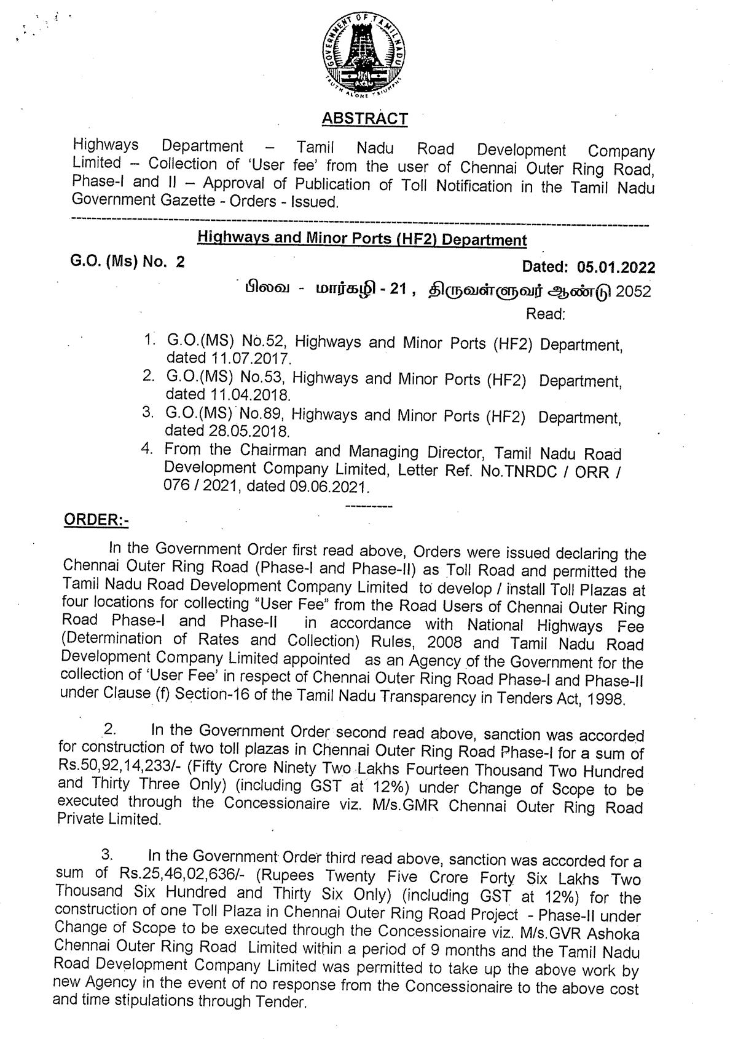

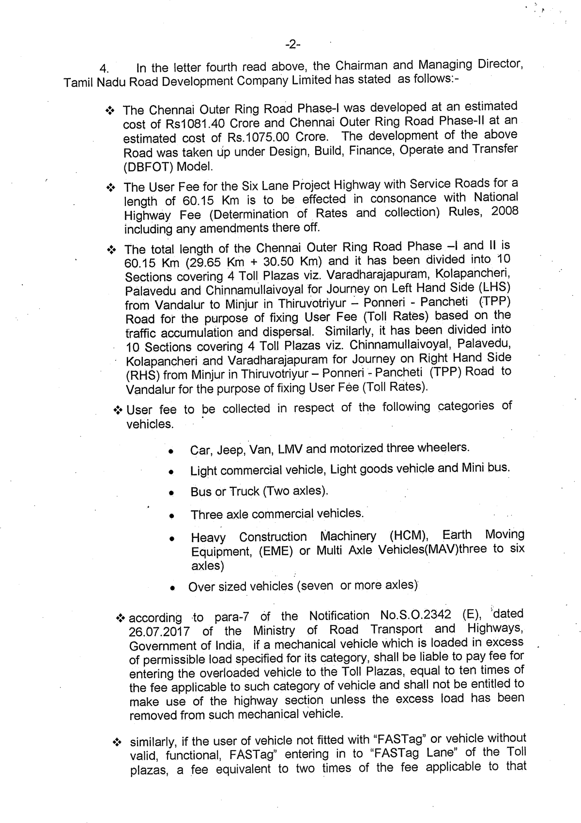

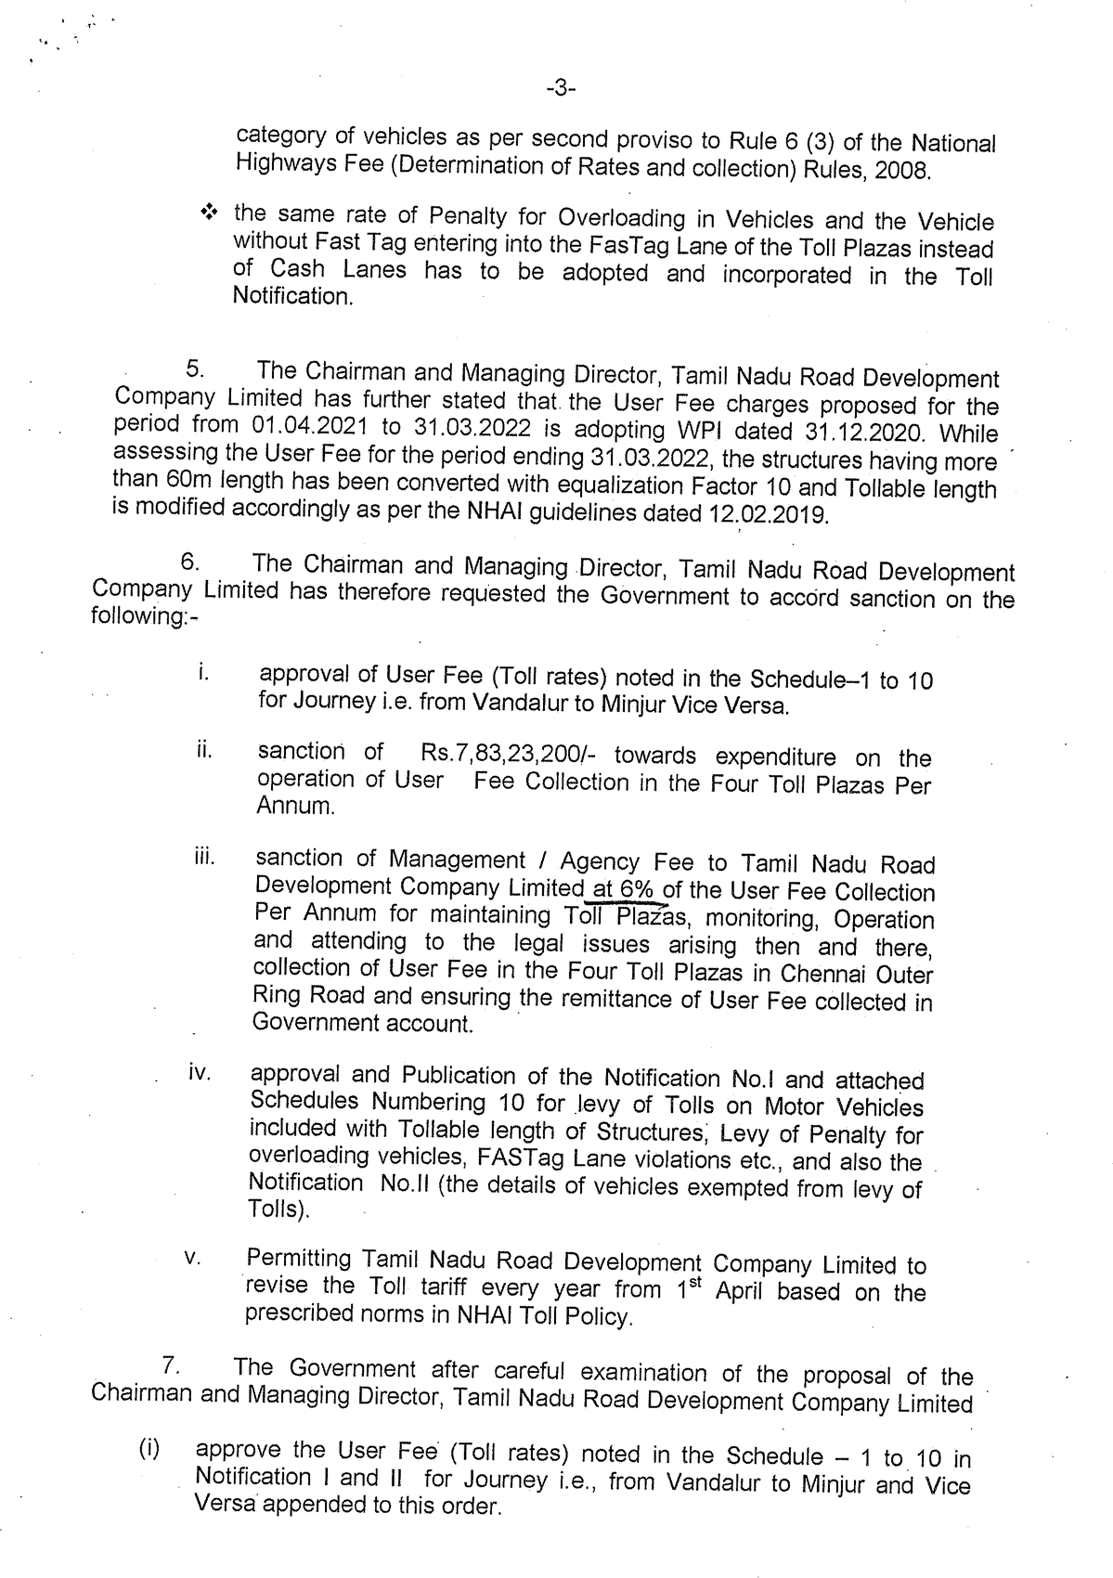

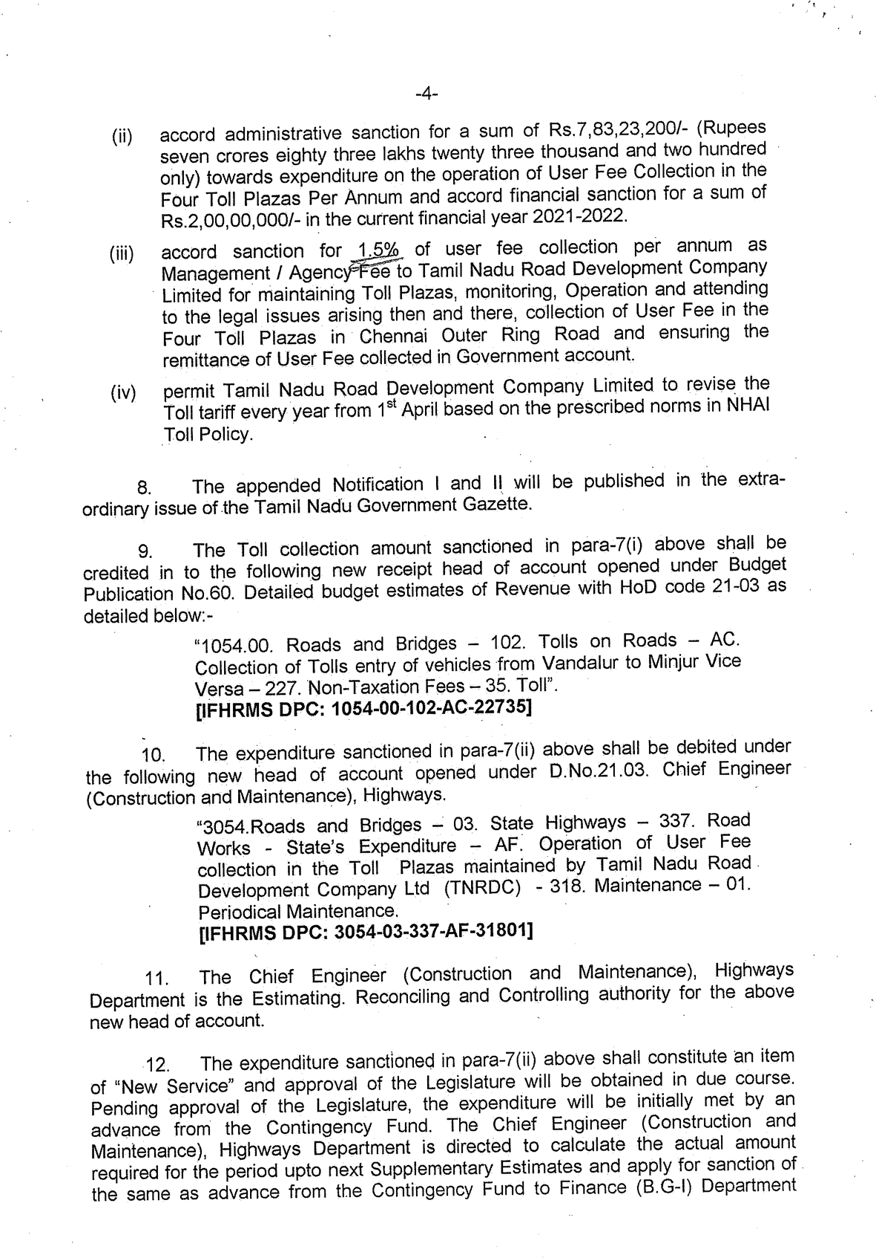

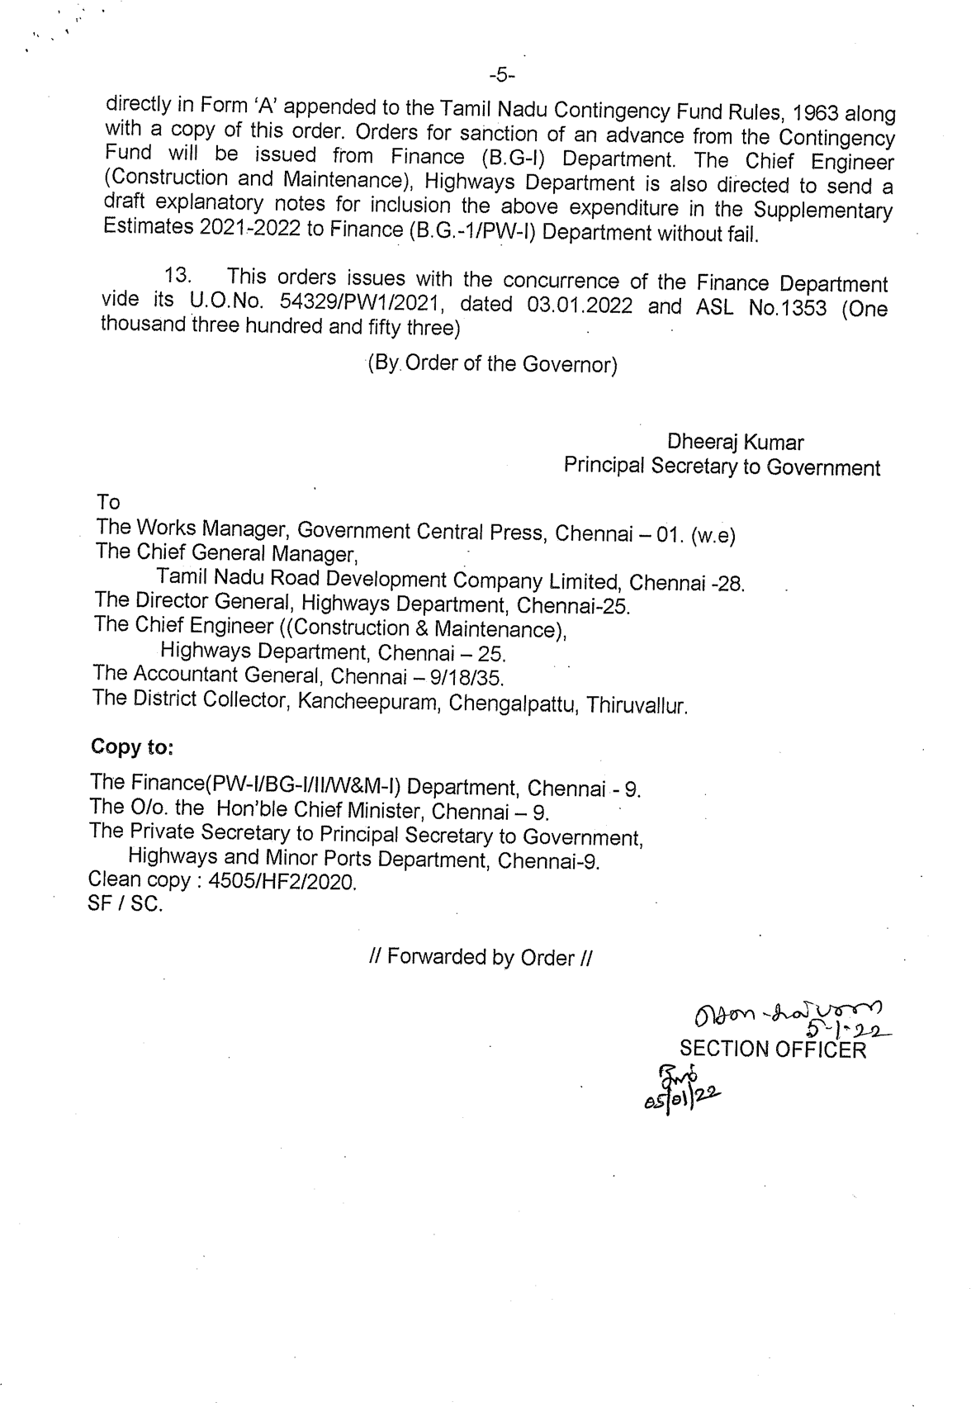

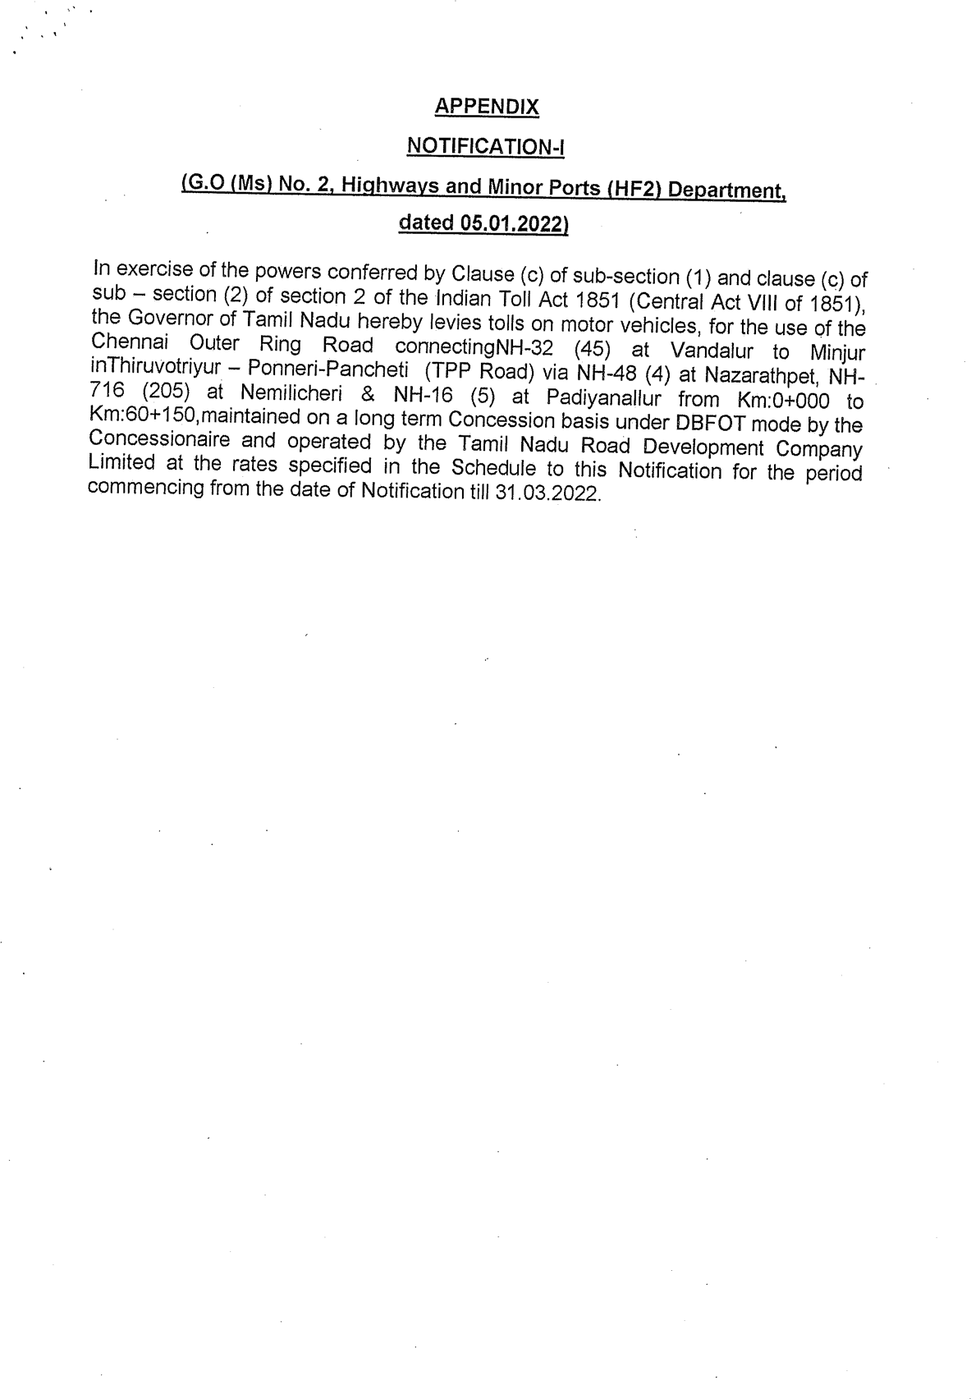

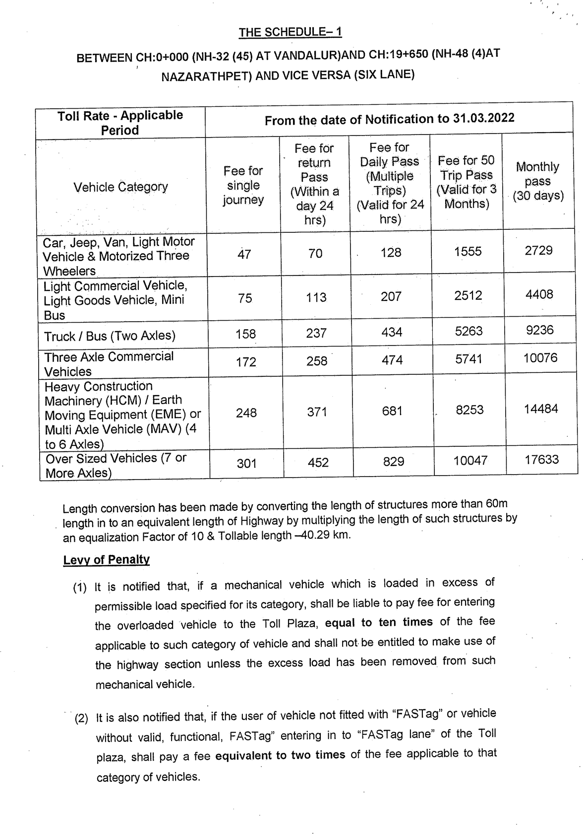

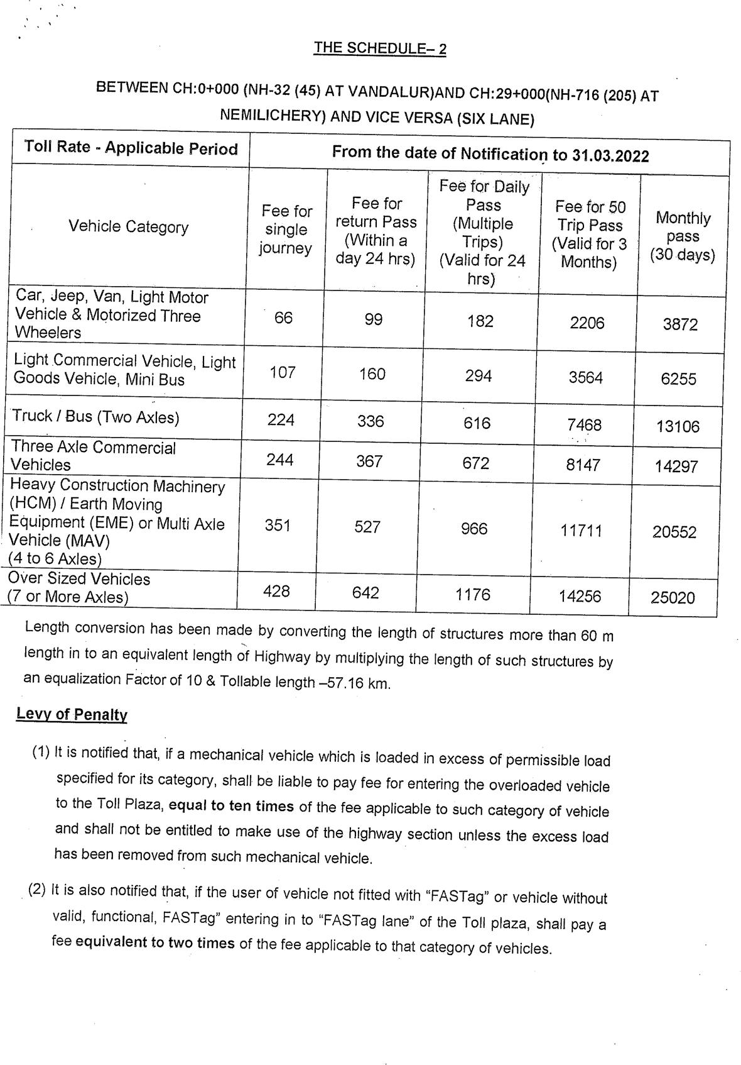

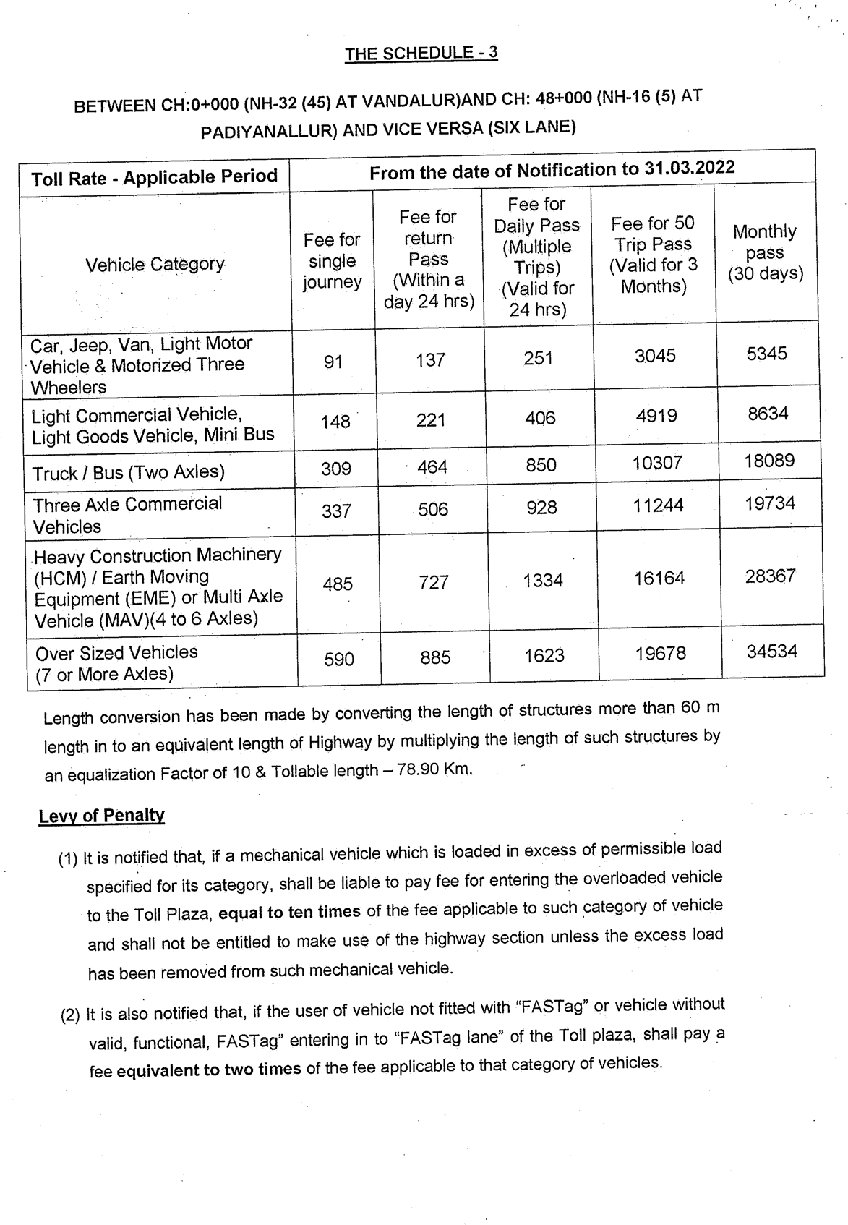

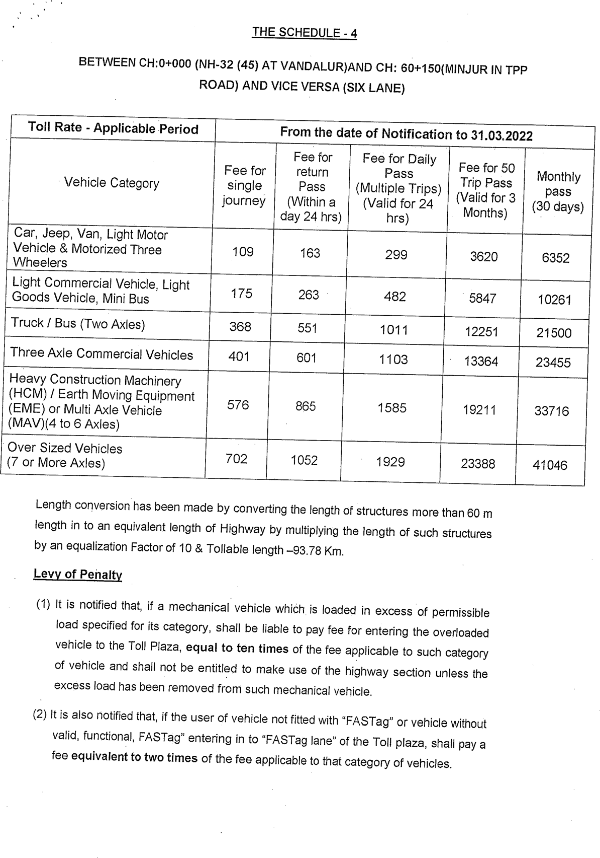

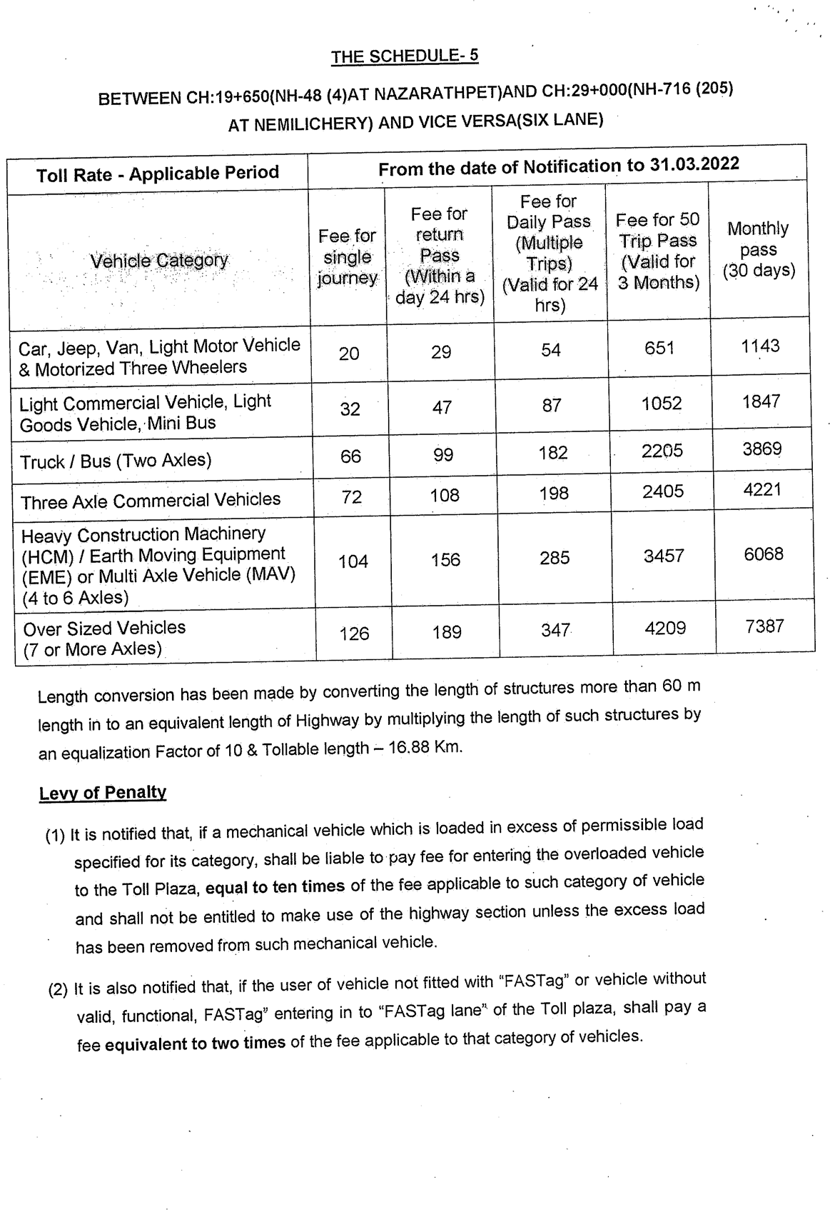

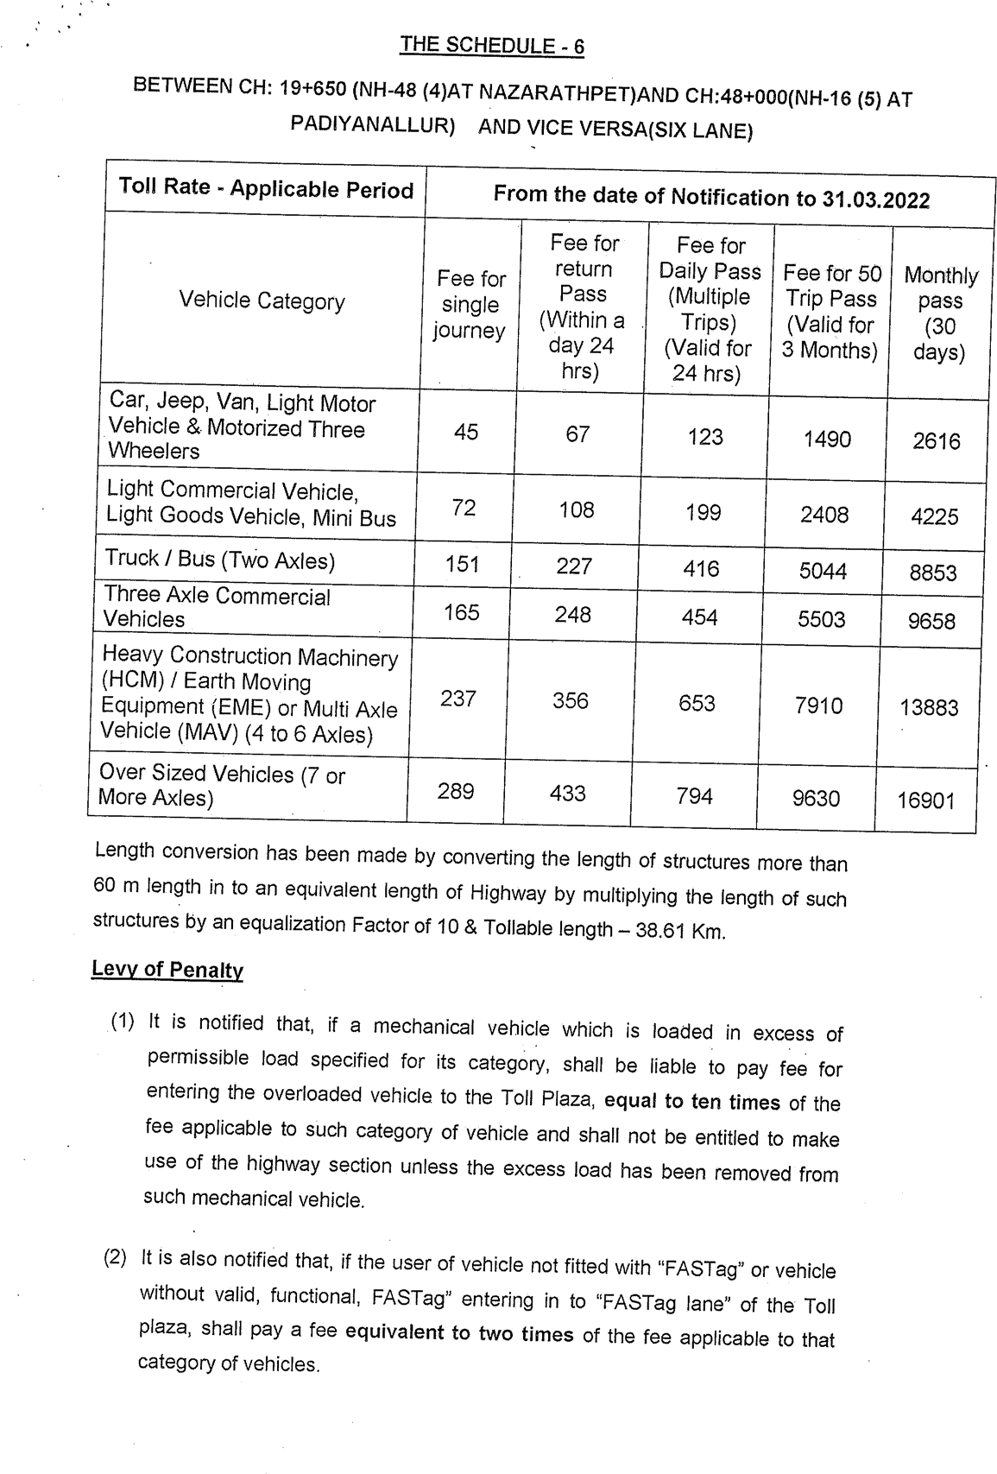

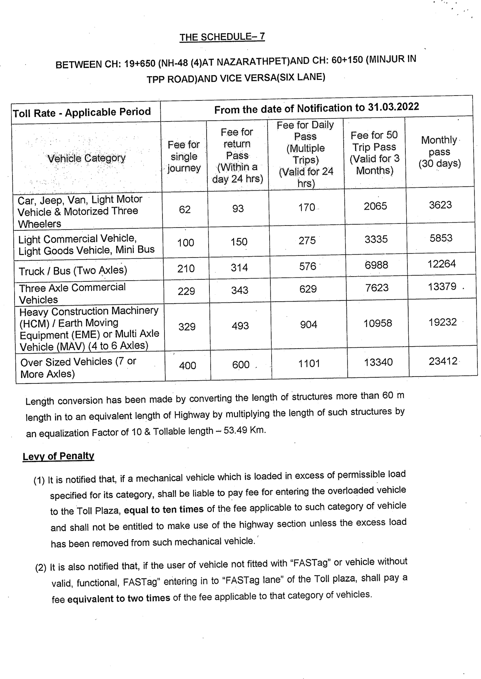

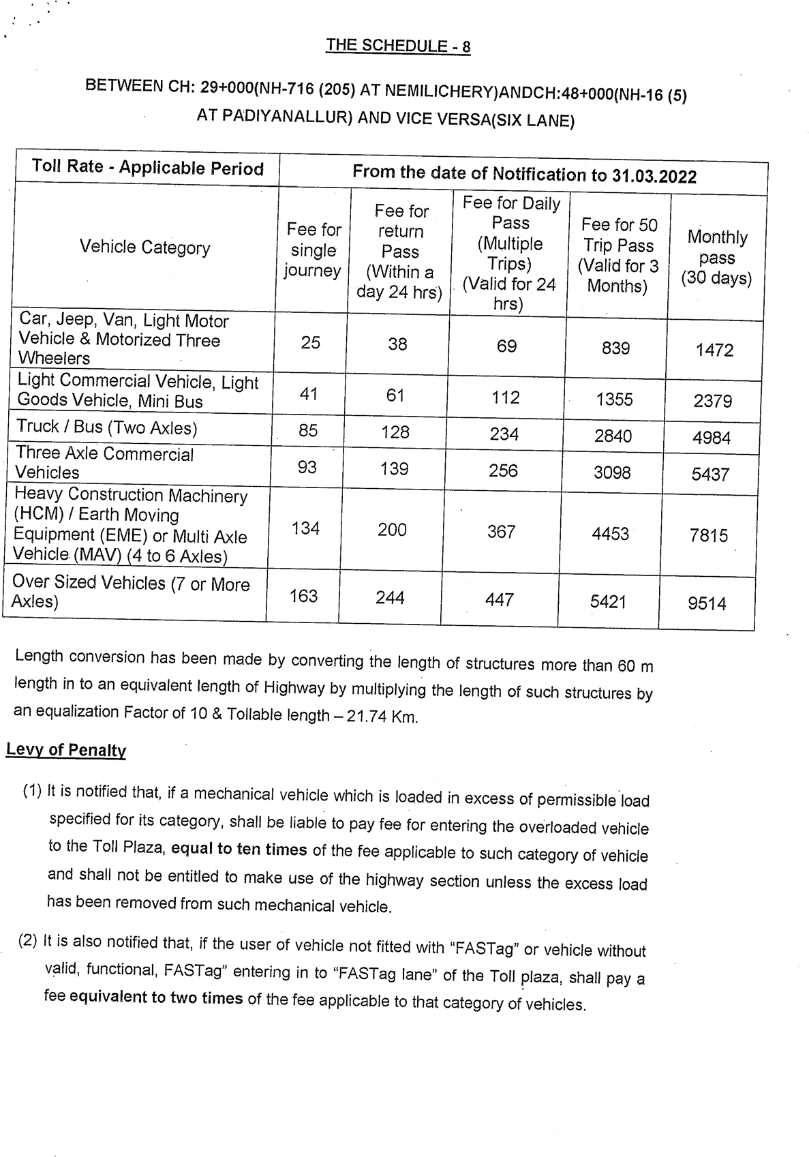

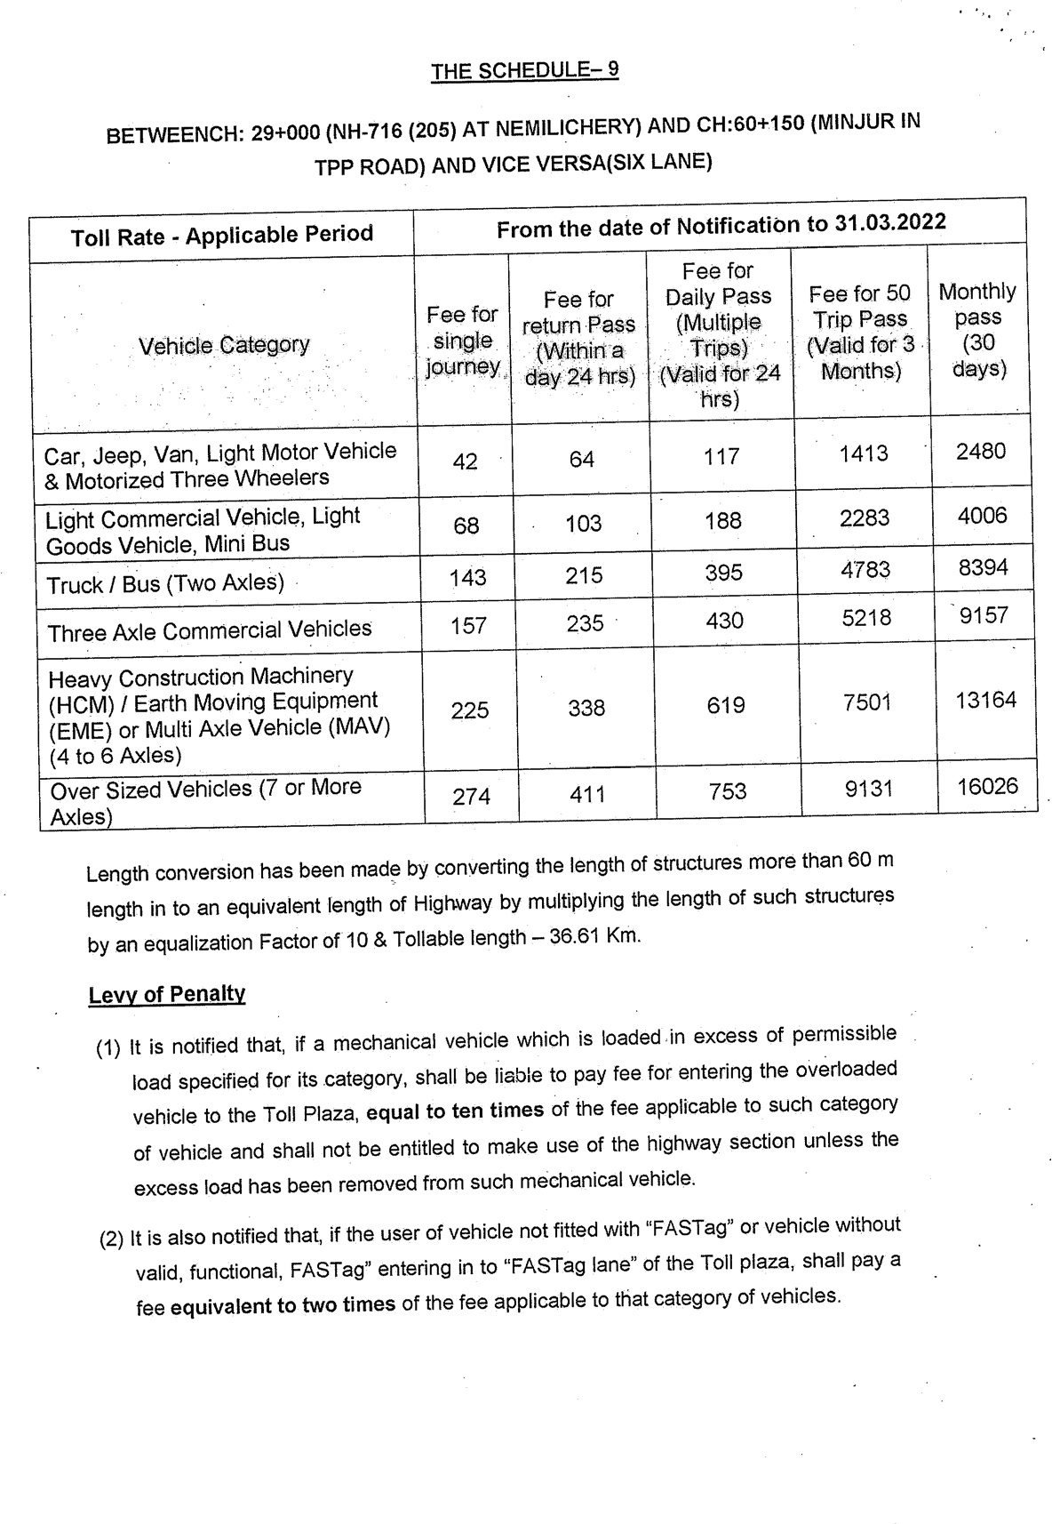

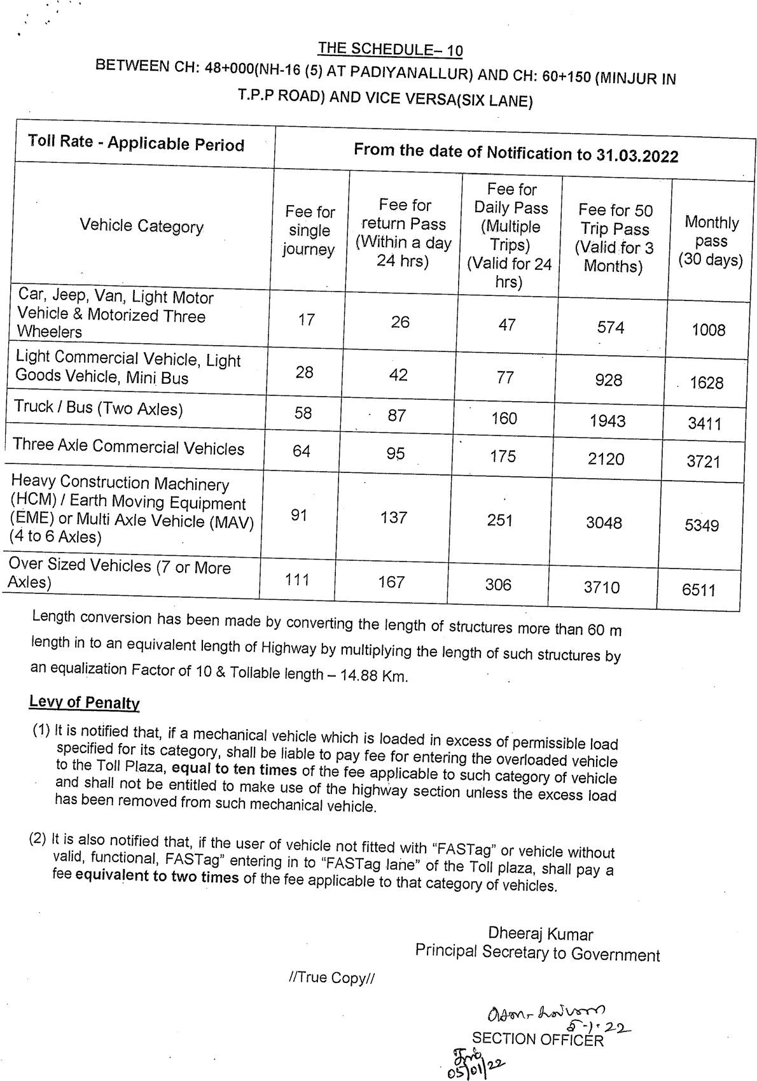

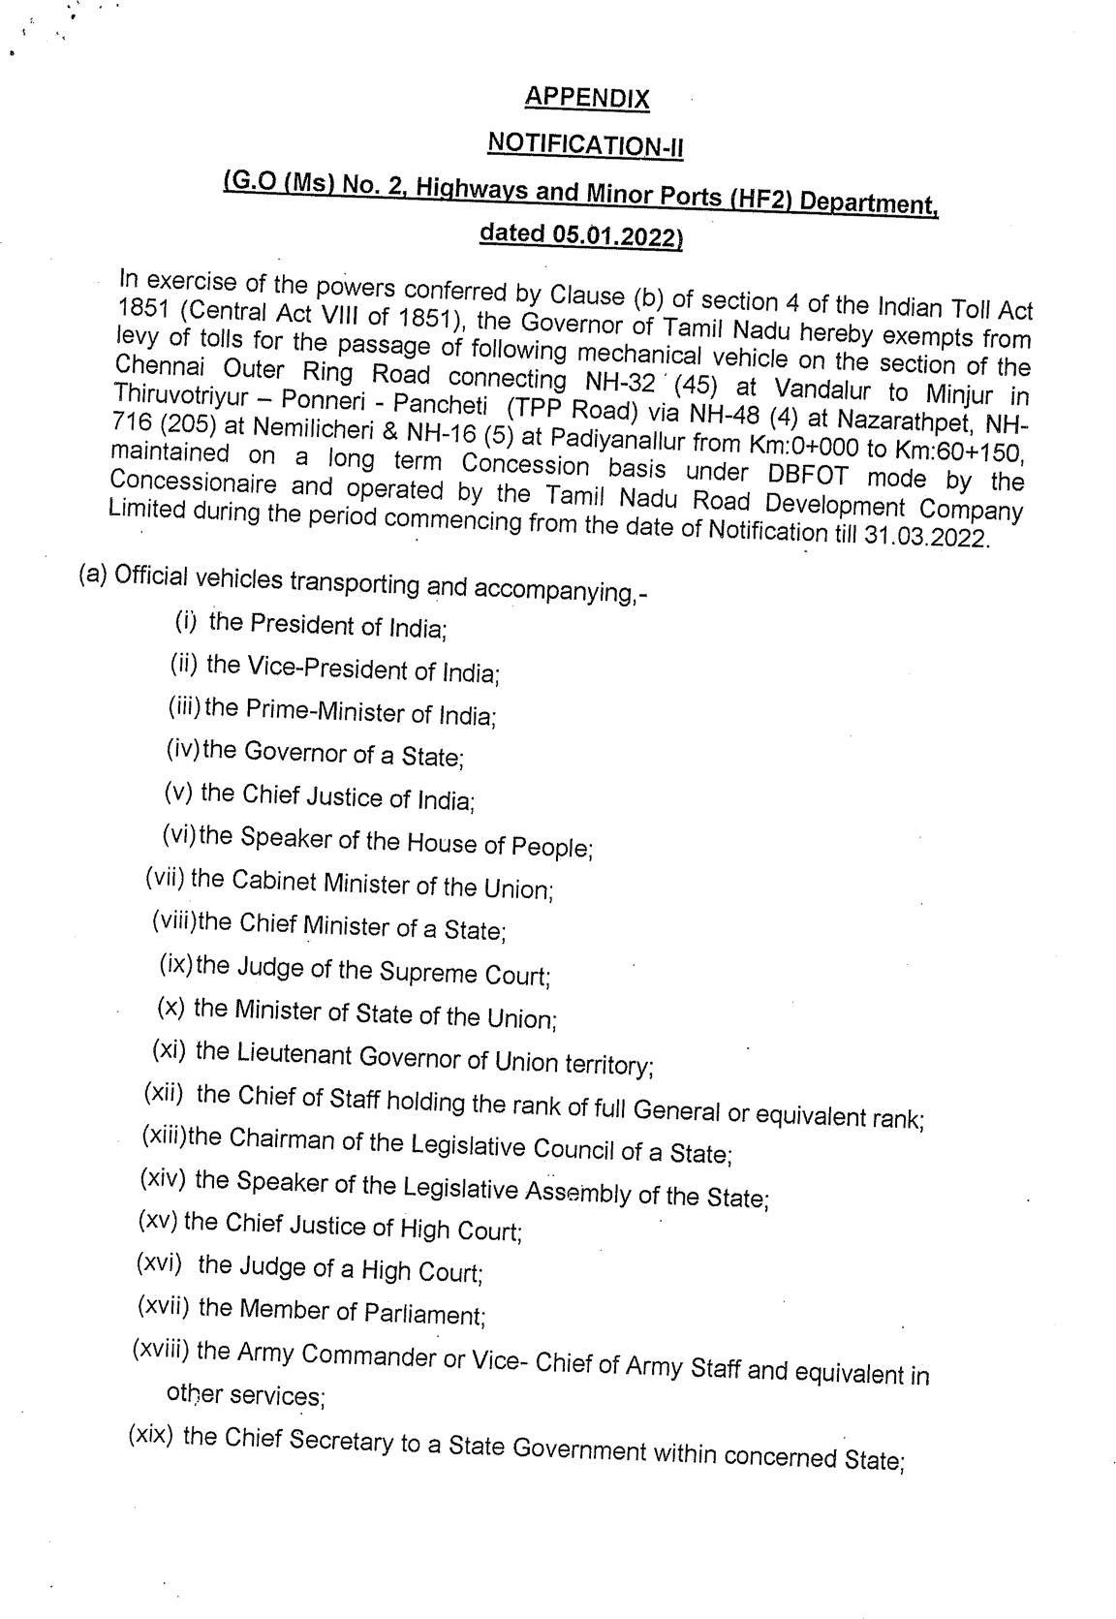

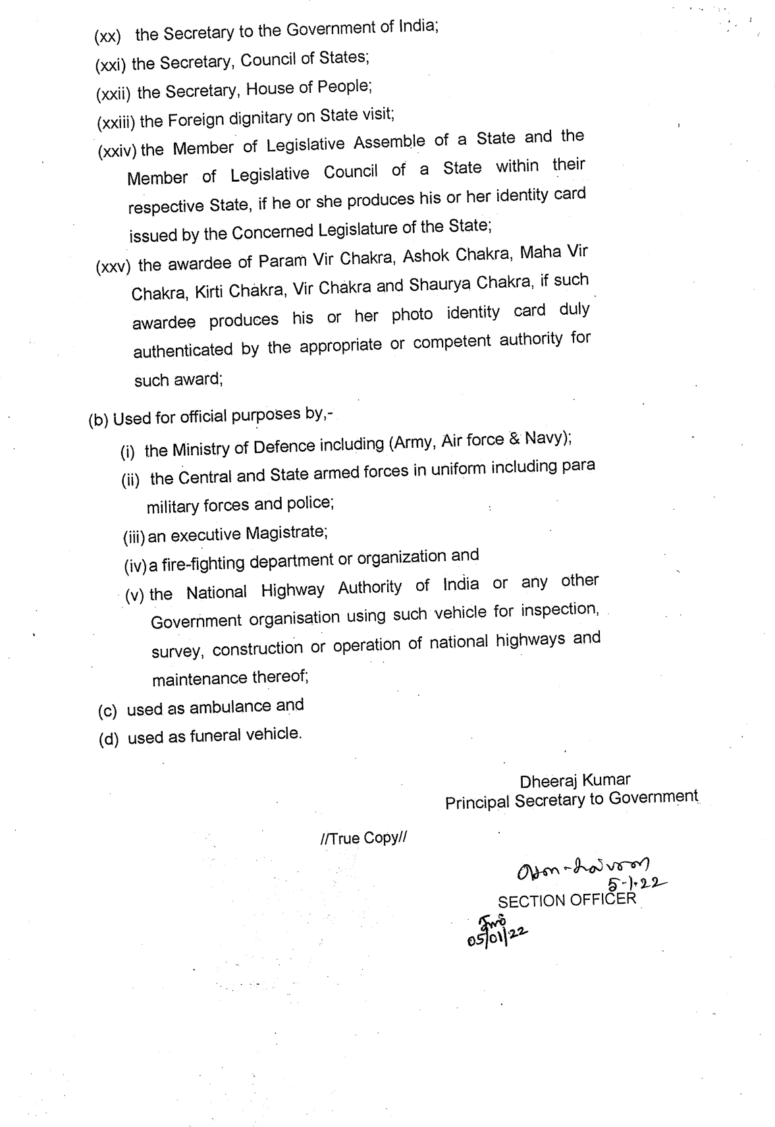

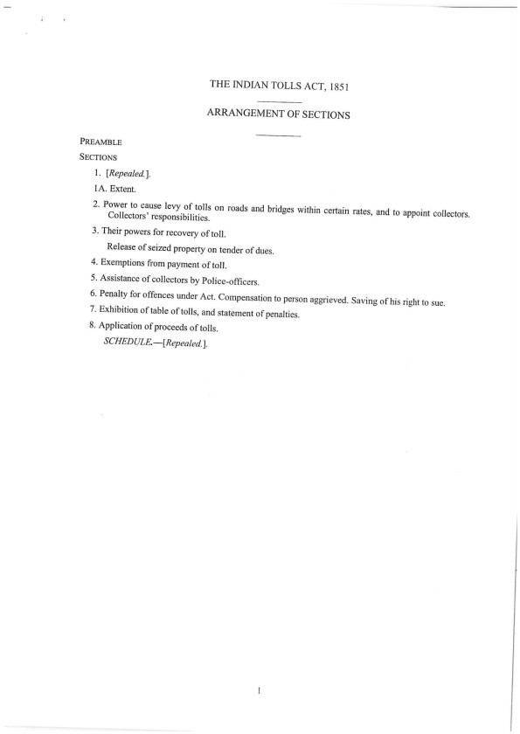

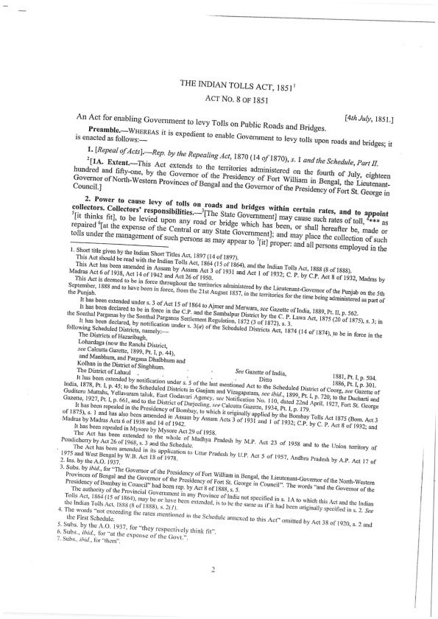

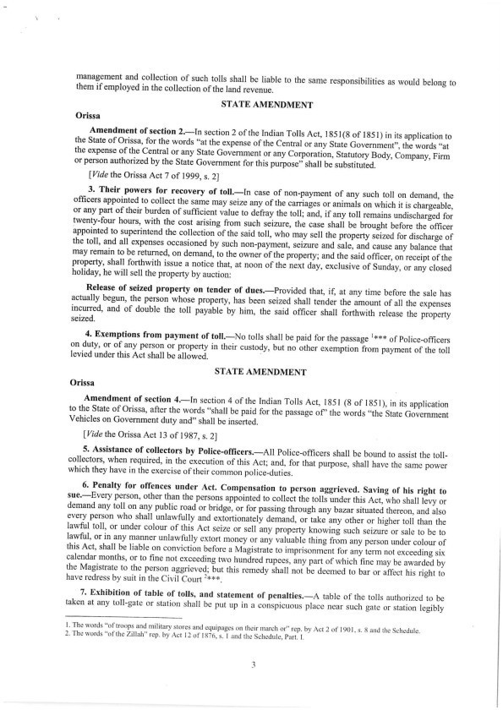

LEVY OF TOLLS ON MOTOR VEHICLES FOR COLLECTION OF ‘USER FEE’ FROM THE USER OF CHENNAI OUTER RING ROAD, PHASE I AND II UNDER THE INDIAN TOLL ACT
GO – JAN 2022

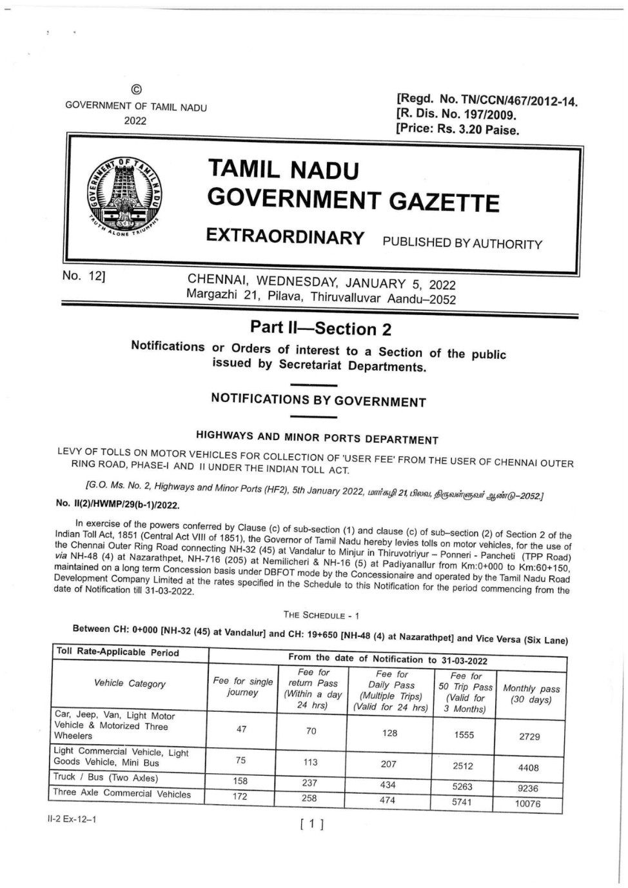

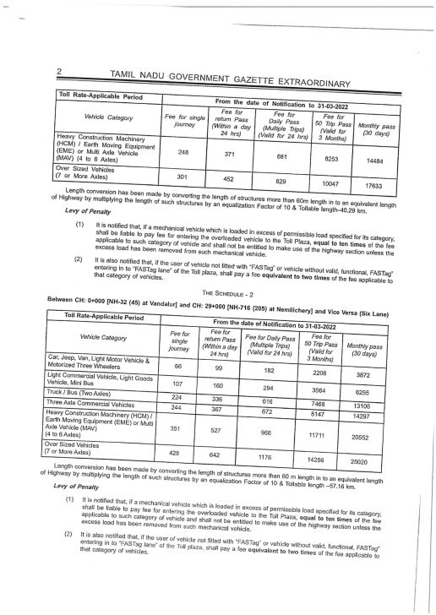

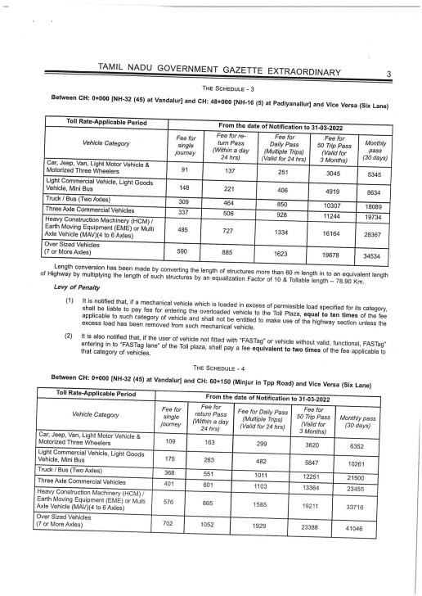

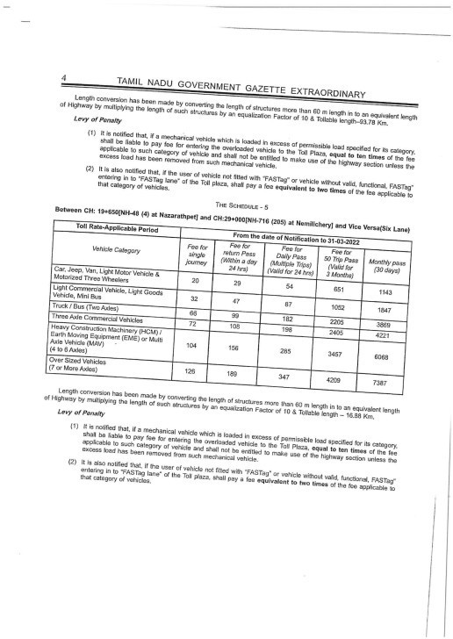

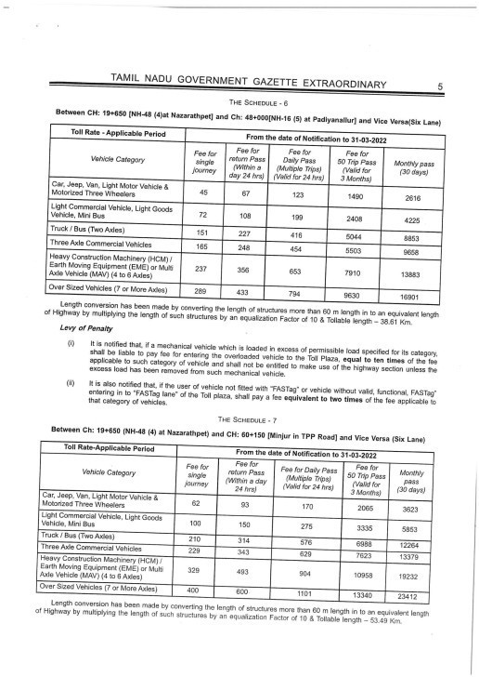

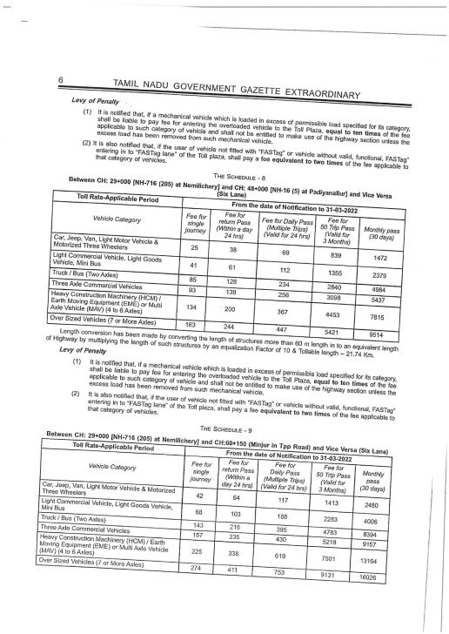

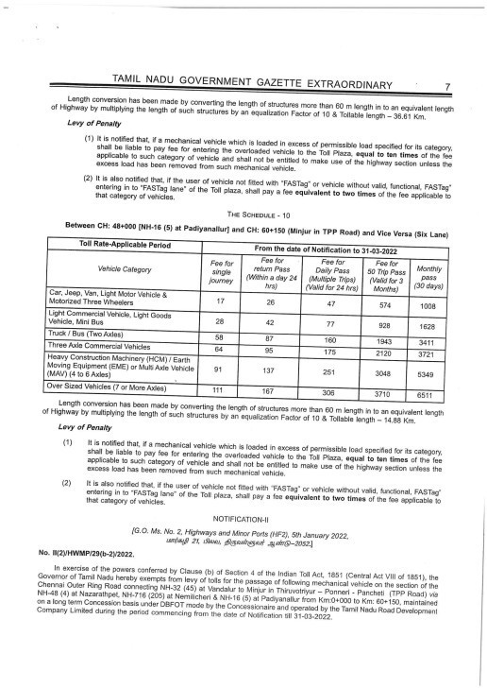

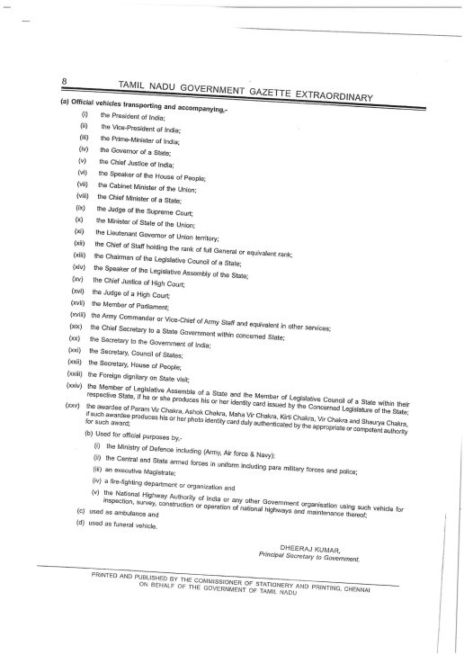

IN PRINCIPAL APPROVAL FOR TOT OF CHENNAI OUTER RING ROAD (PHASE I & II) GO - NOV 22

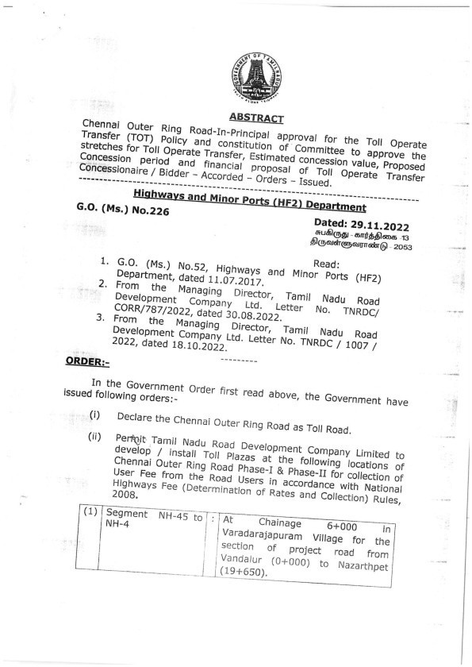

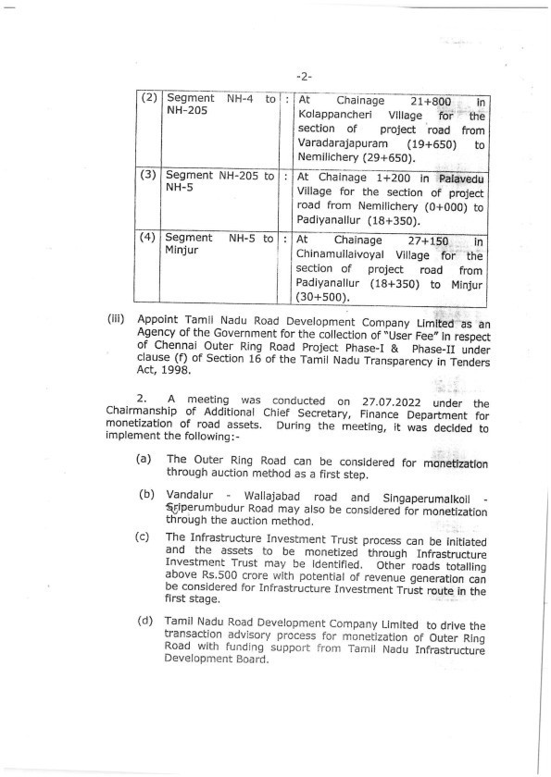

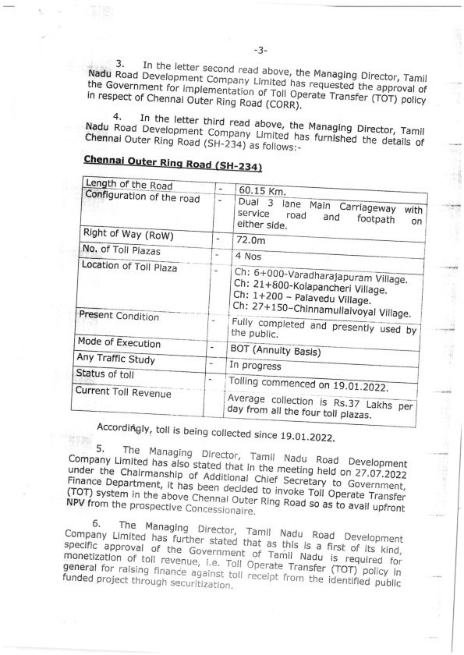

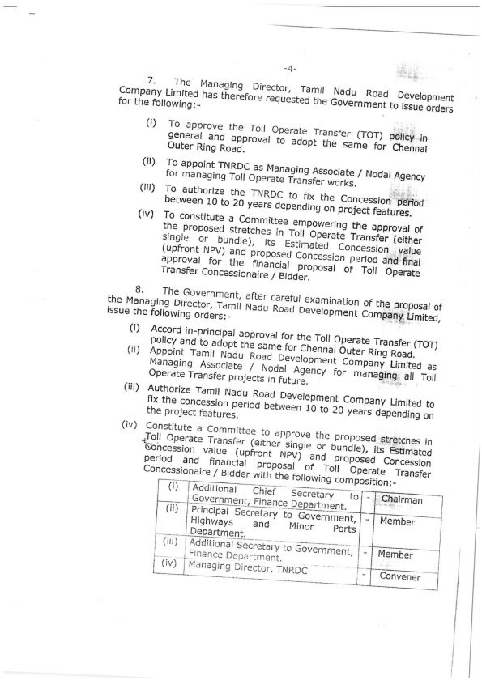

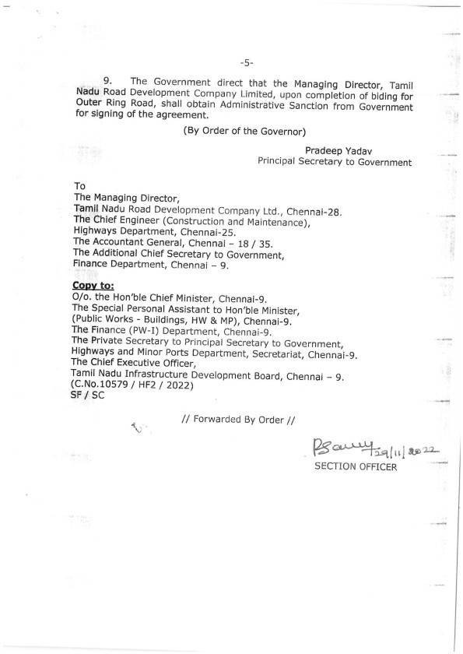

SCHEDULE – N
(See Clause 23A.1)

ESCROW AGREEMENT

THIS ESCROW AGREEMENT is entered into on this the *** day of *** 20**.

AMONGST

- , a company incorporated under the provisions of the Companies Act, 1956 and having its registered (hereinafter referred to as the “Concessionaire” which expression shall, unless repugnant to the context or meaning thereof, include its successors, permitted assigns and substitutes);

- ****[name and particulars of Lenders’ Representative] and having its registered office at *** acting for and on behalf of the Senior Lenders as their duly authorised agent with regard to matters arising out of or in relation to this Agreement (hereinafter referred to as the “Lenders’ Representative” which expression shall, unless repugnant to the context or meaning thereof, include its successors and substitutes);

- ****[name and particulars of the Escrow Bank] and having its registered office at
****(hereinafter referred to as the “Escrow Bank” which expression shall, unless repugnant to the context or meaning thereof, include its successors and substitutes); and

- Governor of TamilNadu, represented by Principal Secretary, Highways and Minor Ports Department and having its principal office at Secretariat, Fort St.George, Chennai 600 009 (hereinafter referred to as the “Authority” which expression shall unless repugnant to the context or meaning thereof include its administrators, successors and assigns);

WHEREAS:

- Authority has entered into a Concession Agreement dated with the Concessionaire (the “Concession Agreement”) for Six lane Chennai Outer Ring Road (CORR) for Phase-I i.e. Vandalur to Nemilichery (29.65 km) and Phase-II i.e. Nemilichery to Minjur in TPP Road (30.50 Km), for a total length of 60.15 Km. and a copy of which is annexed hereto and marked as Annex-A to form part of this Agreement

- The Senior Lenders namely************ and ************* have agreed to finance the Project in accordance with the terms and conditions set forth in the financing agreement. The Senior Lenders are appointed ******** as Lenders Representative as their duly authorised agent with regard to matters relating to the Financial Agreements.

- The Concession Agreement requires the Concessionaire to establish an Escrow Account, inter alia, on the terms and conditions stated in the Escrow Agreement..

NOW IT IS HEREBY AGREED as follows:

- DEFINITIONS AND INTERPRETATION

Definitions

In this Agreement, the following words and expressions shall, unless repugnant to the context or

meaning thereof, have the meaning hereinafter respectively assigned to them:

“Agreement” means this Escrow Agreement and any amendment thereto made in accordance with the provisions contained herein;

“Concession Agreement” means the Concession Agreement referred to in Recital (A) above and annexed hereto as Annex-A, and shall include all of its Recitals and Schedules and any amendments made thereto in accordance with the provisions contained in this behalf therein;

“Cure Period” means the period specified in this Agreement for curing any breach or default of any provision of this Agreement by the Concessionaire, and shall commence from the date on which a notice is delivered by the Authority or the Lenders’ Representative, as the case may be, to the Concessionaire asking the latter to cure the breach or default specified in such notice;

“Escrow Account” means an escrow account established in terms of and under this Agreement, and shall include the Sub-Accounts;

“Escrow Default” shall have the meaning ascribed thereto in Clause 6.1;

“Lenders’ Representative” means the person referred to as the Lenders’ Representative in the foregoing Recitals;

“Parties” means the parties to this Agreement collectively and “Party” shall mean any of the Parties to this Agreement individually;

“Payment Date” means, in relation to any payment specified in Clause 4.1, the date(s) specified for such payment; and

“Sub-Accounts” means the respective Sub-Accounts of the Escrow Account, into which the monies specified in Clause 4.1 would be credited every month and paid out if due, and if not due in a month then appropriated proportionately in such month and retained in the respective Sub Accounts and paid out therefrom on the Payment Date(s).

Interpretation

    - References to Lenders’ Representative shall, unless repugnant to the context or meaning thereof, mean references to the Lenders’ Representative, acting for and on behalf of Senior Lenders.

    - The words and expressions beginning with capital letters and defined in this Agreement shall have the meaning ascribed thereto herein, and the words and expressions used in this Agreement and not defined herein but defined in the Concession Agreement shall, unless repugnant to the context, have the meaning ascribed thereto in the Concession Agreement.

    - References to Clauses are, unless stated otherwise, references to Clauses of this Agreement.

    - The rules of interpretation stated in Clauses 1.2, 1.3 and 1.4 of the Concession Agreement shall apply, mutatis mutandis, to this Agreement.

ESCROW ACCOUNT

  - Escrow Bank to act as trustee

    - The Concessionaire hereby appoints the Escrow Bank to act as trustee for the Authority , the Lenders’ Representative and the Concessionaire in connection herewith and authorises the Escrow Bank to exercise such rights, powers, authorities and discretion as are specifically

delegated to the Escrow Bank by the terms hereof together with all such rights, powers, authorities and discretion as are reasonably incidental hereto, and the Escrow Bank accepts such appointment pursuant to the terms hereof.

    - The Concessionaire hereby declares that all rights, title and interest in and to the Escrow Account shall be vested in the Escrow Bank and held in trust for the Authority , the Lenders’ Representative and the Concessionaire, and applied in accordance with the terms of this Agreement. No person other than the Authority , the Lenders’ Representative and the Concessionaire shall have any rights hereunder as the beneficiaries of, or as third party beneficiaries under this Agreement.

Acceptance of Escrow Bank

The Escrow Bank hereby agrees to act as such and to accept all payments and other amounts to be delivered to and held by the Escrow Bank pursuant to the provisions of this Agreement. The Escrow Bank shall hold and safeguard the Escrow Account during the term of this Agreement and shall treat the amount in the Escrow Account as monies deposited by the Concessionaire, Senior Lenders or the Authority with the Escrow Bank. In performing its functions and duties under this Agreement, the Escrow Bank shall act in trust for the benefit of, and as agent for, the Authority , the Lenders’ Representative and the Concessionaire or their nominees, successors or assigns, in accordance with the provisions of this Agreement.

Establishment and operation of Escrow Account

    - Within 30 (thirty) days from the date of this Agreement, and in any case prior to the Appointed Date, the Concessionaire shall open and establish the Escrow Account with the **** (name of Branch) Branch of the Escrow Bank. The Escrow Account shall be denominated in Rupees.

    - The Escrow Bank shall maintain the Escrow Account in accordance with the terms of this Agreement and its usual practices and applicable regulations, and pay the maximum rate of interest payable to similar customers on the balance in the said account from time to time.

    - The Escrow Bank and the Concessionaire shall, after consultation with the Lenders’ Representative, agree on the detailed mandates, terms and conditions, and operating procedures for the Escrow Account, but in the event of any conflict or inconsistency between this Agreement and such mandates, terms and conditions, or procedures, this Agreement shall prevail.

Escrow Bank’s fee

The Escrow Bank shall be entitled to receive its fee and expenses in an amount, and at such times, as may be agreed between the Escrow Bank and the Concessionaire. For the avoidance of doubt, such fee and expenses shall form part of the O&M Expenses and shall be appropriated from the Escrow Account in accordance with Clause 4.1.

Rights of the parties

The rights of the Authority, the Lenders’ Representative and the Concessionaire in the monies held in the Escrow Account are set forth in their entirety in this Agreement and the Authority, the Lenders’ Representative and the Concessionaire shall have no other rights against or to the monies in the Escrow Account.

Substitution of the Concessionaire

The Parties hereto acknowledge and agree that upon substitution of the Concessionaire with the

Nominated Company, pursuant to the Substitution Agreement, it shall be deemed for the purposes of this Agreement that the Nominated Company is a Party hereto and the Nominated Company shall accordingly be deemed to have succeeded to the rights and obligations of the Concessionaire under this Agreement on and with effect from the date of substitution of the Concessionaire with the Nominated Company.

DEPOSITS INTO ESCROW ACCOUNT

  - Deposits by the Concessionaire

    - The Concessionaire agrees and undertakes that it shall deposit into and/or credit the Escrow Account with: (a) all funds constituting the Financial Package; (b) all Fee and any other revenues from or in respect of the Project Highway, including the proceeds of any rentals, deposits, capital receipts or insurance claims.

    - The Concessionaire may at any time make deposits of its other funds into the Escrow Account, provided that the provisions of this Agreement shall apply to such deposits.

Deposits by the Authority

The Authority agrees and undertakes that, as and when due and payable, it shall deposit into and/or credit the Escrow Account with:

- all payments by the Authority including, if any, in relation to the change of scope in the Project; and

- the Termination Payments..

Interest on deposits

The Escrow Bank agrees and undertakes that all interest accruing on the balances of the Escrow Account shall be credited to the Escrow Account; provided that the Escrow Bank shall be entitled to appropriate therefrom the fee and expenses due to it from the Concessionaire in relation to the Escrow Account and credit the balance remaining to the Escrow Account.

WITHDRAWALS FROM ESCROW ACCOUNT

  - Withdrawals during Concession Period
    - At the beginning of every month, or at such shorter intervals as the Concessionaire may by written instructions determine, the Escrow Bank shall withdraw amounts from the Escrow Account and appropriate them in the following order by depositing such amounts in the relevant Sub-Accounts for making due payments, and if such payments are not due in any month, then retain such monies in such Sub-Accounts and pay out therefrom on the Payment Date(s):
      - all taxes due and payable by the Concessionaire for and in respect of the Project Highway;

      - all payments relating to construction of the Project Highway, subject to and in accordance with the conditions, if any, set forth in the Financing Agreements;
      - O&M Expenses, subject to and in accordance with the conditions, if any, set forth in the Financing Agreements;
      - O&M Expenses and other costs and expenses incurred by the Authority in accordance with the provisions of this Agreement, and certified by the Authority as due and payable to it;

      - monthly proportionate provision of debt service payment due in an Accounting Year;

      - all payments and Damages certified by the Authority as due and payable to it by the Concessionaire pursuant to the Concession Agreement; and
      - balance, if any, in accordance with the instructions of the Concessionaire.

    - No later than 60 (sixty) days prior to the commencement of each Accounting Year, the Concessionaire shall provide to the Escrow Bank, details of the amounts likely to be required for each of the payment obligations set forth in this Clause 4.1; provided that such amounts may be subsequently modified, with prior written approval of the Authority, if fresh information received during the course of the year makes such modification necessary.

Withdrawals upon Termination

Upon Termination of the Concession Agreement, all amounts standing to the credit of the Escrow Account shall, notwithstanding anything in this Agreement, be appropriated and dealt with in the following order:
- all taxes due and payable by the Concessionaire for and in respect of the Project Highway;

- payment due to Senior Lenders;

- all payments and Damages certified by the Authority as due and payable to it by the Concessionaire;
- retention and payments relating to the liability for defects and deficiencies set forth in Article 32;
- incurred or accrued O&M Expenses;

- any other payments required to be made under this Agreement; and

- balance, if any, in accordance with the instructions of the Concessionaire. Provided that the disbursements specified in Sub-clause (g) of this Clause 4.2 shall be undertaken only after the Vesting Certificate has been issued by the Authority.

Application of insufficient funds

Funds in the Escrow Account shall be applied in the serial order of priority set forth in Clauses
4.1 and 4.2, as the case may be. If the funds available are not sufficient to meet all the requirements, the Escrow Bank shall apply such funds in the serial order of priority until exhaustion thereof.

Application of insurance proceeds

Notwithstanding anything in this Agreement, the proceeds from all insurance claims, except life and injury, shall be deposited into and/or credited to the Escrow Account and utilised for any necessary repair, reconstruction, reinstatement, replacement, improvement, delivery or installation of the Project Highway, and the balance remaining, if any, shall be applied in

accordance with the provisions contained in this behalf in this Agreement.

Withdrawals during Suspension

Notwithstanding anything to the contrary contained in this Agreement, the Authority may exercise all or any of the rights of the Concessionaire during the period of Suspension under Article 29 of the Concession Agreement. Any instructions given by the Authorityto the Escrow Bank during such period shall be complied with as if such instructions were given by the Concessionaire under this Agreement and all actions of the Authority hereunder shall be deemed to have been taken for and on behalf of the Concessionaire.

OBLIGATIONS OF THE ESCROW BANK

  - Segregation of funds

Monies and other property received by the Escrow Bank under this Agreement shall, until used or applied in accordance with this Agreement, be held by the Escrow Bank in trust for the purposes for which they were received, and shall be segregated from other funds and property of the Escrow Bank.

Notification of balances

7 (seven) business days prior to each Payment Date (and for this purpose the Escrow Bank shall be entitled to rely on an affirmation by the Concessionaire and/or the Lenders’ Representative as to the relevant Payment Dates), the Escrow Bank shall notify the Lenders’ Representative of the balances in the Escrow Account and Sub-Accounts as at the close of business on the immediately preceding business day.

Communications and notices

In discharge of its duties and obligations hereunder, the Escrow Bank:

- may, in the absence of bad faith or gross negligence on its part, rely as to any matters of fact which might reasonably be expected to be within the knowledge of the Concessionaire upon a certificate signed by or on behalf of the Concessionaire;

- may, in the absence of bad faith or gross negligence on its part, rely upon the authenticity of any communication or document believed by it to be authentic;

- shall, within 5 (five) business days after receipt, deliver a copy to the Authority/ Lenders’ Representative of any notice or document received by it in its capacity as the Escrow Bank from the Concessionaire or any other person hereunder or in connection herewith; and

- shall, within 5 (five) business days after receipt, deliver a copy to the Concessionaire of any notice or document received by it from the Authority/ Lenders’ Representative in connection herewith.

No set off

The Escrow Bank agrees not to claim or exercise any right of set off, banker’s lien or other right or remedy with respect to amounts standing to the credit of the Escrow Account. For the avoidance of doubt, it is hereby acknowledged and agreed by the Escrow Bank that the monies and properties held by the Escrow Bank in the Escrow Account shall not be considered as part of the assets of the Escrow Bank and being trust property, shall in the case of bankruptcy or

liquidation of the Escrow Bank, be wholly excluded from the assets of the Escrow Bank in such bankruptcy or liquidation.

Regulatory approvals

The Escrow Bank shall use its best efforts to procure, and thereafter maintain and comply with, all regulatory approvals required for it to establish and operate the Escrow Account. The Escrow Bank represents and warrants that it is not aware of any reason why such regulatory approvals will not ordinarily be granted to the Escrow Bank.

ESCROW DEFAULT

  - Escrow Default

    - Following events shall constitute an event of default by the Concessionaire (an“Escrow Default”) unless such event of default has occurred as a result of Force Majeure or any act or omission of the Authority or the Lenders’ Representative:

      - the Concessionaire commits breach of this Agreement by failing to deposit any receipts into the Escrow Account as provided herein and fails to cure such breach by depositing the same into the Escrow Account within a Cure Period of 5 (five) business days;

      - the Concessionaire causes the Escrow Bank to transfer funds to any account of the Concessionaire in breach of the terms of this Agreement and fails to cure such breach by depositing the relevant funds into the Escrow Account or any Sub-Account in which such transfer should have been made, within a Cure Period of 5 (five) business days; or

      - the Concessionaire commits or causes any other breach of the provisions of this Agreement and fails to cure the same within a Cure Period of 5 (five) business days.

    - Upon occurrence of an Escrow Default, the consequences thereof shall be dealt with under and in accordance with the provisions of the Concession Agreement.

TERMINATION OF ESCROW AGREEMENT

  - Duration of the Escrow Agreement
This Agreement shall remain in full force and effect so long as any of its obligations to the Authority remain to be discharged, unless terminated earlier by consent of all the Parties or otherwise in accordance with the provisions of this Agreement.

  - Substitution of Escrow Bank
The Concessionaire may, by not less than 45 (forty five) days prior notice to the Escrow Bank and the Authority, terminate this Agreement and appoint a new Escrow Bank, provided that arrangements are made satisfactory to the Authority for transfer of amounts deposited in the Escrow Account to a new Escrow Account established with the successor Escrow Bank. The termination of this Agreement shall take effect only upon coming into force of an Escrow Agreement with the substitute Escrow Bank.

Closure of Escrow Account

The Escrow Bank shall, at the request of the Concessionaire and the Lenders’ Representative made on or after the payment by the Concessionaire of all outstanding amounts under the Concession Agreement and the Financing Agreements including the payments specified in Clause 4.2, and upon confirmation of receipt of such payments, close the Escrow Account and Sub-Accounts and pay any amount standing to the credit thereof to the Concessionaire. Upon closure of the Escrow Account hereunder, the Escrow Agreement shall be deemed to be terminated.

SUPPLEMENTARY ESCROW AGREEMENT

  - Supplementary escrow agreement

The Lenders’ Representative and the Concessionaire shall be entitled to enter into a supplementary escrow agreement with the Escrow Bank providing, inter alia, for detailed procedures and documentation for withdrawals from Sub-Accounts pursuant to Clause 4.1.1 and for matters not covered under this Agreement such as the rights and obligations of Senior Lenders and lenders of Subordinated Debt, investment of surplus funds, restrictions on withdrawals by the Concessionaire in the event of breach of this Agreement or upon occurrence of an Escrow Default, procedures relating to operation of the Escrow Account and withdrawal therefrom, reporting requirements and any matters incidental thereto; provided that such supplementary escrow agreement shall not contain any provision which is inconsistent with this Agreement and in the event of any conflict or inconsistency between provisions of this Agreement and such supplementary escrow agreement, the provisions of this Agreement shall prevail.

INDEMNITY

  - General indemnity

    - The Concessionaire will indemnify, defend and hold the Authority, Escrow Bank and the Senior Lenders, acting through the Lenders’ Representative, harmless against any and all proceedings, actions and third party claims for any loss, damage, cost and expense arising out of any breach by the Concessionaire of any of its obligations under this Agreement or on account of failure of the Concessionaire to comply with Applicable Laws and Applicable Permits.

    - Authoritywill indemnify, defend and hold the Concessionaire harmless against any and all proceedings, actions and third party claims for any loss, damage, cost and expense arising out of failure of the Authority to fulfil any of its obligations under this Agreement materially and adversely affecting the performance of the Concessionaire’s obligations under the Concession Agreement or this Agreement other than any loss, damage, cost and expense arising out of acts done in discharge of their lawful functions by the Authority, its officers, servants and agents.

    - The Escrow Bank will indemnify, defend and hold the Concessionaire harmless against any and all proceedings, actions and third party claims for any loss, damage, cost and expense arising out of failure of the Escrow Bank to fulfil its obligations under this Agreement materially and adversely affecting the performance of the Concessionaire’s obligations under the Concession Agreement other than any loss, damage, cost and expense, arising out of acts done in discharge of their lawful functions by the Escrow Bank, its officers, servants and agents.

Notice and contest of claims

In the event that any Party hereto receives a claim from a third party in respect of which it is entitled to the benefit of an indemnity under Clause 9.1 or in respect of which it is entitled to

reimbursement (the “Indemnified Party”), it shall notify the other Party responsible for indemnifying such claim hereunder (the “Indemnifying Party”) within 15 (fifteen) days of receipt of the claim and shall not settle or pay the claim without the prior approval of the Indemnifying Party, which approval shall not be unreasonably withheld or delayed. In the event that the Indemnifying Party wishes to contest or dispute the claim, it may conduct the proceedings in the name of the Indemnified Party and shall bear all costs involved in contesting the same. The Indemnified Party shall provide all cooperation and assistance in contesting any claim and shall sign all such writings and documents as the Indemnifying Party may reasonably require.

DISPUTE RESOLUTION

  - Dispute resolution

    - Any dispute, difference or claim arising out of or in connection with this Agreement, which is not resolved amicably, shall be decided finally by reference to arbitration to a Board of Arbitrators comprising one nominee of each Party to the dispute, and where the number of such nominees is an even number, the nominees shall elect another person to such Board. Such arbitration shall be held in accordance with the Rules of Arbitration of the International Centre for Alternative Dispute Resolution, New Delhi (the “Rules”) or such other rules as may be mutually agreed by the Parties, and shall be subject to the provisions of the Arbitration and Conciliation Act, 1996.

    - The Arbitrators shall issue a reasoned award and such award shall be final and binding on the Parties. The venue of arbitration shall be Chennai and the language of arbitration shall be English.

MISCELLANEOUS PROVISIONS

  - Governing law and jurisdiction

This Agreement shall be construed and interpreted in accordance with and governed by the laws of India, and the Courts at Chennai shall have jurisdiction over all matters arising out of or relating to this Agreement.

Waiver of sovereign immunity

Authority unconditionally and irrevocably:

- agrees that the execution, delivery and performance by it of this Agreement constitute commercial acts done and performed for commercial purpose;

- agrees that, should any proceedings be brought against it or its assets, property or revenues in any jurisdiction in relation to this Agreement or any transaction contemplated by this Agreement, no immunity (whether by reason of sovereignty or otherwise) from such proceedings shall be claimed by or on behalf of the Authority with respect to its assets;

- waives any right of immunity which it or its assets, property or revenues now has, may acquire in the future or which may be attributed to it in any jurisdiction; and

- consents generally in respect of the enforcement of any judgement or award against it in any such proceedings to the giving of any relief or the issue of any process in any jurisdiction in connection with such proceedings (including the making, enforcement or execution against it or in respect of any assets, property or revenues whatsoever irrespective of their use or intended

use of any order or judgement that may be made or given in connection therewith).

Priority of agreements

In the event of any conflict between the Concession Agreement and this Agreement, the provisions contained in the Concession Agreement shall prevail over this Agreement.

Alteration of terms

All additions, amendments, modifications and variations to this Agreement shall be effectual and binding only if in writing and signed by the duly authorised representatives of the Parties.

Waiver

    - Waiver by any Party of a default by another Party in the observance and performance of any provision of or obligations under this Agreement:

      - shall not operate or be construed as a waiver of any other or subsequent default hereof or of other provisions of or obligations under this Agreement;

      - shall not be effective unless it is in writing and executed by a duly authorised representative of the Party; and

      - shall not affect the validity or enforceability of this Agreement in any manner.

    - Neither the failure by any Party to insist on any occasion upon the performance of the terms, conditions and provisions of this Agreement or any obligation thereunder nor time or other indulgence granted by any Party to another Party shall be treated or deemed as waiver of such breach or acceptance of any variation or the relinquishment of any such right hereunder.

No third party beneficiaries

This Agreement is solely for the benefit of the Parties and no other person or entity shall have any rights hereunder.

Survival

    - Termination of this Agreement:

      - shall not relieve the Parties of any obligations hereunder which expressly or by implication survive termination hereof; and

      - except as otherwise provided in any provision of this Agreement expressly limiting the liability of either Party, shall not relieve either Party of any obligations or liabilities for loss or damage to the other Party arising out of, or caused by, acts or omissions of such Party prior to the effectiveness of such termination or arising out of such termination.

    - All obligations surviving the cancellation, expiration or termination of this Agreement shall only survive for a period of 3 (three) years following the date of such termination or expiry of this Agreement.

Severability

If for any reason whatever any provision of this Agreement is or becomes invalid, illegal or

unenforceable or is declared by any court of competent jurisdiction or any other instrumentality to be invalid, illegal or unenforceable, the validity, legality or enforceability of the remaining provisions shall not be affected in any manner, and the Parties will negotiate in good faith with a view to agreeing to one or more provisions which may be substituted for such invalid, unenforceable or illegal provisions, as nearly as is practicable to such invalid, illegal or unenforceable provision. Failure to agree upon any such provisions shall not be subject to dispute resolution under Clause 10.1 of this Agreement or otherwise.

Successors and assigns

This Agreement shall be binding on and shall inure to the benefit of the Parties and their respective successors and permitted assigns.

Notices

All notices or other communications to be given or made under this Agreement shall be in writing and shall either be delivered personally or sent by courier or registered post with an additional copy to be sent by facsimile. The address for service of each Party and its facsimile number are set out under its name on the signing pages hereto. A notice shall be effective upon actual receipt thereof, save that where it is received after 5.30 (five thirty) p.m. on a business day, or on a day that is not a business day, the notice shall be deemed to be received on the first business day following the date of actual receipt. Without prejudice to the foregoing, a Party giving or making a notice or communication by facsimile shall promptly deliver a copy thereof personally, or send it by courier or registered post to the addressee of such notice or communication. It is hereby agreed and acknowledged that any Party may by notice change the address to which such notices and communications to it are to be delivered or mailed. Such change shall be effective when all the Parties have notice of it.

Language

All notices, certificates, correspondence and proceedings under or in connection with this Agreement shall be in English.

Authorised representatives

Each of the Parties shall, by notice in writing, designate their respective authorised representatives through whom only all communications shall be made. A Party hereto shall be entitled to remove and/or substitute or make fresh appointment of such authorised representative by similar notice.

Original Document

This Agreement may be executed in four counterparts, each of which when executed and delivered shall constitute an original of this Agreement.

IN WITNESS WHEREOF THE PARTIES HAVE EXECUTED AND DELIVERED THIS AGREEMENT AS OF THE DATE FIRST ABOVE WRITTEN.

SIGNED, SEALED AND | SIGNED, SEALED AND
DELIVERED | DELIVERED
For and on behalf of | For and on behalf of
CONCESSIONAIRE by: | SENIOR LENDERS by the  Lenders’ Representative:
(Signature) | (Signature)
(Name) | (Name)
(Designation) | (Designation)
(Address) | (Address)
(Fax No.) | (Fax No.)
SIGNED, SEALED AND | SIGNED, SEALED AND
DELIVERED | DELIVERED
For and on behalf of | For and on behalf of
ESCROW BANK by: | GOVERNMENT OF TAMIL  NADU, HIGHWAYS DEPARTMENT by:
(Signature) | (Signature)
(Name) | (Name)
(Designation) | (Designation)
(Address) | (Address)
(Fax No.) | (Fax No.)
In the presence of:
1. | 2.

SCHEDULE – O
(See Clause 31.4)

VESTING CERTIFICATE

- Governor of Tamil Nadu represented by Pricipal Secretary, Highways and Minor Ports Department (the “Authority”) refers to the Concession Agreement dated
(the “Agreement”) entered into between the Authority and
for Six lane Chennai Outer Ring Road (CORR) for Phase-I i.e. Vandalur to Nemilichery (29.65 km) and Phase-II i.e. Nemilichery to Minjur in TPP Road (30.50 Km), for a total length of 60.15 Km. on toll, operate and transfer on annuity (“TOT”) basis.
- Authority hereby acknowledges compliance and fulfilment by the Concessionaire of the Divestment Requirements set forth in Clause 31.1 of the Agreement on the basis that upon issue of this Vesting Certificate, Authority shall be deemed to have acquired, and all title and interest of the Concessionaire in or about the Project Highway shall be deemed to have vested unto the Authority, free from any encumbrances, charges and liens whatsoever.
- Notwithstanding anything to the contrary contained hereinabove, it shall be a condition of this Vesting Certificate that nothing contained herein shall be construed or interpreted as waiving the obligation of the Concessionaire to rectify and remedy any defect or deficiency in any of the Divestment Requirements and/or relieving the Concessionaire in any manner of the same.

Signed this *** day of ***, 20** at Chennai.

AGREED, ACCEPTED AND SIGNED | SIGNED, SEALED AND DELIVERED
For and on behalf of | For and on behalf of
CONCESSIONAIRE by: | AUTHORITY by:
(Signature) | (Signature)
(Name) | (Name)
(Designation) | (Designation)
(Address) | (Address)
In the presence of:
1. | 2.

SCHEDULE – P
(See Clause 4.1.3)

SUBSTITUTION AGREEMENT

THIS SUBSTITUTION AGREEMENT is entered into on this the *** day of *** 20**.

AMONGST

- Governor of TamilNadu, represented by Principal Secretary, Highways and Minor Ports Department and having its principal offices at Secretariat, Fort St. George, Chennai 600 009, Tamil Nadu, India (hereinafter referred to as the “Authority” which expression shall unless repugnant to the context or meaning thereof include its administrators, successors and assigns);

- ¹, a company incorporated under the provisions of the Companies Act, 1956 and having its registered office at ,, (hereinafter referred to as the “Concessionaire” which expression shall unless repugnant to the context or meaning thereof include its successors and permitted assigns and substitutes);

- **** [name and particulars of Lenders’ Representative] and having its registered office at ****, acting for and on behalf of the Senior Lenders as their duly authorised agent with regard to matters arising out of or in relation to this Agreement (hereinafter referred to as the “Lenders’ Representative”, which expression shall unless repugnant to the context or meaning thereof include its successors and substitutes);

WHEREAS:

- Authority has entered into a Concession Agreement dated with the Concessionaire (the “Concession Agreement”) for Six lane Chennai Outer Ring Road (CORR) for Phase-I i.e.Vandalur to Nemilichery (29.65 km) and Phase-II i.e. Nemilichery to Minjur in TPP Road (30.50 Km), for a total length of 60.15 Km on toll, operate and transfer basis on annuity (TOT Annuity), and a copy of which is annexed hereto and marked as Annex-A to form part of this Agreement.

- Senior Lenders have agreed to finance the Project in accordance with the terms and conditions set forth in the Financing Agreements.

- Senior Lenders have requested the Authority to enter into this Substitution Agreement for securing their interests through assignment, transfer and substitution of the Concession to a Nominated Company in accordance with the provisions of this Agreement and the Concession Agreement.

- In order to enable implementation of the Project including its, operation and maintenance, the

1 All project-specific provisions in this document have been enclosed in square parenthesis and may be modified suitably, as necessary.

Authority has agreed and undertaken to transfer and assign the Concession to a Nominated Company in accordance with the terms and conditions set forth in this Agreement and the Concession Agreement.

NOW IT IS HEREBY AGREED as follows:

- DEFINITIONS AND INTERPRETATION

Definitions

In this Substitution Agreement, the following words and expressions shall, unless repugnant to the context or meaning thereof, have the meaning hereinafter respectively assigned to them:

“Agreement” means this Substitution Agreement and any amendment thereto made in accordance with the provisions contained in this Agreement;

“Financial Default” means occurrence of a material breach of the terms and conditions of the Financing Agreements or a continuous default in Debt Service by the Concessionaire for a minimum period of 3 (three) months;

“Lenders’ Representative” means the person referred to as the Lenders’ Representative in the foregoing Recitals;

“Nominated Company” means a company, incorporated under the provisions of the Companies Act, 1956, selected by the Lenders’ Representative, on behalf of Senior Lenders, and proposed to the Authority for assignment/transfer of the Concession as provided in this Agreement;

“Notice of Financial Default” shall have the meaning ascribed thereto in Clause 3.2.1; and

“Parties” means the parties to this Agreement collectively and “Party” shall mean any of the Parties to this Agreement individually.

Interpretation

    - References to Lenders’ Representative shall, unless repugnant to the context or meaning thereof, mean references to the Lenders’ Representative, acting for and on behalf of Senior Lenders.

    - References to Clauses are, unless stated otherwise, references to Clauses of this Agreement.

    - The words and expressions beginning with capital letters and defined in this Agreement shall have the meaning ascribed thereto herein, and the words and expressions used in this Agreement and not defined herein but defined in the Concession Agreement shall, unless repugnant to the context, have the meaning ascribed thereto in the Concession Agreement.

    - The rules of interpretation stated in Clauses 1.2, 1.3 and 1.4 of the Concession Agreement shall

apply, mutatis mutandis, to this Agreement.

ASSIGNMENT

  - Assignment of rights and title

The Concessionaire hereby assigns the rights, title and interest in the Concession to, and in favour of, the Lenders’ Representative pursuant to and in accordance with the provisions of this Agreement and the Concession Agreement by way of security in respect of financing by the Senior Lenders under the Financing Agreements.

SUBSTITUTION OF THE CONCESSIONAIRE

  - Rights of substitution

    - Pursuant to the rights, title and interest assigned under Clause 2.1, the Lenders’ Representative shall be entitled to substitute the Concessionaire by a Nominated Company under and in accordance with the provisions of this Agreement and the Concession Agreement.

    - The Authority hereby agrees to substitute the Concessionaire by endorsement on the Concession Agreement in favour of the Nominated Company selected by the Lenders’ Representative in accordance with this Agreement. (For the avoidance of doubt, the Senior Lenders or the Lenders’ Representative shall not be entitled to operate and maintain the Project Highway as Concessionaire either individually or collectively).

Substitution upon occurrence of Financial Default

    - Upon occurrence of a Financial Default, the Lenders’ Representative may issue a notice to the Concessionaire (the “Notice of Financial Default”) along with particulars thereof, and send a copy to the Authority for its information and record. A Notice of Financial Default under this Clause 3 shall be conclusive evidence of such Financial Default and it shall be final and binding upon the Concessionaire for the purposes of this Agreement.

    - Upon issue of a Notice of Financial Default hereunder, the Lenders’ Representative may, without prejudice to any of its rights or remedies under this Agreement or the Financing Agreements, substitute the Concessionaire by a Nominated Company in accordance with the provisions of this Agreement.

    - At any time after the Lenders’ Representative has issued a Notice of Financial Default, it may by notice require the Authority to suspend all the rights of the Concessionaire and undertake the operation and maintenance of the Project Highway in accordance with the provisions of Article 29 of the Concession Agreement, and upon receipt of such notice, the Authority shall undertake Suspension under and in accordance with the provisions of the Concession Agreement. The aforesaid Suspension shall be revoked upon substitution of the Concessionaire by a Nominated Company, and in the event such substitution is not completed within 120 (one hundred and twenty) days from the date of such Suspension, the Authority may terminate the

Concession Agreement forthwith by issuing a Termination Notice in accordance with the provisions of the Concession Agreement; provided that upon written request from the Lenders’ Representative and the Concessionaire, the Authority may extend the aforesaid period of 120 (one hundred and twenty) days by a period not exceeding 90 (ninety) days.

Substitution upon occurrence of Concessionaire Default

    - Upon occurrence of a Concessionaire Default, the Authority shall by a notice inform the Lenders’ Representative of its intention to issue a Termination Notice and grant 60 (sixty) days time to the Lenders’ Representative to make a representation, stating the intention to substitute the Concessionaire by a Nominated Company.

    - In the event that the Lenders’ Representative makes a representation to the Authority within the period of 60 (sixty) days specified in Clause 3.3.1, stating that it intends to substitute the Concessionaire by a Nominated Company, the Lenders’ Representative shall be entitled to undertake and complete the substitution of the Concessionaire by a Nominated Company in accordance with the provisions of this Agreement within a period of 120 (one hundred and twenty) days from the date of such representation, and the Authority shall either withhold Termination or undertake Suspension for the aforesaid period of 120 (one hundred and twenty) days; provided that upon written request from the Lenders’ Representative and the Concessionaire, the Authority shall extend the aforesaid period of 120 (one hundred and twenty) days by a period not exceeding 90 (ninety) days.

Procedure for substitution

    - Authority and the Concessionaire hereby agree that on or after the date of Notice of Financial Default or the date of representation to the Authority under Clause 3.3.2, as the case may be, the Lenders’ Representative may, without prejudice to any of the other rights or remedies of the Senior Lenders, invite, negotiate and procure offers, either by private negotiations or public auction or tenders for the take over and transfer of the Project Highway including the Concession to the Nominated Company upon such Nominated Company’s assumption of the liabilities and obligations of the Concessionaire towards the Authority under the Concession Agreement and towards the Senior Lenders under the Financing Agreements.

    - To be eligible for substitution in place of the Concessionaire, the Nominated Company shall be required to fulfil the eligibility criteria that were laid down by the Authority for shortlisting the bidders for award of the Concession; provided that the Lenders’ Representative may represent to the Authority that all or any of such criteria may be waived in the interest of the Project, and if the Authority determines that such waiver shall not have any material adverse effect on the Project, it may waive all or any of such eligibility criteria.

    - Upon selection of a Nominated Company, the Lenders’ Representative shall request the Authority to:

      - accede to transfer to the Nominated Company the right to operate and maintain the

Project Highway in accordance with the provisions of the Concession Agreement;

      - endorse and transfer the Concession to the Nominated Company, on the same terms and conditions, for the residual Concession Period; and

      - enter into a Substitution Agreement with the Lenders’ Representative and the Nominated Company on the same terms as are contained in this Agreement.

    - If the Authority has any objection to the transfer of Concession in favour of the Nominated Company in accordance with this Agreement, it shall within 15 (fifteen) days from the date of proposal made by the Lenders’ Representative, give a reasoned order after hearing the Lenders’ Representative. If no such objection is raised by the Authority, the Nominated Company shall be deemed to have been accepted. Authority thereupon shall transfer and endorse the Concession within 15 (fifteen) days of its acceptance/deemed acceptance of the Nominated Company; provided that in the event of such objection by the Authority, the Lenders’ Representative may propose another Nominated Company whereupon the procedure set forth in this Clause 3.4 shall be followed for substitution of such Nominated Company in place of the Concessionaire.

Selection to be binding

The decision of the Lenders’ Representative and the Authority in selection of the Nominated Company shall be final and binding on the Concessionaire. The Concessionaire irrevocably agrees and waives any right to challenge the actions of the Lenders’ Representative or the Senior Lenders or the Authority taken pursuant to this Agreement including the transfer/assignment of the Concession in favour of the Nominated Company. The Concessionaire agrees and confirms that it shall not have any right to seek revaluation of assets of the Project or the Concessionaire’s shares. It is hereby acknowledged by the Parties that the rights of the Lenders’ Representative are irrevocable and shall not be contested in any proceedings before any court or Authority and the Concessionaire shall have no right or remedy to prevent, obstruct or restrain the Authority or the Lenders’ Representative from effecting or causing the transfer by substitution and endorsement of the Concession as requested by the Lenders’ Representative.

PROJECT AGREEMENTS

  - Substitution of Nominated Company in Project Agreements

The Concessionaire shall ensure and procure that each Project Agreement contains provisions that entitle the Nominated Company to step into such Project Agreement, in its discretion, in place and substitution of the Concessionaire in the event of such Nominated Company’s assumption of the liabilities and obligations of the Concessionaire under the Concession Agreement.

TERMINATION OF CONCESSION AGREEMENT

  - Termination upon occurrence of Financial Default

At any time after issue of a Notice of Financial Default, the Lenders’ Representative may by a notice in writing require the Authority to terminate the Concession Agreement forthwith, and upon receipt of such notice, the Authority shall undertake Termination under and in accordance with the provisions of Article 30 of the Concession Agreement.

Termination when no Nominated Company is selected

In the event that no Nominated Company acceptable to the Authority is selected and recommended by the Lenders’ Representative within the period of 120 (one hundred and twenty) days or any extension thereof as set forth in Clause 3.3.2, the Authority may terminate the Concession Agreement forthwith in accordance with the provisions thereof.

DURATION OF THE AGREEMENT

  - Duration of the Agreement

This Agreement shall come into force from the date hereof and shall expire at the earliest to occur of the following events:

- Termination of the Agreement; or

- no sum remains to be advanced, or is outstanding to the Senior Lenders, under the Financing Agreements.

INDEMNITY

  - General indemnity

    - The Concessionaire will indemnify, defend and hold the Authority and the Lenders’ Representative harmless against any and all proceedings, actions and third party claims for any loss, damage, cost and expense of whatever kind and nature arising out of any breach by the Concessionaire of any of its obligations under this Agreement or on account of failure of the Concessionaire to comply with Applicable Laws and Applicable Permits.

    - Authority will indemnify, defend and hold the Concessionaire harmless against any and all proceedings, actions and third party claims for any loss, damage, cost and expense arising out of failure of the Authority to fulfil any of its obligations under this Agreement, materially and adversely affecting the performance of the Concessionaire’s obligations under the Concession Agreement or this Agreement, other than any loss, damage, cost and expense, arising out of acts done in discharge of their lawful functions by the Authority, its officers, servants and agents.

    - The Lenders’ Representative will indemnify, defend and hold the Concessionaire harmless

against any and all proceedings, actions and third party claims for any loss, damage, cost and expense arising out of failure of the Lenders’ Representative to fulfil its obligations under this Agreement, materially and adversely affecting the performance of the Concessionaire’s obligations under the Concession Agreement, other than any loss, damage, cost and expense, arising out of acts done in discharge of their lawful functions by the Lenders’ Representative, its officers, servants and agents.

Notice and contest of claims

In the event that any Party hereto receives a claim from a third party in respect of which it is entitled to the benefit of an indemnity under Clause 7.1 or in respect of which it is entitled to reimbursement (the “Indemnified Party”), it shall notify the other Party responsible for indemnifying such claim hereunder (the “Indemnifying Party”) within 15 (fifteen) days of receipt of the claim and shall not settle or pay the claim without the prior approval of the Indemnifying Party, such approval not to be unreasonably withheld or delayed. In the event that the Indemnifying Party wishes to contest or dispute the claim, it may conduct the proceedings in the name of the Indemnified Party and shall bear all costs involved in contesting the same. The Indemnified Party shall provide all cooperation and assistance in contesting any claim and shall sign all such writings and documents as the Indemnifying Party may reasonably require.

DISPUTE RESOLUTION

  - Dispute resolution

    - Any dispute, difference or claim arising out of or in connection with this Agreement which is not resolved amicably shall be decided by reference to arbitration to a Board of Arbitrators comprising one nominee each of the Authority, Concessionaire and the Lenders’ Representative. Such arbitration shall be held in accordance with the Rules of Arbitration of the International Centre for Alternative Dispute Resolution, New Delhi (the “Rules”) or such other rules as may be mutually agreed by the Parties, and shall be subject to provisions of the Arbitration and Conciliation Act, 1996.

    - The Arbitrators shall issue a reasoned award and such award shall be final and binding on the Parties. The venue of arbitration shall be Chennai and the language of arbitration shall be English.

MISCELLANEOUS PROVISIONS

  - Governing law and jurisdiction

This Agreement shall be construed and interpreted in accordance with and governed by the laws of India, and the Courts at Chennai shall have jurisdiction over all matters arising out of or relating to this Agreement.

Waiver of sovereign immunity

Authority unconditionally and irrevocably:

- agrees that the execution, delivery and performance by it of this Agreement constitute commercial acts done and performed for commercial purpose;

- agrees that, should any proceedings be brought against it or its assets, property or revenues in any jurisdiction in relation to this Agreement or any transaction contemplated by this Agreement, no immunity (whether by reason of sovereignty or otherwise) from such proceedings shall be claimed by or on behalf of the Authority with respect to its assets;

- waives any right of immunity which it or its assets, property or revenues now has, may acquire in the future or which may be attributed to it in any jurisdiction; and

- consents generally in respect of the enforcement of any judgement or award against it in any such proceedings to the giving of any relief or the issue of any process in any jurisdiction in connection with such proceedings (including the making, enforcement or execution against it or in respect of any assets, property or revenues whatsoever irrespective of their use or intended use of any order or judgement that may be made or given in connection therewith).

Priority of agreements

In the event of any conflict between the Concession Agreement and this Agreement, the provisions contained in the Concession Agreement shall prevail over this Agreement.

Alteration of terms

All additions, amendments, modifications and variations to this Agreement shall be effectual and binding only if in writing and signed by the duly authorised representatives of the Parties.

Waiver

    - Waiver by any Party of a default by another Party in the observance and performance of any provision of or obligations under this Agreement:

      - shall not operate or be construed as a waiver of any other or subsequent default hereof or of other provisions of or obligations under this Agreement;

      - shall not be effective unless it is in writing and executed by a duly authorised representative of the Party; and

      - shall not affect the validity or enforceability of this Agreement in any manner.

    - Neither the failure by either Party to insist on any occasion upon the performance of the terms, conditions and provisions of this Agreement or any obligation thereunder nor time or other

indulgence granted by a Party to another Party shall be treated or deemed as waiver of such breach or acceptance of any variation or the relinquishment of any such right hereunder.

No third party beneficiaries

This Agreement is solely for the benefit of the Parties and no other person or entity shall have any rights hereunder.

Survival

    - Termination of this Agreement:

      - shall not relieve the Parties of any obligations hereunder which expressly or by implication survive termination hereof; and

      - except as otherwise provided in any provision of this Agreement expressly limiting the liability of either Party, shall not relieve either Party of any obligations or liabilities for loss or damage to the other Party arising out of or caused by acts or omissions of such Party prior to the effectiveness of such termination or arising out of such termination.

    - All obligations surviving the cancellation, expiration or termination of this Agreement shall only survive for a period of 3 (three) years following the date of such termination or expiry of this Agreement.

Severability

If for any reason whatever any provision of this Agreement is or becomes invalid, illegal or unenforceable or is declared by any court of competent jurisdiction or any other instrumentality to be invalid, illegal or unenforceable, the validity, legality or enforceability of the remaining provisions shall not be affected in any manner, and the Parties will negotiate in good faith with a view to agreeing to one or more provisions which may be substituted for such invalid, unenforceable or illegal provisions, as nearly as is practicable to such invalid, illegal or unenforceable provision. Failure to agree upon any such provisions shall not be subject to dispute resolution under Clause 8 of this Agreement or otherwise.

Successors and assigns

This Agreement shall be binding on and shall inure to the benefit of the Parties and their respective successors and permitted assigns.

Notices

All notices or other communications to be given or made under this Agreement shall be in writing, shall either be delivered personally or sent by courier or registered post with an additional copy to be sent by facsimile. The address for service of each Party and its facsimile number are set out under its name on the signing pages hereto. A notice shall be effective upon

actual receipt thereof, save that where it is received after 5.30 (five thirty) p.m. on any day, or on a day that is a public holiday, the notice shall be deemed to be received on the first working day following the date of actual receipt. It is hereby agreed and acknowledged that any Party may by notice change the address to which such notices and communications to it are to be delivered or mailed. Such change shall be effective when all the Parties have notice of it.

Language

All notices, certificates, correspondence and proceedings under or in connection with this Agreement shall be in English.

Authorised representatives

Each of the Parties shall by notice in writing designate their respective authorised representatives through whom only all communications shall be made. A Party hereto shall be entitled to remove and/or substitute or make fresh appointment of such authorised representative by similar notice.

Original Document

This Agreement may be executed in three counterparts, each of which when executed and delivered shall constitute an original of this Agreement.

IN WITNESS WHEREOF THE PARTIES HAVE EXECUTED AND DELIVERED THIS AGREEMENT AS OF THE DATE FIRST ABOVE WRITTEN.

SIGNED, SEALED AND DELIVERED | SIGNED, SEALED AND DELIVERED
For and on behalf of | For and on behalf of
CONCESSIONAIRE by: | AUTHORITY by:
(Signature) | (Signature)
(Name) | (Name)
(Designation) | (Designation)
(Address) | (Address)
(Fax No.) | (Fax No.)
SIGNED, SEALED AND DELIVERED
For and on behalf of
SENIOR LENDERS by the Lenders’ Representative:
(Signature)
(Name)
(Designation)
(Address)
(Fax)
In the presence of:
1. | 2.

SCHEDULE-Q
(See Article 41)

Year-Wise distribution of Concession Fee based on Unexpired Cash Flows

End of Financial Year | Year Wise distribution of Concession Fee (Unexpired Cash Flows)  (Percentage of Concession Fee) | Termination Payment towards Scope of Work as per Schedule B  (Percentage of Estimated Project Cost)
0 | 100.0% | NA
1 | 100.0% | NA
2 | 93.5% | NA
3 | 91.2% | NA
4 | 89.7% | NA
5 | 84.5% | NA
6 | 79.6% | NA
7 | 74.9% | NA
8 | 69.1% | NA
9 | 62.2% | NA
10 | 56.2% | NA
11 | 48.7% | NA
12 | 40.4% | NA
13 | 31.0% | NA
14 | 15.4% | NA
15 | 0.0% | NA

* Proportion of unexpired cashflows shall be the minimum of the actual proportion of the unexpired cashflow of the current year or the preceding year.

SCHEDULE-R
(See Article 37)

Procedure for Dispute Resolution Board
The parties to the Concession Agreement mutually agree as follows:

- The DRB shall comprise of 3 (three) Members having experience in the field of construction or have been involved in the Works related to construction and with the interpretation of contractual documents. 1 (One) Member shall be selected by each of the Authority and the Concessionaire. In the event the parties fail to select the member within 28 (twenty eight) days of the date of the signing of Concession Agreement, in that eventuality, upon the request of either or both parties such Member shall be selected by the International Centre for Alternative Dispute Resolution, New Delhi within 14 (fourteen) days. The third Member shall be selected by the other 2 (two) members from the same list. If the 2 (two) Members selected by or on behalf of the parties fail to select the third Member within 14 (fourteen) days after the later of their selections, then upon the request of either or both parties such third Member shall be selected by the International Centre for Alternative Dispute Resolution, New Delhi within 14 (fourteen) days. The third Member shall serve as Chairman of the Board.
- The Board shall be constituted when each of the 3 (three) Board Members has signed a Board Member’s declaration of Acceptance as required by the DRB’s rules and procedures (which, along with the declaration of acceptance form, are attached as Annexure herewith).
- In the event of death, disability, or resignation of any Member, such Member shall be replaced in the same manner as the Member being replaced was selected. If for any other reason, a Member fails or is unable to serve, the Chairman (or failing the action of the Chairman then either of the other Members) shall inform the Parties and such non-serving Member shall be replaced in the same manner as the Member being replaced was selected. Any replacement made by the parties shall be completed within 28 (twenty eight) days after the event giving rise to the vacancy on the Board, failing which the replacement shall be made by the International Centre for Alternative Dispute Resolution, New Delhi in the same manner as described above. Replacement shall be considered complete when the new Member signs the Board Member’s Declaration of Acceptance. Throughout any replacement process, the Members not being replaced shall continue to serve and the Board shall continue to function and its activities shall have the same force and effect as if the vacancy had not occurred, provided, however, that the Board shall not conduct a hearing nor issue a decision until the replacement is completed.
- If either the Authority or the Concessionaire is dissatisfied with any decision of the Board, and/or if the Board fails to issue its decision within 56 (fifty six) days after receipt of all the pleadings (along with the supporting documents) of the parties by the Chairman of the Board or any extension mutually agreed upon by the Authority and the Concessionaire, in such a case, either the Authority or the Concessionaire may, within 28 (twenty eight) days after his receipt of the decision, or within 28 (twenty eight) days after the expiry of the said period, as the case may be, give notice to the other party, with a copy for information to the Independent Engineer, of his intention to refer the matter to the arbitration.

- It is mandatory to refer all the disputes to DRB before issuance of completion certificate and satisfactory completion of punch list items. No dispute shall be entertained after completion of aforementioned date.
- If the Board has issued a decision to the Authority and the Concessionaire within the said 56 (fifty six) days or any extension mutually agreed upon by the Authority and the Concessionaire and no notice of intention to commence arbitration as to such dispute has been given by either the Authority or the Concessionaire within 28 (twenty eight) days after the parties received such decision from the Board, the decision shall become final and binding upon the Authority and Concessionaire.
- Whether or not it has become final and binding upon the Authority and the Concessionaire, a decision shall be admissible as evidence in any subsequent dispute resolution procedure, including any arbitration or litigation having any relation to the dispute to which the decision relates.
- All decision of DRB which have become final and binding or till they have been reversed in subsequent Arbitration process shall be implemented by the parties forthwith. Such implementation shall also include any relevant action of the Independent Engineer.
- If during the Concession Period, the Authority and the Concessionaire are of the opinion that the Disputes Resolution Board is not performing its functions properly, the Authority and the Concessionaire may together disband the Disputes Resolution Board and reconstitute it. In that case, a new board shall be selected in accordance with the provisions applying to the selection of the original Board as specified above, except that words “within 28 (twenty eight) days after the signing of this Concession Agreement” shall be replaced by the words “within 28 (twenty eight) days after the date on which the notice disbanding the original Board became effective”.
- The Authority and the Concessionaire shall jointly sign a notice specifying that the Board shall stand disbanded with effect from the date specified in the notice. The notice shall be posted by email to each Member of the Board. A Member shall be deemed to have received the email even if he refuses to have received the same.
- All other terms and conditions of the original Concession Agreement shall remain unaltered/unaffected and the parties shall remain bound by terms and conditions as contained therein.

Annexure to Schedule R

Disputes Resolution Board’s Rules and Procedures

- Except for providing the services required hereunder, the Board Members shall not give any advice to either party or to the Independent Engineer concerning conduct of the Works. The Board Members:
  - Shall have no financial interest in any party to the Concession Agreement, or the Independent Engineer, or a financial interest in the contract, except for payment for services on the Board.
  - Shall have had no previous employment by, or financial ties to, any party to the Concession Agreement, or the Independent Engineer, except for fee based consulting services/advisers on other projects, and/or be Retired Government Officers (not connected in whole or part with the project), all of which must be disclosed in writing to both parties prior to appointment to the Board.
  - Shall have disclosed in writing to both parties prior to appointment to the Board any and all recent or close professional or personal relationships with any director, officer, or employee of any party to the Concession Agreement, or the Independent Engineer, and any and all prior involvement in the project to which the Concession relates;
  - Shall not, while Board member, be employed whether as a consultant or adviser or otherwise by either party to the Concession Agreement, or the Independent Engineer, except as a Board Member, without the prior consent of the parties and the other Board Members;
  - Shall not, while a Board Member, engage in discussion or make any agreement with any party to the Concession Agreement, or with the Independent Engineer, regarding employment whether as a consultant or otherwise whether after the Concession is completed or after service as a Board Member is completed.
  - Shall remain and be impartial and independent of the parties and shall disclose in writing to the Authority, the Concessionaire and one another any fact or circumstance which might be such as to cause either the Authority or the Concessionaire to question the continued existence of the impartiality and independence required of Board Members; and
  - Shall be fluent in the language of the Concession.

- Except for its participation in the Board’s activities as provided in the Concession Agreement and in this Agreement none of the Authority, the Concessionaire, and or the Independent Engineer shall solicit advice or consultation from the Board or the Board Members on matters dealing with the conduct of the Works.
- The Concessionaire shall:

  - Furnish to each Board member 1 (one) copy of all documents which the Board may request including Concession Agreement, progress reports and other documents pertinent to the performance of the Concession Agreement.
  - In cooperation with the Authority, coordinate the site visits of the Board, including conference facilities, and secretarial and copying service.
- The Board shall begin its activities following the signing of a Board Member’s Declaration of Acceptance by all three Board Members, and it shall terminate these activities as set forth below:
  - The Board shall terminate its regular activities when either (i) issuance of completion certificate and completion of punch list items or (ii) the parties have terminated the Concession and when, in either case, the Board has communicated to the parties and the Independent Engineer its decision on all disputes previously referred to it.
  - Once the Board has terminated its regular activities as provided by the previous paragraph, the Board shall remain available to process any dispute referred to it by either party. In case of such a referral, Board Members shall receive payments as provided in paragraphs 7(a)(ii), (iii) and (iv).
- Board Members shall not assign or subcontract any of their work under these Rules and Procedures.
- The Board Members are Independent and not employees or agents of either the Authority or the Concessionaire.
- Payments to the Board Members for their services shall be governed by the following provisions:

  - Each Board Member will receive payments as follows:

    - A retainer fee per calendar month as specified in the schedule of fee made part of this Schedule and its revision from time to time. This retainer fee shall be considered as payment in full for:
      - Being available, on 7 (seven) days’ notice, for all hearings, Site Visits, and other meetings of the Board.
      - Being conversant with all project developments and maintaining relevant files.

      - All offices and overhead expenses such as secretarial services, photocopying and office supplies (but not include telephone calls, faxes and telexes) incurred in connection with the duties as a Board Member.
    - A daily fee as specified in the schedule of fee in respect of fee for site visit & meeting, fee for meeting/ hearing not at site and extra charges for days (max. of 2 (two) days for travel on each occasion) other than hearing / meeting days.
    - Expenses, in addition to the above, all reasonable and necessary travel expenses (including economy class air fare, subsistence, and other direct travel expenses). Receipts for all expenses in excess of [Rs. 2000/- (Rupees Two Thousand only)] shall be provided.

    - Reimbursement of any taxes that may be levied on payments made to the Board Member pursuant to this paragraph 7.
  - The retainer fee and other fees shall remain fixed for the period of each Board Member’s term until revised by the Authority.
  - Phasing out of monthly retainer fee. Beginning with the next month after the completion certificate (or, if there are more than one, the one issued last) has been issued, the Board members shall receive only one-third of the monthly retainer fee till next 1 (one) year. Beginning with the next month after the Board has terminated its regular activities pursuant to paragraph 4(a) above, the Board members shall no longer receive any monthly retainer fee.
  - Payments to the Board Members shall be shared equally by the Authority and the Concessionaire. The concerned Project Implementation Unit (PIU) of Authority shall pay members’ invoices within 30 (thirty) calendar days after receipt of such invoices and shall invoice the Concessionaire for one-half of the amounts of such invoices. The Concessionaire shall pay such invoices within 30 (thirty) days’ time period after receipt of such invoices.
- Board Site Visits:

  - The Board shall visit the Site and meet the representatives of the Authority, the Concessionaire and the Independent Engineer at regular intervals, at times of critical construction events, at the written request of either party, and in any case not less than 6 (six) times in any period of 12 (twelve) months. The timing of Site visits shall be as agreed among the Authority, the Concessionaire and the Board, but failing agreement shall be fixed by the Board.
  - Site visits shall include an informal discussion of the status of the construction of the Works. Site visits shall be attended by personnel from the Authority, the Concessionaire and the Independent Engineer.
  - At the conclusion of each Site visit, the Board shall prepare a report covering its activities during the visit and shall send copies to the parties and to the Independent Engineer.
- Procedure for Dispute Referral to the Board:

  - If either party objects to any action or inaction of the other party or the Independent Engineer, the objecting party may file a written Notice of Dispute to the other party with a copy to the Independent Engineer stating that it is given pursuant to the Agreement and state clearly and in details the basis of the dispute.
  - The party receiving the Notice of Dispute will consider it and respond to it in writing within 14 (fourteen) days after receipt.
  - This response shall be final and conclusive on the subject, unless a written appeal to the response is filed with the responding party within 10 (ten) days after receiving the response and call upon Independent Engineer to mediate and assist the parties in arriving an amicable settlement thereof. Both parties are encouraged to pursue the matter further to attempt to settle the dispute.

  - If the Independent Engineer receiving the Notice of Dispute fails to provide a written response within 14 (fourteen) days after receipt of such Notice or failing mediation by Independent Engineer, either party may require such dispute to be referred to the Board, either party may refer the dispute to the Board by written Request to the Board. The Request for decision shall state clearly and in full detail the specific issues of the dispute (s) to be considered by Board and shall be addressed to the Chairman of the Board, with copies to the other Board Members, the other party, and the Independent Engineer, and it shall state that it is made pursuant to this Agreement.
  - When a dispute is referred to the Board, and the Board is satisfied that the dispute requires the Board’s assistance, the Board decide when to conduct a hearing on the dispute. The Board may request that written documentation and arguments from both parties be submitted to each Board Member before the hearing begins. The parties shall submit insofar as possible agreed statements of the relevant facts.
  - During the hearing, the Concessionaire, the Authority, and the Independent Engineer shall each have ample opportunity to be heard and to offer evidence. The Board’s decision for resolution of the dispute will be given in writing to the Authority, the Concessionaire and the Independent Engineer as soon as possible, and in any event not more than 56 (fifty six) days or any mutually extended period between the Authority and the Concessionaire. The time period of 56 (fifty six) days of issuance of DRB decision will reckon/start from the day of first hearing that begins after submission of complete pleadings (including supporting documents, if any) by the parties.
- Conduct of Hearings:

  - Normally hearings will be conducted at the Site, but any location that would be more convenient and still provide all required facilities and access to necessary documentation may be utilized by the Board. Private session of the Board may be held at any cost effective location convenient to the Board. Video recordings of all hearings shall invariably be made.
  - The Authority, the Independent Engineer and the Concessionaire shall be given opportunity to have representatives at all hearings. Parties should restrain to bring any Advocate/Law Firm during DRB hearings.
  - During the hearings, no Board Member shall express any opinion concerning the merit of the respective arguments of the parties.
  - After the hearings are concluded, the Board shall meet privately to formulate its decision. The private meeting (s) of the Board shall not exceed 3 (three) sittings. All Board deliberations shall be conducted in private, with all Members’ individual views kept strictly confidential. The Board’s decisions, together with an explanation of its reasoning shall be submitted in writing to both parties and to the Independent Engineer. The decision shall be based on the pertinent Concession provisions, applicable laws and regulations and the facts and circumstances involved in the dispute.
  - The Board shall make every effort to reach a unanimous decision. If this proves impossible the majority shall decide and the dissenting Member may prepare a written minority report together with an explanation of its reasoning for submission to both parties and to the Independent Engineer.

- In all procedural matters, including the furnishing of written documents and arguments relating to disputes, site visits and conduct of hearings, the Board shall have full and the final authority. If a unanimous decision on any such matter proves impossible, the majority shall prevail.
- After having been selected and where necessary approved each Board Member shall sign (two) copies of the following declaration and make 1 (one) copy available each to the Authority and to the Concessionaire.

“BOARD MEMBER’S DECLARATION OF ACCEPTANCE”

WHEREAS

- A Concession Agreement (the Concession) for the project [fill in the name of project] has been signed on [fill in date] between [name of Authority] and [name of Concessionaire] (the Concessionaire).;
- The provisions of Agreement and Dispute Resolution Board’s rules and procedure provided for establishment and operation of Dispute Resolution Board (DRB).
- The undersigned has been selected to serve as a Board Member on said Board; NOW THEREFORE, the undersigned Board Member hereby declares as follows:
- I accept the selection as a Board Member and agree to serve on the Board and to be bound by the provisions of Concession Agreement and rules and procedure provided for establishment and operation of Dispute Resolution Board (DRB).
- With respect to paragraph 1 of Dispute Resolution Board’s Rules and Procedure. said Annex A, I declare
  - that I have no financial interest of the kind referred to in subparagraph (a):

  - that I have had no previous employment nor financial ties of the kind referred to in subparagraph (b); and
  - that I have made to both parties any disclosures that may be required by sub-paragraphs
(b) and (c).

- I declare that I have no. of Arbitrations (list enclosed) and no. of DRBs (list enclosed) in progress and that I will give sufficient time for the current assignment.

BOARD MEMBER

[insert name of Board Member)

Date: .

Schedule of expenses and fees payable to the Member (s) of Dispute Resolution Board (DRB)

The fee and other expenses payable to the Members of DRB shall be as under: -

S. No. | PARTICULAR | AMOUNT PAYBLE
1 | Retainer-ship fee, secretarial assistance and incidental charges (telephone, fax, postage etc.) | Rs. 50,000/- (Rupees Fifty Thousand only) per month for one package and maximum of Rs. 75,000/- (Rupees Seventy Five Thousand) per month for 2 (two) or more packages
2(i) | Fee for Site visit or meetings at Site | Rs. 25,000/- (Rupees Twenty Five Thousand only) per day
(ii) | Fee for meetings/hearings not at Site | Rs. 10,000/- (Rupees Ten Thousand only) per day
3 | Traveling expenses | Economy class by air, AC first class by train and AC taxi by road
4 | Lodging & Boarding | Rs.15,000/- (Rupees Fifteen Thousand only) per day (Metro Cities); or  Rs. 10,000/- (Rupees Ten Thousand only) per day (in other cities); or  Rs. 5,000/- (Rupees Five Thousand only) per day (own arrangement)
5 | Extra charges for days other than hearing/meeting days (travel days maximum of 2 days on each occasion) | Rs.5,000/- (Rupees Five Thousand only)
6 | Local conveyance | Rs.2,000/- (Rupees Two Thousand only)

Notes:

- Lodging, boarding and travelling expenses will be allowed only for those Members who are residing 100 (one hundred) kms away from the place of meeting.
- Delhi, Mumbai, Chennai, Kolkata, Bangalore and Hyderabad shall be considered as metro cites.
- The above schedule of fee and expenses shall be applicable on or after the date of issue of this circular.
The expenses are to be shared equally by the Parties i.e. Authority and Concessionaire.

